 Indy Mopar Club News
November 2007 www.indymoparclub.com Jan Peel and Dave Watt, editors

Meetings are the last Thursday of every month except December due to the holidays.
November 29 is the next regular meeting at Ryans Family Steakhouse on US 31 South in Greenwood, 7pm.

Upcoming events: December 16, 2007. Christmas party, details will be posted soon on the Upcoming Events website page.

Trivia question: What three exterior pieces were unique to a 1969 Dodge Charger 500 compared to a standard 1969 Dodge Charger? Answer at the bottom of the page.

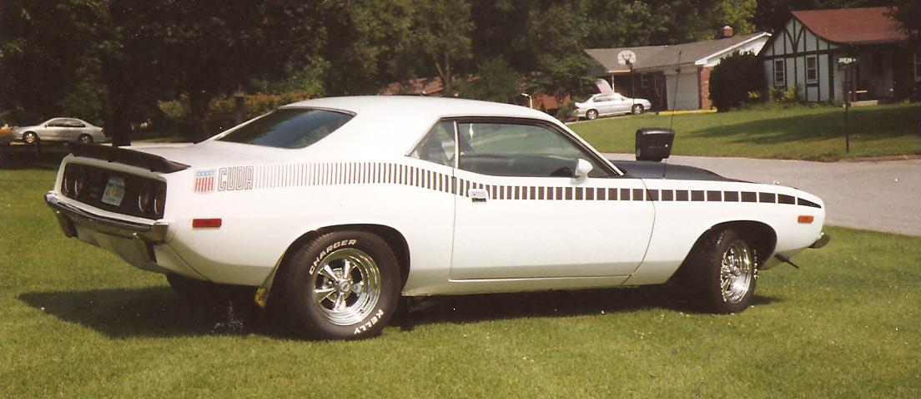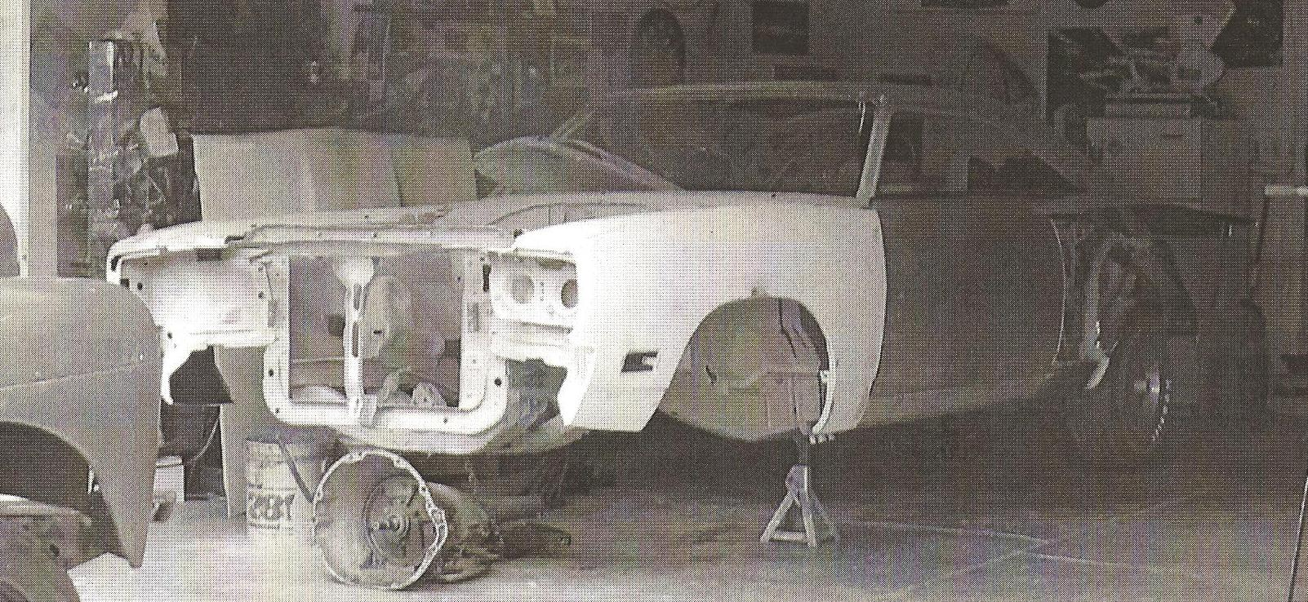
Feature cars of the month. Read the story below. By Pat McKarski
There I was in the spring of 1970 and my brother brings home his orange and black 1969 Road Runner. Well, who knew that this would be the start of a long love affair with several beautiful Mopars?

I was lucky enough to purchase my first car for $150, it was a 1963 Plymouth Fury four door, 318 engine, push button transmission. I must say this car was not the best on the eyes, but for a basic stock 318, it ran great. I then moved on to several Darts and a Road Runner or two.
The years have passed and the children have all grown up and left home. Pat and I are enjoying the Indy Mopar Club and cruising around in our 74 Cuda which was purchased to fill the void of not having our 70 Road Runner on the road. I am sure you all have heard of the horror stories or have lived one out yourselves.

The Road Runner is one such story. We purchased it 3 or 4 years ago and drove it that summer. I say 3 or 4 years because it has been in the back of a body shop so long I really can’t remember when I disassem-bled it and took it to have the body work and paint done. I am sorry to say that the money I gave up front to do the work is gone and the car is now back in my garage in several pieces unfinished. I must say if I did not love these cars so, and have a wonderful wife that loves the cars as much as I do, we would have sold everything and given up.

Well, here it is, the summer of our lives and we are having fun and enjoying the time we get to spend with our Mopar family members. I guess I have rambled on enough about this and that, now to talk about the Cuda and Road Runner.

First the Cuda built in 1974, a 318 car green in color is how it started life. Well the years have produced a 400hp plus 360 plus 6, with a 3.91 Sure Grip, delivering the rotation to the rear end is a TCI 727 automatic transmission. The skin tone has changed to pay tribute to the all American racing team of Swede Savage, and Dan Gurney both drove the AAR Cuda for one year. (Continued on page 2)

- - - - - - - - - - - - - - - - - - - - - - - - - - - - -
Trivia answer: A fiberglass rear window plug and unique piece of glass were used on the 1969 Dodge Charger 500 to make it aerodynamically smooth. Also, a 1968 Coronet grille was flush mounted to prevent air getting trapped in the front end. Did you get it right?
(Continued from page 1)
We do have fun with this car! I am not sure if everyone will agree with what I am going to do with the Road Runner, but here are my plans. I am kicking around the thought of making this a four speed car. I know most everybody that knows me and the car knows it is a numbers matching 383 plum crazy car. I haven’t made up my mind, but I am tilting in the direction of changing the car. I guess the future will tell what comes from all of this. I am hoping to make a lot of progress this winter on getting the purple bird back with its feathers intact and flying down the road.

I would like to say any body shop that is looking to get some excellent advertisement I am sure I can be persuaded to use my Road Runner as a model.

Thank you one and all, and Happy Holidays from Pat and Pat McKarski. Mopar or no car.
- - - - - - - - - - - - - - - - - - - - - - - - - - - - -

Welcome to our newest members: Jerry & Melinda Lay, Yorktown, 1964 Plymouth Valiant Convertible and 1967 Dodge Dart (joined at the October meeting); and Dick & Dorinda Crawmer, Martinsville, 1967 Charger.
<><><><><><><><><><><><><><><><><><>

INDY MOPAR CLUB Monthly Meeting October 25, 2007 7:00 PM
Secretary’s Report
Welcome and sign in – John Bauer, President:
John Bauer brought the meeting to order at 7:00 PM. John asked all members and guests to introduce themselves.

Secretary’s Report – Chris Rigney:
Chris gave the highlights of the September meeting.

Treasurer’s Report/Membership Update – Mike Leyes:
Mike gave the treasurers report as of October 25, 2007. September 27, 2007 balance was $5,263.46; income was $38.00; Expenses were $2,138.73; ending balance is $3,162.73.

John suggested that we still need to donate the balance of $1666.94 to Juvenile Diabetes Research Foundation, our charity organization. Jim Parker made the motion to make the donation, Mike Rigney seconded the motion, the motion carried.

There then followed a discussion regarding the expenses for 2008. Raising the dues was a possibility. Ginger Zimmerman suggested that we start up the 50/50 raffle each month at the meeting to raise more money for the club rather than raise the dues.

The monthly newsletters are a big expense with so many members. It was decided that as many newsletters as possible would be sent by E-mail. Dave will E-mail the newsletter and Jan will mail the balance.

We currently have 91 members in the club.

Event Calendar – Dan Kelly:
Dan talked about upcoming events for the year: Meeting November 29th and the Christmas Party, which will be December 16, 2007, more information on this in the December newsletter.

Event Advertising – Pat & Pat McKarski:
Pat gave an update on the advertising. They are presently advertising in Indy Auto & RV; Old Cars Only; and Mopar Collector’s Guide.

Communications Report – Dave Watt:
Dave volunteered to E-mail the newsletter to all members that have an E-mail address. The balance will be mailed out.

Old Business – John Bauer:
- Member Profile
  - November – Pat(rick) & Pat(ricia) McKarski
  - Tony Fields

- Larry Mayes will update the Indy Mopar Club application form for 2008

New Business – John Bauer:
- Joint get together with another Mopar club.
Tri State Mopar Club: Eric Gegert (513) 892-2042 kagebert@fuse.net River Valley Mopar Club

- John then introduced Russ Flagle, Ken Lazzeri, and Sam Wilson from Indy Cylinder Head. They gave a very interesting presentation and handed out material regarding Indy Cylinder Head.

- Upcoming Car Shows
2007 Halloween Cruise-In / Car Show sponsored by Lowered Horizons October 27th at 4004 S Meridian Street. Hours 2-7 P.M.

- Nominations for 2008 Officers were then opened.
1. President: Dave Watt (declined); Steve Wisdom and Pat(rick) McKarski
2. Vice President: John Bauer and Ronda Cherry
3. Treasurer: Mike Leyes
4. Secretary: Sue Mayes and Ronda Cherry
5. Communications Director: Steve Wisdom and Dave Watt

- IMC Name Tags – renewals

- Preparations will be made for the Swap Meet in March, 2008.

- Discussion regarding a new location for the monthly meetings. It is very difficult to hear in our present location. Joe’s Crab Shack was suggested.

- John then adjourned the meeting.

Respectfully submitted – Chris Rigney, Secretary
<><><><><><><><><><><><><><><><><><>

Attendance at our October meeting: John & Carol Ann Bauer, Bob Beisel, Bill Bratton, Ronda Cherry, Rick & Susan Eilert, Dave & Terry Fishburn, Dan Kelly, Ken & Debbie Komlanc, Ken Lazzeri, Ed & Mary Leyes, Mike Leyes, Susan Mayes, Patrick McKarski, Scott Oller, Jim Parker, Stan & Jan Peel, Chris Rigney, Bob & Karen Rosenberger, Darren Turpen, Chris Usher, Dave Watt, Steve Wisdom, and Rick & Ginger Zimmerman. The following guests were also present: Jerry & Melinda Lay and Sam Wilson from Indy Cylinder Head.
<><><><><><><><><><><><><><><><><><>

December Birthdays: Troy Sissom, 12-5; Cheryl Wisdom, 12-8; Sue Mayes, 12-9; Jim Parker, 12-14; John Marquette, 12-16; Dave Watt, 12-17; Joy Kelly, 12-23.
December Anniversaries: Ken & Pat Mosier, 12-10 (no year given); Ken & Sharon Scobel, 12-13; (no year given); Rick & Susan Eilert, 12-14 (34 years); John & Carol Ann Bauer, 12-22 (no year given); Bill & Constance Bratton, 12-28 (22 years); Congratulations to all!
<><><><><><><><><><><><><><><><><><>

Club Member Information for all
From Larry Mayes: There is a new Mopar magazine out now with Greg Rager as the Editor. Mopar Enthusiast magazine is at this time a bi-monthly, but plans are for it to become monthly. A “Charter” subscription rate is $17.97 for 6 issues. You can subscribe by calling 1-800-448-3611 with a credit card handy between 9am and 5pm Eastern time. Send check or money order to: Mopar Enthusiast magazine P.O. Box 431 Sidney, OH. 45365 I’m not sure if the “Charter” price is still available, but would be worth asking. Tell them the Indy Mopar Club sent you.
- - - - - - - - - - - - - - - - - - - - -

From Ginger & Rick Zimmerman: Their son, Ryan Johnson, went to Kuwait first and is now in Baghdad. He saw his first herd of camels while on the bus going to the rifle range in Kuwait. For those of you who are interested his E-mail address is Snow_boarder3384@hotmail.com and his address is:
Pvt. Ryan Johnson
1-75 CAV, 2 BCT, 101 ABN
Unit # 43488
APO AE 09344
<><><><><><><><><><><><><><><><><><>

Tattler’s Corner
At the October 13th car show in Martinsville it is my understanding that a certain someone (R.E.) decided to play a joke on Bob Biesel and called him on his cell phone to say that he was stranded on Hwy 37. Bob got all packed up and was ready to go when R.E. called him back and told him he was there in the parking lot. Now is that ornery or what!
<><><><><><><><><><><><><><><><><><>

Any errors in this newsletter may be attributed to Jan Peel. If you have any news to be shared with the club such as births, illness, etc., please E-mail to Jpeel83719@aol.com or give me a call at 317-357-5760 and I will include it in the next newsletter. This is YOUR newsletter and we want to make it as interesting as possible.

Please remember to vote – Your ballot is enclosed

Happy Thanksgiving
2008 Indy Mopar Club officer nominations.
Circle one name per office.

President
- Pat McKarski
- Steve Wisdom

Vice President
- John Bauer
- Ronda Cherry

Treasurer
- Mike Leyes- unopposed

Secretary
- Sue Mayes – Later withdrawn
- Ronda Cherry

Communications Director
- Dave Watt
- Steve Wisdom

Mail ballot to:
Mike Leyes
3130 E. Hardacre Ct.
New Castle In. 47362
Or e-mail ballot to: Mike.Leyes@outokumpu.com

Support your Indy Mopar Club Member businesses listed below.
