 Indy Mopar Club News
May 2008 www.indymoparclub.com Jan Peel and Dave Watt, editors
Meetings are the last Thursday of every month

Next regular meeting: Thursday May 29, 2008 will be held at MCL Cafeteria, 3630 South East street Indianapolis (US 31- N of Southern Plaza between Sumner & National). Meet for dinner at 6pm, meeting at 7pm. A Map Quest link is available on the IMC website.

2008 schedule of events. Watch for more events and details to be added.

May 17, 2008 the Indy Mopar Club will host an Open Car Show at Fletcher Used Cars in Edinburgh. Registration 9-noon, awards at 3pm. Door prizes, 50/50 drawing, food, and DJ are some of the activities for the day.

June 21, 2008 the Indy Mopar Club will host an all Mopar Car Show at Fletcher Chrysler Dodge Jeep, 3099 S. Morton Street (US 31 South), Franklin Indiana. Registration 9-noon, awards at 3pm. Top 20, Presidents Choice, and The Finer Details awards. Event T-shirt and goody bag to the first 40 entries. Door prizes, 50/50 drawing, food, and DJ are some of the events planned. Rain or shine.

September 20, 2008 the Indy Mopar Club will host an all Mopar Car Show at Danville Chrysler Dodge Jeep. See website Upcoming Events page for new dealership location. Registration 9-noon, awards at 3pm. Top 20, Presidents Choice, and The Finer Details awards. Event T-shirt and goody bag to the first 40 entries. Door prizes, 50/50 drawing, food, and DJ are some of the events planned. Rain date is September 27.

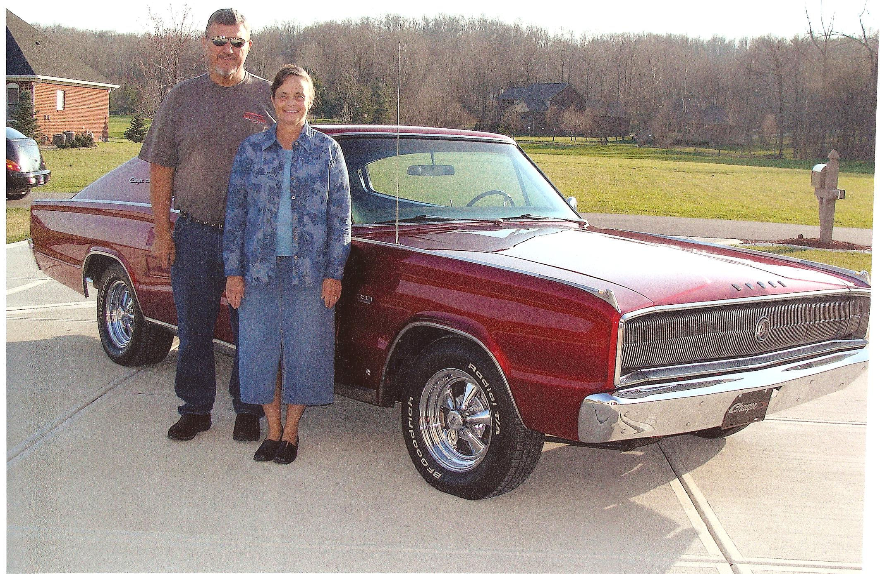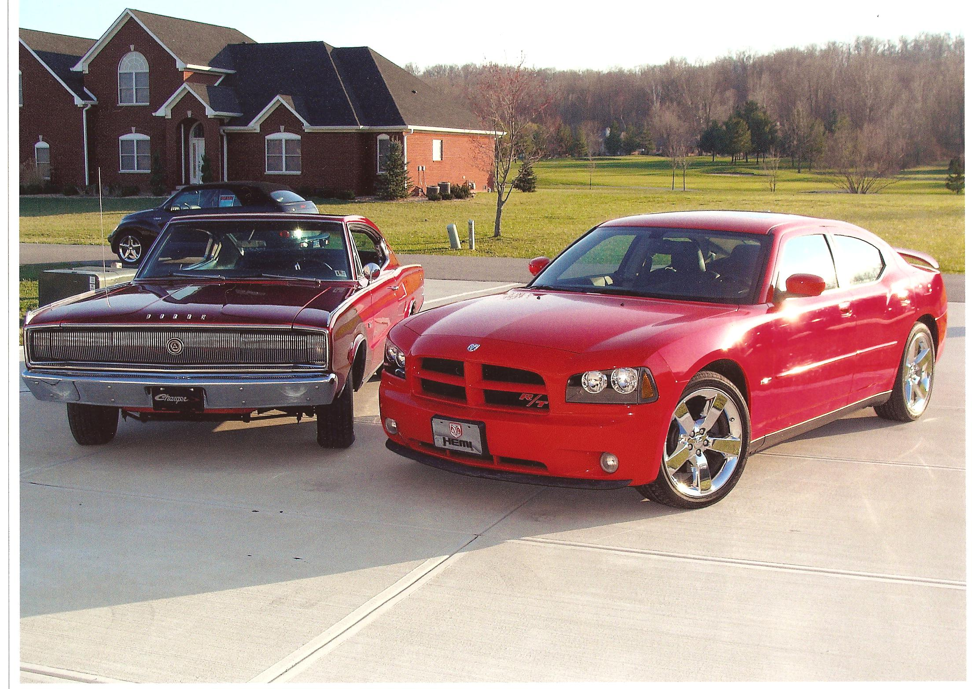
Read about the Crawmer’s first and latest generation Charger’s below.

Hello, I am Dick Crawmer and, with my wife of 39 years Dorinda, live in the Martinsville area. I was raised with Plymouths as our family cars after my mother learned to drive. During high school, my first car was a 1951 Plymouth Cranbrook coupe, flathead 6 and 3-speed on the column-quite the chick magnet! After graduating high school, I bought a 1957 Desoto hemi, dual quad from a classmate. Unfortunately, it needed more work than I thought I could afford, so I traded it in - today that shows very little foresight!

One of my dreams most of our married life has been to own a classic muscle car, but never had the time or resources, so just drooled over everyone else’s. A couple of years ago, with Dorinda’s blessing, I began casually looking on the internet and, of course got hooked. In January of 2007, we drove to Johnstown PA to look at a 1967 Charger, and upon seeing, knew it was the one for us. I was intrigued with the body style reminiscent of my teen years. The car had already been stripped to bare metal, restored inside and out, and repainted, replacing the original blue with Brandywine Kandy. The engine was originally a 383 2-barrel, but was torn down and rebuilt. It is bored out .030” over with heavier cam and performance parts, including Edelbrock aluminum heads and 4-barrel carburetor with Edelbrock intake. The previous owner had gone through a very acrimonious divorce and badly needed the money, so I took advantage of his misfortune. I had 4-wheel disc brakes installed, then had the car shipped to Indianapolis, where we proudly took delivery in March. Since delivery, I replaced the 650 carb with a 750 and 2400 Stahl convertor, which performs much better. I have done some cosmetic work, but have several projects, such as rebuilding gauges and refurbishing the dash, as well as polishing the exterior chrome and repairing the rotating headlights, but that will come in due course as resources and opportunity arise.

We went to several cruise-ins at Washington Square Mall during that first summer and thoroughly enjoyed the camaraderie and friendship of former strangers, who had shared interests. After attending the Good Guys Nationals at Clermont, we were hooked and have enjoyed various shows and cruises since, as well joining the Indy Mopar Club. Even our grandkids like to ride in “Papaw’s race car”!

We also purchased a 2007 Charger R/T with the Road and Track package in TorRed (yeah, it’s got a Hemi!). Now we have the original body style and the latest.

Dick and Dorinda Crawmer
<><><><><><><><><><><><><><><><><><>

Welcome to new members Carlton & Regina Brock, Indianapolis, 1968 Plymouth GTX; Terry & Debbie Cummings, Greenwood, 1950 Dodge Wayfarer 2 Dr Coupe; Chris Dewees, New Castle, 1966 Dodge Coronet 500; Michael & Patricia Patterson, Thorntown, 1965 Plymouth Barracuda; David & Cindy Sanders, 1970 Dodge Dart Swinger, 2007 Dodge Ram 1500, and 2006 Dodge Charger; Stan & Kerry Sanders, Bainbridge, 1948 Dodge BIB Pickup, 1970 Plymouth Satellite, 2004 Dodge Ram, and 1967 Plymouth Sport Fury Convertible. We hope to see all of you real soon.
<><><><><><><><><><><><><><><><><><>

Palmer Auto Group / Indy Mopar Club May 3rd results

Despite an “iffy” rain shower day it turned out sunny and no rain for the 39 car registrars. Everyone enjoyed the music provided by our ABC Dee Jay and the food provided by the IUPUI Dentistry School. Pictures were taken by Rose Richards and have been posted on the IMC website.

And now for the “Rest of the Story” – The Top 20 Winners (In no particular order)
Jim Parker – 1962 Dodge Dart
A Adamo – 1959 Dodge Royal
Bob Schonegg – 1970 Challenger
Verne Williams – 1969 Road Runner
Ken Komlanc – 1968 Roadrunner
Dave Watt – 1969 ½ Road Runner
John Bauer – 1968 Road Runner
Jim Kelly – 1963 Plymouth Savoy Wagon
Ken Scobel – 1966 Dodge Charger
Mark Smith – 1969 Road Runner
Rick Eilert – 1973 Road Runner
Ginger Zimmerman – 1969 Road Runner
Robert Vorpe – 1966 Coronet
Pat & Pat McKarski – 1971 Road Runner
Bob & Karen Rosenburger – 1970 Hemi Cuda
Chad Dockter – 1967 Barracuda Convertible
Jim Childress – 1963 Dodge 440 Wedge
Ronda Cherry – 1971 Challenger
Gary Jump – 1971 Cuda
Bruce Snyder – 1968 Charger
President’s Choice: Jim Kelly – 1963 Plymouth Savoy Wagon
Finer Detail Award: Bill Dugan – 1970 Challenger
Congratulations to all! We hope to see you at future Indy Mopar Car Shows

Pictured below are some of our hard working team. So many work in the “background” that are the backbone of both our club and the Car Shows we “put on” to raise money for our charity – The Juvenile Diabetic Research Foundation. Without them we could not donate the money that we do each year. Thanks to all!

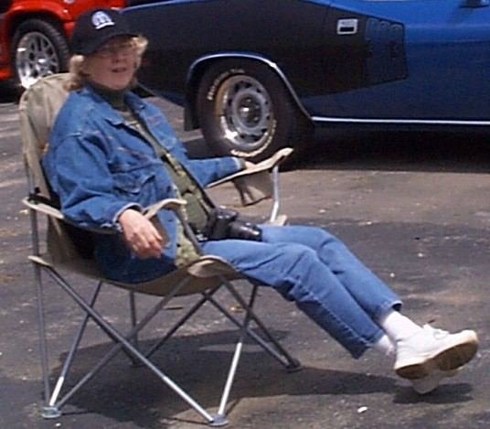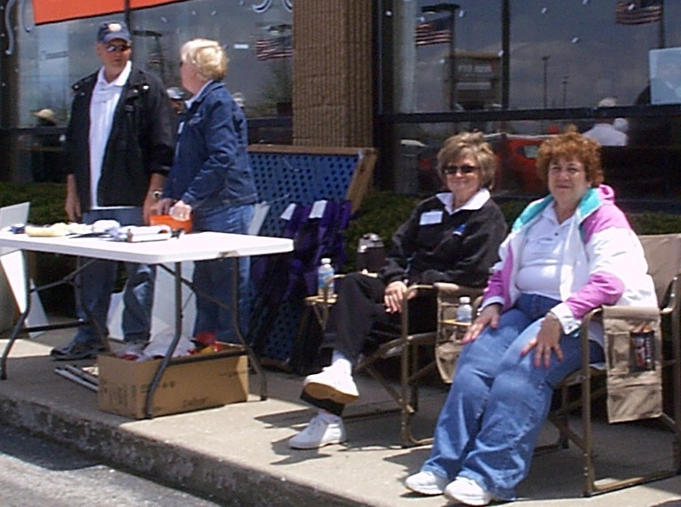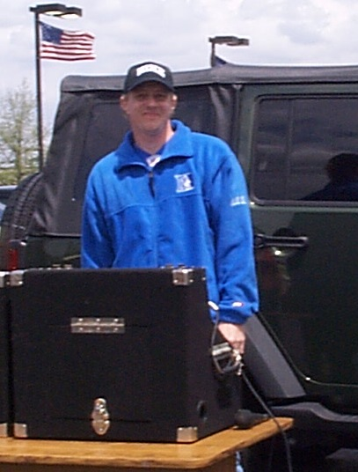
Rose Richards – Photographer Tired Door Prize Workers ABC Dee Jay
<><><><><><><><><><><><><><><><><><>

INDY MOPAR CLUB Monthly Meeting Secretary Report April 24, 2008 7:00 PM
A group of 22 members and 4 guests met at the Indy Powder Coating facility for a very good instruction and demonstration of the powder coating process. There were lots of questions and answers during this, and a couple people tried out the “shooting” of a sample piece to be processed. Our gracious host then allowed us to use their facility for our short meeting as follows:
Welcome and sign in – Steve Wisdom, President:
Steve Wisdom brought the meeting to order at 7:00 PM. Steve asked all members and guests to introduce themselves and tell about their favorite car.

Secretary’s Report – Ronda Cherry:
Ronda read the highlights of the March 2008 meeting.

Treasurer’s Report/Membership Update – Mike Leyes:
Mike gave the treasurers report as of April 24, 2008. March 27, 2008 Balance was $2,121.83;
Income for April was 1 membership dues of $30.00, 1 additional 08 member shirt $10.00, 20 Old
Car Show shirts $40.00, 50/50 Flower Fund $39.00 – Total $119.00.
Expenses – Reimburse Dave Watt for photo album $9.00, Reimburse Steve Wisdom for Palmer Shirts
$822.56 – Total $278.61
Balance April 24, 2008 is $1,4090.27.
We currently have 67 members in the club.
Event Calendar – John Bauer:
John talked about upcoming events for the year:
May 3rd Palmer Dodge-Indy Mopar Club all Mopar Car Show – Rain date May 10th
May 17th Edinburgh Open Car Show
June 21st Fletcher Chrysler-Indy Mopar Club all Mopar Car Show
September 20th Danville Chrysler- Indy Mopar Club all Mopar Car Show – Rain date September 27th

Event Advertising – Pat & Pat McKarski:
Pat gave a brief update on the advertising. They are presently advertising in
Indy Auto & RV
Old Cars Only
Mopar Collector’s Guide.
Old Car Trader
Pat has also been in touch with 101.9 radio station

Communications Director Report – Dave Watt:
Dave Watt reported that the lady from St. Matthews already has a Seeing Eye Dog so made the
recommendation that we use the donation jars at all car shows for the Walk-a-thon. Approved.

Old Business – Steve Wisdom:
- Club Member Profile for Newsletter & Website
  - May – Larry Mayes
  - June – Dick & Dorinda Crawmer
  - July – James Bratby
  - August – Mark Smith

- Joint get together with another Mopar club.
Tri State Mopar Club: Eric Gegert (513) 892-2042 kagebert@fuse.net
1. June 29 Car Show at Greensburg Rebeccah Park – this is on hold until the May meeting.

- IMC Name Tags (Renewals for 2008) – Larry Mayes & Sue were not in attendance – put on hold.

- Palmer Show – Pike Plaza – Volunteers:
Registration Table – Bill Bratton, Tom Kelly, and Mark Smith
Goodie Bags – Jim Parker, Chris Usher, and Steve Wisdom
Parking – Rick Zimmerman and Pat McKarski
Pictures – Rose Richard
Door Prize Table – John and Carol Ann Bauer, Mark Smith
50/50 and Door Prize Tickets – Jan Peel
Food & Drinks – Taken care of – John Bauer
Event T-shirts & Awards – Steve Wisdom - Taken care of
D.J. has been confirmed – ABC Dee Jay

- Fletcher Edinburgh Show – Volunteers:
Registration Table – Bob Schonegg, Dick & Dorinda Crawmer, and Steve Wisdom
Goodie Bags – Jessica and Gary McCormick
Parking – Rick Zimmerman and Pat McKarski
Pictures – Dave Stephenson
Door Prize Table – Chris Usher, Jim Parker and Cheryl Wisdom
50/50 and Door Prize Tickets – Jan Peel
Food & Drinks – Whosoever Will Community Church
Event T-shirts & Awards – Steve Wisdom - Taken care of
D.J. has been confirmed – ABC Dee Jay

- Donation Jars
- Walk-a-thon at all 4 Car Shows

New Business – Steve Wisdom:
- Dodges on the Circle – Contact John Bauer and Tom Kelly
- Finer Detail Award – Ken Mosier

Steve Wisdom then adjourned the meeting.

Respectfully submitted – Ronda Cherry, Secretary
<><><><><><><><><><><><><><><><><><>
Attendees at the Indy Powder Coating tour/meeting were John Bauer, James & Laura Bratby, Bill Bratton, Ronda & Dennis Cherry, Dick & Dorinda Crawmer, Adam Erwin, Ed Leyes, Mike Leyes, Pat & Pat McKarski, Scott Oller, Jan Peel, Bob Schonegg, Ken Scobel, Mark Smith, Dave Stephenson, Bob Thomas, Dave Watt, Steve Wisdom, and guests Stan Sanders, Carl Schunke, Ray Shake, Steve Wyland.

June Birthdays: Wendy Erwin, 6-3; Larry Mayes, 6-13; Rose Richard, 6-15; Sharon Scobel, 6-15; David Stephenson, 6-15; Julia Schonegg, 6-17; Fred Kelley, 6-19; Dave Fishburn, 6-21; Bill Bratton, 6-26; Ken Scobel, 6-26; Bill Dawson, 6-27; Ben Jones, 6-28; Kathy Jones, 6-29; Ken Mosier, 6-30.

June Anniversaries: Mike & Lori Benge, 6-3; Adam & Wendy Erwin, 6-4; Gary & Jessica McCormick, 6-5; Ed & Mary Leyes, 6-8; Ken & Debbie Komlanc, 6-9; Scott & Janet Oller, 6-12; Curt & Marily Huff, 6-14; Tom & Teresa Kelly, 6-26; Bob & Diane Biesel, 6-27; Mark & Mary Fields, 6-27.
Congratulations to all!
<><><><><><><><><><><><><><><><><><>
Information
New information for Rick & Ginger’s son Ryan who is stationed in Iraq:
Pfc Ryan Johnson
1-75 CAV, 2 BCT, 101 ABN
Unit # 43488
APO AE 09344
His E-mail address is now: airborneu173@aim.com
<><><><><><><><><><><><><><><><><><>

Tattler’s Corner
Jan is going to get new glasses, determined after her Blooper-Scooper in last month’s newsletter – it read that John Bauer has a very rare car – a Barraduca – should have been Barracuda, and at the meetings we discuss our bobby – should have been hobby – but it provided a good laugh from all the members so it was worth it.
<><><><><><><><><><><><><><><><><><>

Best Car For The Money
Have you ever thought of how the advent of the Plymouth Road Runner during the 1968 model year changed the idea of muscle cars? Introduced in September of 1967, it was an instant hit.
Some other cars have been claimed to be the father of muscle cars, but I believe the Road Runner is the first truly affordable muscle car. The '55 Chrysler C300 has been claimed, in more recent years, to have been the first, but the term "muscle car" was not even heard of in 1955. A big-bodied car like the 300, even if it did have the highest horsepower engine of its day, cannot be classified as a muscle car. The 1964 Pontiac GTO has also been proclaimed the first muscle car, but I am a bit biased, so it doesn't get the title either. They did put a big block engine in a medium-sized car, true, but it was not affordable... at least not as affordable as the Road Runner would be. The '67 Plymouth GTX, it is true, did have a lot of horsepower (375 horses from the 440 Magnum); but, being a fancy car, it does not qualify in my book either.
The first truly affordable muscle car has to be the 1968 Road Runner, priced at $2831 for a coupe, if my memory serves me correctly. I still think about all the ads for this car that appeared in not only the car magazines but most of the other best-selling magazines of the day.
Think about it. Can it be 40 years ago that our beloved Road Runner came to pass? That basic coupe with rubber floor mats, a vinyl bench seat and no arm rests was light and affordable. It came, at first, with only a four-speed transmission. Later the 727 automatic became available. The only two engines offered that first year were the venerable 335-horse 383 Magnum and the incomparable 425-horsepower 426 cubic inch HEMI motor. Either way, what a choice! Although, for its time, the HEMI was an expensive option at $700-plus.
The coupe is what they came out with first. Later in the spring or early summer, the hardtop line was added. The hardtop brought you a bit fancier Road Runner, since the Satellite interior--called the Decor Group--was available in this model.
The coupe started life as the Belvedere two-door sedan. Can you imagine that light little coupe with that powerful HEMI motor in it? I can't, as I never did drive one at the time. I have ridden with friends in them in recent years, but drivers never get "on them" now like they would have in the old days, right? Wish I could have had the opportunity back then to just let it all hang out: HANG ON!
Just imagine all those 425 horses just wanting to let loose through the four-speed to lay rubber with the 7:75 x 14-inch tires (or maybe 8:25 x 15-inchers if you opted for that). Bias ply tires were "it" back then. Polyglas came on the scene anywhere from one to two years later, and radials followed a year or so after that. I recall the polyglas tires (F70 x 14s) being put on my 1967 Satellite, mounted on chrome reverse rims which were the rage at the time. The car was jacked up with shackles so the rims and tires could fit under the fenders. So cool, compared to what we had available before, eh? When what came to be known as the "coke bottle" body style, like that of the Chargers and Road Runners, came out in 1968, we found that the wide tires would fit under them nicely, but not on my '67.
I'LL SIDETRACK A BIT from the facts just for some enjoyable memories of the first Road Runner I got to "flog on." That happened during the early summer of 1970. I was working on road construction in South Dakota and I needed a ride home for the weekend. My buddy Butch had a '68 Runner. Since he had to drive the company truck to the next site up in northeastern North Dakota, he asked me to drive his Road Runner there, a distance of perhaps 400 miles. Interstate highway speed limits at that time were 75 MPH, and they let you get away with a lot more. I asked Butch "how fast can I run her?" His answer was: "Put 'er at about four grand; she runs good there." It must have had the standard 3:23 Sure Grip in it, because four grand on the tach was 115 MPH! YES, you heard me right!
I left Selby, South Dakota, a little after 6:00 PM and was at the site near Grand Forks, North Dakota, four hours later. My only stop was a gas stop / bathroom break about halfway there. Sun-flower seeds and a beverage in my hand got me through. What a ride!
Yes, I do know that I was not running according to "specs" at the time, but I was young (25) and young at heart. Tell me that none of you ever ran a good run like that! You can see why the Road Runner was popular with the moonshine runners down south. After all, I had to see if those ol' ads with the southern boys runnin' 'shine were true. THEY WERE!
To be continued in the next issue, this column will give you more facts and tales of fun about the best car made for the money: the Plymouth Road Runner! I will write mainly about the Road Runner throughout 2008, as this is the 40th anniversary year of our beloved Road Runner... hard to believe, but it is!
CLIF NELSON cknelson@polarcomm.com

Copied and reprinted with permission of Clif Nelson and Lanny Knutson, Editor of the National Plymouth Owners Club, Inc., the “Bulletin”.

<><><><><><><><><><><><><><><><><><>
THE LAWS OF LIFE
Law of Mechanical Repair - After your hands become coated with grease, your nose will begin to itch or you'll have to “make a pit stop”.
Law of the Workshop - Any tool, when dropped, will roll to the least accessible corner.
Law of Probability - The probability of being watched is directly proportional to the stupidity of your act.
Law of the Alibi - If you tell the boss you were late for work because you had a flat tire, the very next morning you will have a flat tire.
Variation Law - If you change lines (or traffic lanes), the one you were in will start to move faster than the one you are in now (works every time).
Law of the Result - When you try to prove to someone that a machine won't work, it will.
Law of Biomechanics - The severity of the itch is inversely proportional to the reach.
Law of Coffee - As soon as you sit down to a cup of hot coffee, your boss will ask you to do SOMETHING which will last until the coffee is cold.
