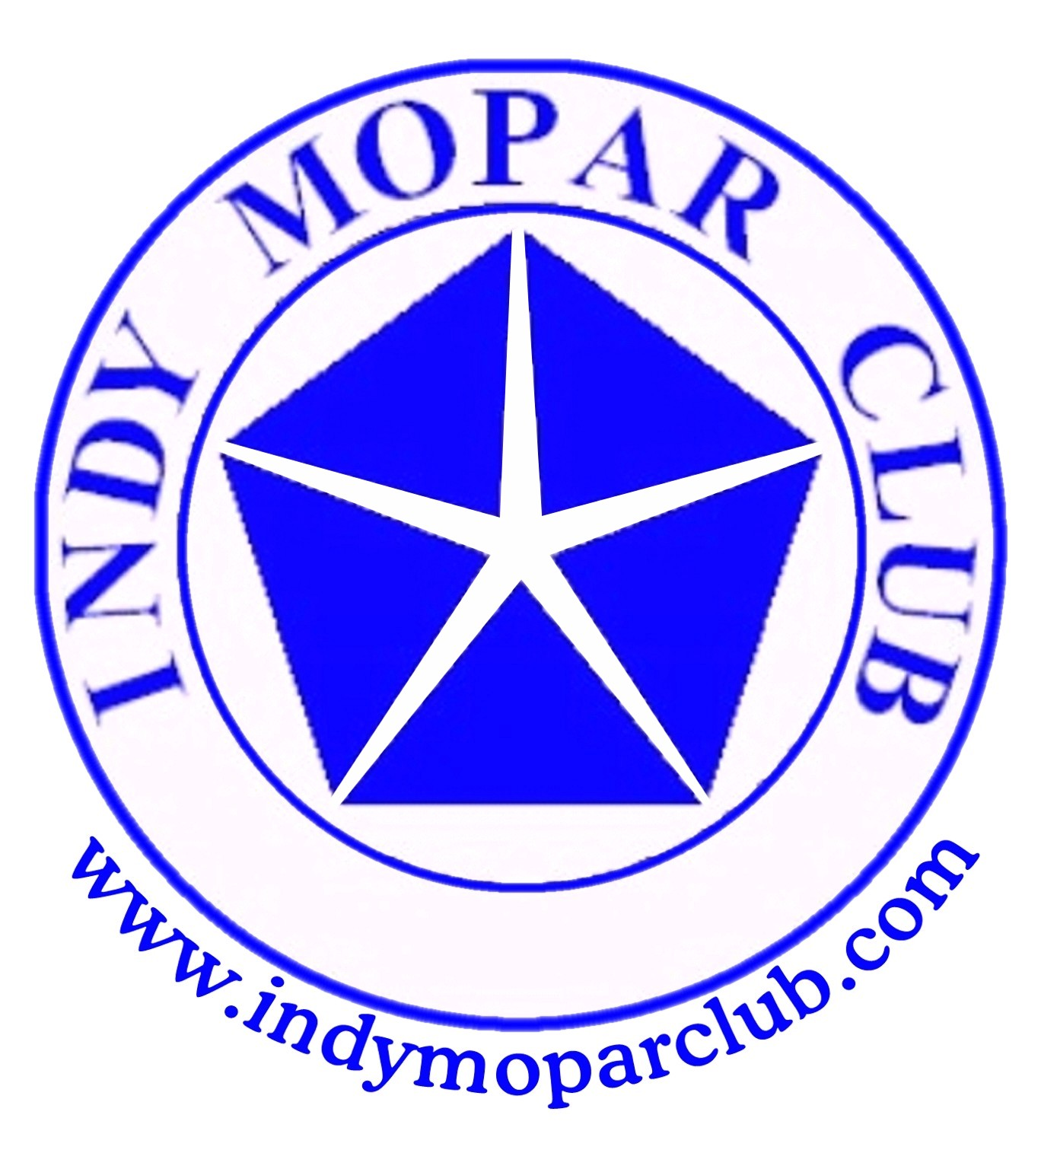 Indy Mopar Club News
May 2007 w ww.indymoparclub.com Jan Peel and Dave Watt, Editors
Indy Mopar Club Officers - 2007
President Vice President Secretary Treasurer
John Bauer Dan Kelly Chris Rigney Mike Leyes

Meetings are the last Thursday of every month, except December due to the holidays, at Ryan’s Steakhouse on US 31 South in Greenwood. Arrive early to enjoy dinner and chat with club members.
Next two meetings: Thursday May 31 and Thursday June 28

Trivia question: Since this is the month of May in Indianapolis, there has to be a trivia question based on an Indy 500 pace car. What car paced the 1987 Indy 500? Answer below.

July 7, 2007, 9-3pm, the Indy Mopar Club will host an all Mopar car show at Fletcher Chrysler Dodge Jeep at 3099 North Morton (US31) in Franklin Indiana, (317)-738-1470. Top 20 awards, door prizes, 50/50 drawing, DJ, food and more. Rain or shine.

September 22, 2007, 9-3pm, The Indy Mopar Club will host an all Mopar car show at Danville Chrysler Dodge Jeep located at 20 S. County Road 300 E. #362 in Danville Indiana, (317)-745-5809. Top 20 awards, door prizes, 50/50 drawing, DJ, food and more. Rain date: September 29, 2007.

Trivia answer: The 1987 Chrysler LeBaron paced the 1987 Indy 500.

Stan & Jan Peel – 1969 Plymouth Fury III Convertible
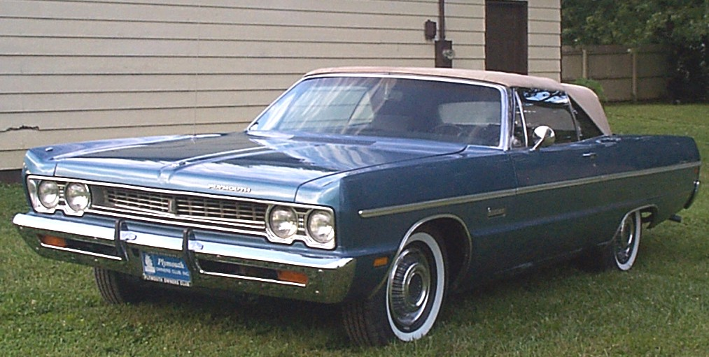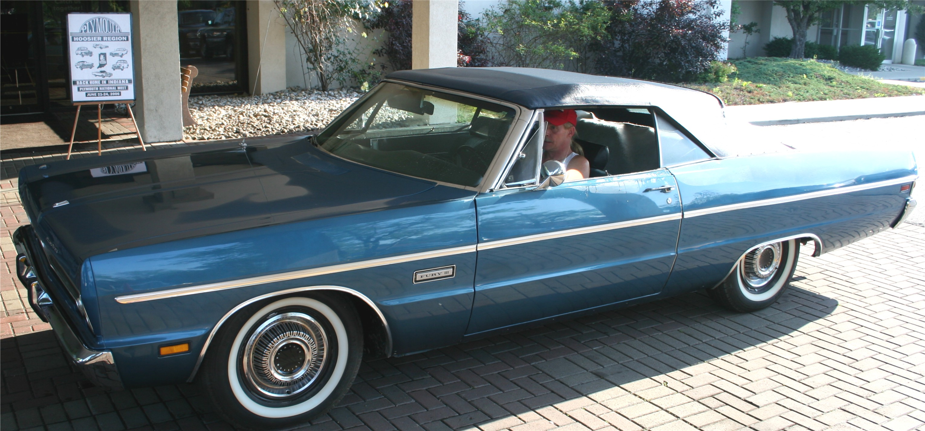
Before the new top was installed. At the 2006 Plymouth Club National Meet (new top)
The original owner bought it new in 1969, trading in a 1968 Plymouth Satellite. It cost $4,900, less $3,500 trade in leaving a finance balance of $1,400. I got a call one day from a salesman at Welliver’s in Martinsville stating that a young lady out of Bloomington wanted to trade for a new car and they didn’t want to take the trade. They wanted to know if I would be interested in buying it from her, as she needed cash to make the deal.
The car looked pretty tired but it was well optioned, had a 383 engine, dual exhaust, light package, dual mirrors, etc. It showed some rust repair in the quarters, but didn’t look that bad. Being a New York state car (Original Owner) I figured some rust was inevitable. So this was purchased November 30, 1993, with 132,000 miles on it.
In 1996 I pulled the engine and had it rebuilt and then started stripping the body. The front fenders had been patched with galvanized steel riveted in, also the quarter panels, and this entailed stripping off large chunks of Bondo that covered the patches and rivets. The front floor had to be replaced as well as the trunk floor. What was left in the gas tank looked like molasses. So the gas tank had to be pulled, solvent treated to clean it out, then gas tank sealer to finish the job.
In 2002 I started putting it back together, and in the summer of 2003 I started the engine for the first time. It was painted in April of 2004. In 2005 I had a new dark blue convertible top installed. I was finally ready to start driving it. On a trip back from Illinois in 2006 the transmission decided to really mess up. We had to stop 3 times to put transmission oil in it to get it home. Needless to say, the transmission also got rebuilt.
What a long haul! It has just turned 134,000 miles at the start of this year! It isn’t perfect, but we enjoy driving it.
Author – Stan Peel
P.S. If you’re puzzled by the grille, that’s the way I got it. It’s a Sport Fury grille, different from the normal ’69 Fury III. I don’t know if it came from the factory that way or if it had been in an accident and the front dog-house was changed.
<><><><><><><><><><><><><><><><><><>
The Indy Mopar Club held an all Mopar car show at Palmer Auto Group on May 5, 2007
Dealership employees voted for the top 20, Presidents Choice and Finer Details awards. Many door prizes were given out, 50/50 drawing, DJ, food and more. Luckily the weather held out for the 43 participants.
Palmer Auto Group employees were responsible for choosing the Top 20 winners and are listed in no particular order, results below:

Jim Parker- '62 Dodge Dart
Sue Mayes- '67 Dodge Dart
Steve Cage- '70 Plymouth Superbird
Randy Fleetwood- '72 Dodge Dart
Rick Eilert- '70 Plymouth Barracuda
Steve Wisdom- '70 Plymouth Road Runner
Bob Vorpe- '71 Dodge Dart
Mike Bowman- '69 Plymouth Road Runner
Ken Scobel- '66 Dodge Charger
Dave Watt- '69 Plymouth Road Runner
Tom Kelly- '79 Dodge 'Lil Red Express
John Klir- '68 Plymouth GTX
Verne Williams- '69 Plymouth GTX
Brent McClure- '05 Dodge Ram
Mike and Chris Rigney- '67 Dodge Coronet
Ed Leyes- '70 Dodge Challenger
Mike Leyes- '70 Dodge Challenger T/A
Pat and Pat McKarski- '74 Plymouth 'Cuda
Gerry Dwyer- '69 Dodge Superbee
Bill Dawson- '87 Dodge Ram 50

Presidents Choice Award went to Steve Wisdom- '70 Plymouth Road Runner
The Finer Detail Award went to Jim Vansickle- '70 Dodge Challenger T/A
Sue Mayes won the Reaction Time Racing contest. (She did it for all the women!)
We had 43 registrations for the show. We’d like to thank all the volunteers that contributed their time to make the show a success. It takes a lot of work to put on a car show. The success we have shows the dedication that our members put forth to pull this off.
<><><><><><><><><><><><><><><><><><>
Welcome to our new members: Bill & Constance Bratton, New Palestine, 99 Dodge Dakota; Gary & Jessica McCormick, Speedway, 72 Dodge Dart, 03 Dodge Ram 1500, & 05 Jeep Liberty; and Raymond & Suzanne Vansickle, Lebanaon, 70 Dodge Challenger T/A. We hope to see you soon at a meeting or event.
<><><><><><><><><><><><><><><><><><>
INDY MOPAR CLUB Monthly Meeting April 26, 2007 7:00 PM
Secretary’s Report
Welcome and sign in – John Bauer, President:
John brought the meeting to order at 7 PM. Then asked everyone to introduce themselves and tell a little about their cars and anything else pertinent.
Old Business
Treasurer’s Report/Membership Update – Mike Leyes:
Mike gave the treasurers report as of April 26. Beginning balance for April was $1,730.94; Income was $2,124.00; Expenses were $1,463.39; Ending balance is $2,391.55. We have 1 member renewal and 2 new members. Total of 74 members in club as of April 26th.

Event Calendar – Dan Kelly gave an updated report:
**May 5, 2007, 9-3 PM, The Indy Mopar Club will host an all Mopar car show at Palmer Dodge North at 4545 East 96th Street, Indianapolis, (317)-846-5555. Top 20 awards, door prizes, 50/50 drawing, Drag Racing simulator, DJ, food, and more. Rain date is May 12, 2007.
**May 18-20, Chrysler Classic at National Trails Raceway, Columbus, Ohio
**May 31, Thursday. 7 PM Indy Mopar Meeting at Ryan’s Steakhouse, US 31 South in Greenwood
**June 16, Saturday, 19th Annual Hog Jog Cruise-in & Car Show in Flora, Indiana
**June 24, Sunday, 9th Annual Wanamaker Old Settler’s Day Classic Car Show, Wanamaker. For more info call Stephanie at 317-862-9352 or sschemenaur14@sbcglobal.net
**June 28, Thursday. 7 PM Indy Mopar Meeting at Ryan’s Steakhouse, US 31 South in Greenwood
**July 7, 2007, 9-3pm, the Indy Mopar Club will host an all Mopar car show at Fletcher Chrysler Dodge Jeep at 3099 North Morton (US31) in Franklin Indiana, (317)-738-1470. Top 20 awards, door prizes, 50/50 drawing, Drag Racing simulator, DJ, food and more. Rain date to be determined.
**July 14, Saturday, “Rollin Back the 70’s Car Show and Carnival, Mike Aulby’s Arrowhead Bowl, 2331 Brothers Dr., Lafayette, IN. For more info call 765-427-8893 or www.arrowheadbowl.com
**July 26, Thursday. 7 PM Indy Mopar Meeting at Ryan’s Steakhouse, US 31 South in Greenwood
**August 10-12, Mopar Nationals at National Trails Raceway, Columbus, Ohio
**August 26th, Sunday, Kokomo Transmission Cruze-In Car Show, Kokomo, Indiana
**August 30, Thursday. 7 PM Indy Mopar Meeting at Ryan’s Steakhouse, US 31 South in Greenwood
**September 22, 2007, 9-3pm, The Indy Mopar Club will host an all Mopar car show at Danville Chrysler Dodge Jeep located at 20 S. County Road 300 E. #362 in Danville Indiana, (317)-745-5809. Top 20 awards, door prizes, 50/50 drawing, Drag Racing simulator, DJ, food and more. Rain date is September 29, 2007.
**September 25, Thursday. 7 PM Indy Mopar Meeting at Ryan’s Steakhouse, US 31 South in Greenwood

Pat McKarski is posting advertising for the Indy Mopar car shows with Mopar Collector Guide, Indy RV, Old Cars Only, and Mopar Muscle.
Communications Report – Dave Watt: Dave reported that he has updated the IMC web-site with new background and pictures. He will post the May 5th Palmer Dodge North car show on the web-site. Stan Peel will have the May Member Profile. Jim Parker volunteered for the July Member Profile.
Dave suggested that our car show shirts say Mopar Club Show.
John reminded the membership that Rick & Ginger Zimmerman still need help with the open car show for Fletcher Chrysler Edinburgh. Steve Fletcher wants the club to help sponsor, proceeds will go to the Juvenile Diabetic Research Foundation. See Rick & Ginger to help with the show or contact them at 317-933-3384.
Pat McKarski suggested that we display the car that won the Finer Detail Award at the next Car Show.
John suggested that we use a generic flyer rather than a photographed flyer. The membership decided that we would pick three cars and go with that.
New Business
John suggested we try to get together with another Mopar Club for a car show. Other Mopar Clubs attend our car shows and we would like to return the favor.
Dave Watt suggested that we purchase food from Gordon’s and serve the food for the Palmer Dodge North show with our members serving.
The tentative Christmas party will be December 15th or 16th. Steve Wisdom will report at the next meeting.
John then adjourned the meeting at 8:20.
Respectfully submitted – Chris Rigney, Secretary
<><><><><><><><><><><><><><><><><><>

Attendance April 26th meeting:
John Bauer, Ronda Cherry, Rick & Susan Eilert, Ken & Debbie Komlanc, Ed Leyes, Mike Leyes, Susan Mayes, Pat & Pat McKarski, Jim Parker, Stan & Jan Peel, Mike & Chris Rigney, Ken Scobel, Bob Thomas, Chris Usher, Dave Watt, Thomas Williams, and Steve Wisdom.
<><><><><><><><><><><><><><><><><><>
A little late but they were omitted in last month’s newsletter: May Birthdays: Brenda Grantham, 5-6; Bob Schonegg, 5-7; John Bauer, 5-9; Ed Leyes, 5-12; Gary McCormick, 5-21; Michael Harter, 5-22; Steve Wisdom, 5-22; Mary Leyes, 5-23; Mark Underwood, 5-26; Mike Leyes, 5-28. May Anniversaries: Chad & Renee Neukam, 5-11 (1 year); Bob & Kim Vorpe, 5-17 (no year given); Steve & Brenda Grantham, 5-21 (36 years); Steve & Michelle Haug, 5-25 (no year given).
June Birthdays: Larry Mayes, 6-13; Rose Richard, 6-15; Sharon Scobel, 6-15; Dave Stephenson, 6-15; Julia Schonegg, 6-17; Steve Haug, 6-19; Lisa Culpepper, 6-21; Michelle Haug, 6-24; Bill Bratton, 6-26; Ken Scobel, 6-26; Ben Jones, 6-28; Kathy Jones, 6-29; Ken Mosier, 6-30. June Anniversaries: Mike & Lori Benge, 6-3 (18 years); Adam & Wendy Erwin, 6-4 (19 years); Gary & Jessica McCormick, 6-5 (3 years); Ed & Mary Leyes, 6-8 (44 years); Ken & Debbie Komlanc, 6-9 (no year given); Brent & Julie Norman, 6-10 (18 years); Curt & Marily Huff, 6-14 (40 years); Bob & Diane Biesel, 6-27 (7 years); Mark & Mary Fields, 6-27 (no year given). Congratulations to all!
<><><><><><><><><><><><><><><><><><>
Some pictures from the Palmer Group North Car show May 5th
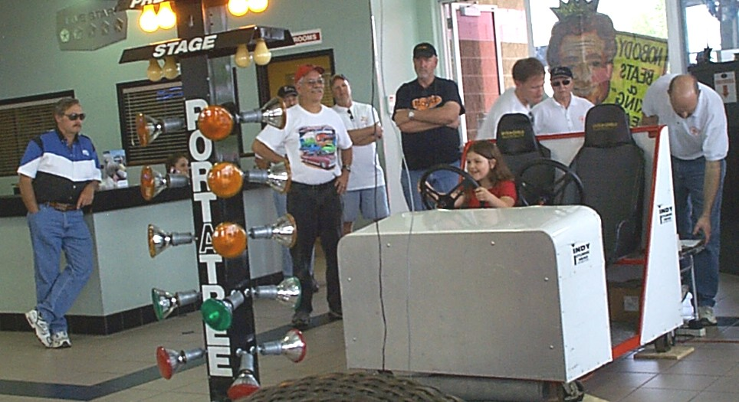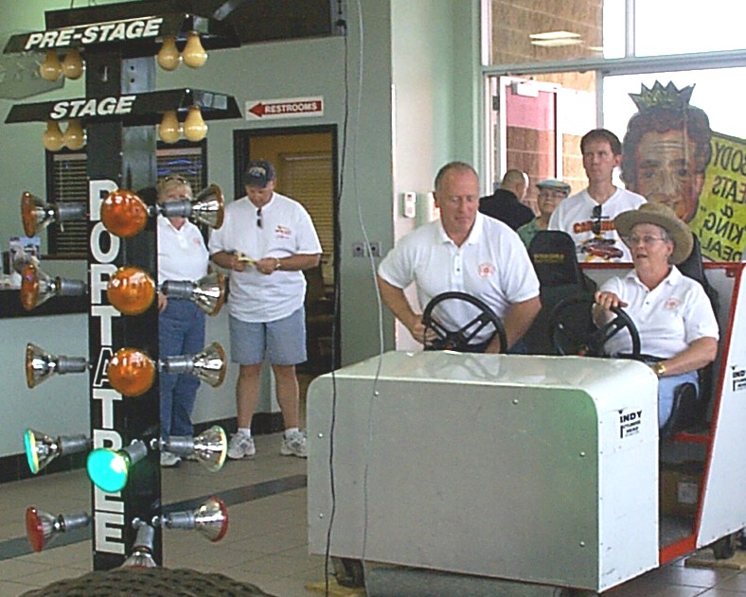
Ric Lafollette’s daughter testing it out! Sue Mayes practicing for her winning run!
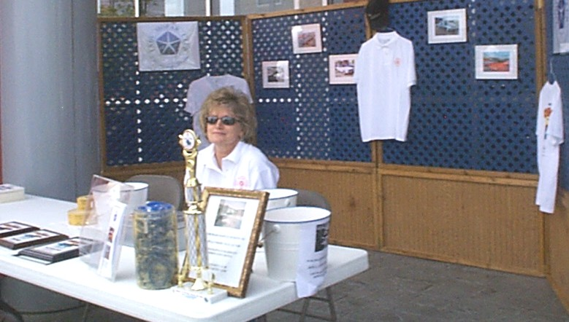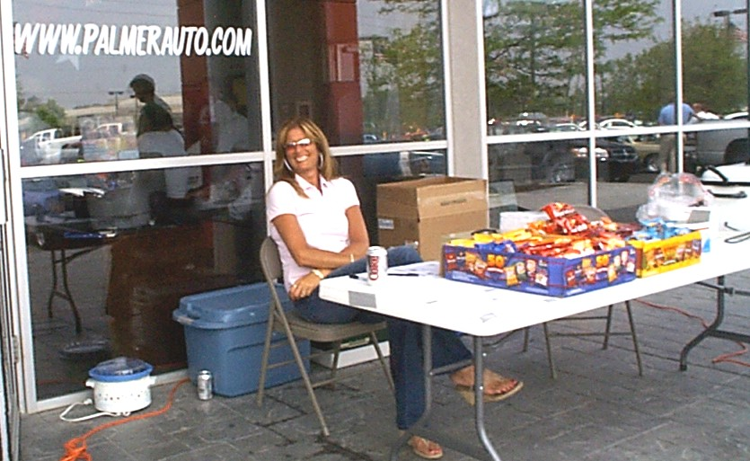
Carol Ann hard at work Ginger ready for business
<><><><><><><><><><><><><><><><><><>
Fletcher Chrysler Edinburgh / Indy Mopar Club Open Car Show May 19th, 2007
The proceeds exceeded $1400 which will be donated to the Juvenile Diabetes Research Foundation which is the club chosen charity.
There were 67 Registrants. Food was provided by the WhosoEver Community Church - c/o Pastor Lewis Burton. Over 60 Door Prizes were awarded during the show.

Top 25 Winners (in no specific order)
Kevin Jackson - 68 Pontiac Lemans Ted Novicky - 48 Plymouth
John Henry - 57 Chevy Wagon Bill Perkins - 55 Nomad
Mike Steinson - 35 Ford David Maloney - 65 Mustang
Bob Walker - 42 International Truck Wayne Rupp - 37 Ford
Robert Lemly - 64 Corvette Bob Hatchett - 41 Dodge
John Young - 70 Chevy Monte Carlo Dean Burton - 55 Chevy Belair
Gary Christensen - 78 Chevy Corvette Pace Car Chris Walker - 57 Chevy
Lowel Baker - 55 Chevy Jean Henderson - 48 Plymouth Coupe
David Johnson - 54 Chevy Danny Cambel - 72 Chevelle
Joe Henson - 30 Ford Coupe Walter Blonk - 50 Chevy Pick up
Bryan Eliclger - 69 Chevy Camero Lewis Burton - 57 Chevy
Chris Landis - 99 Chevy Camero Danny Campbell - 55 Chevy
Danny Henderson - 50 Studebaker
Speciality Awards:
Best Chevy Cindy Stevenson 60 Corvette
Best Ford Clayton Robey 56 Ford Victoria
Best Engine Steve Stevenson 90 Chevy 1500
Best Truck Joe Price 50 Chevy
Best Mopar Steve Humphreys 70 Roadrunner
Best GM Jim Terrell 67 Chevelle
Best Paint Bill Sears 40 Chevy
Club Awards:
Best Indy Mopar Club Car Ronda Cherry 71 Challenger
2nd Place Indy Mopar Club Car Kurt Huff 70 Roadrunner
Awards were also presented to the: Oldest Participant - Youngest Participant and the Farthest Drive
Indy Mopar Club Presented - Edinburgh Fletcher Used Cars and Truck with an Appreciation Award for their support and contribution...accepted by JR Fletcher.
Submitted by Ginger Zimmerman
<><><><><><><><><><><><><><><><><><>
Tattler’s Corner
Did you notice our very capable “food serving crew” at the Palmer show? They did a “bang-up” job. Seems like there were a lot of smiles that day from everyone helping out. Must have been the Spring weather. And did you notice the “mini” dancing going on behind the door prize table in Edinburgh? Hmm!
<><><><><><><><><><><><><><><><><><>
FOR SALE
**1968 Dodge Polara 500 Convertible 96% Brand New. 440 HP, 273 Highway gears. MUST SELL! Owned for 30 years, it has been garaged for 27 years. In the last 7 or 8 years I have taken it apart, had it painted, and have had parts rebuilt and/or bought new parts. It has new top, carpet, bumpers, Performer Intakes, headers. Dash has been reconditioned, and needs to be put back in car. Most items above still in packing they were in when returned to me. Needs new wheels & tires. Lost my storage space – MUST SELL! Everything is there, just needs to be put back together. Call Herb Miller at 317-543-0985 or 317-525-9661. $5,000.00 FIRM.
<><><><><><><><><><><><><><><><><><>
ADDITIONAL UPCOMING EVENTS
**June 14-16, 2007, Tulsa Region Plymouth Owners Club, Tulsa, OK, featuring the Exhumation and
Unveiling of the 1957 Plymouth Time Capsule.
**June 23, 2007, Saturday, Hoosier Region Plymouth Owners Club will tour to a 1913 Chrysler Dealership in Miamisburg, Ohio, that is still in operation. For further information contact Stan Peel at 317-357-5760.
**July 17-21, 2007, WPC Club National Meet, Chicago, IL., hosted by Northern Il. Region in Lincolnshire, IL www.chryslerclub.org
**August 18, 2007, Saturday, 2007 Cool Creek Park Jukebox Saturday Classic Car or Motorcycle Show, Westfield. Must be a pre-1982 car, truck, hotrod, custom or motorcycle. Call Michelle at 317-896-5874.
**September 19-23, 2007, Plymouth Owners Club National Meet, Concord, NC, hosted by North Carolina Region Plymouth Owners Club. For further information contact Stan Peel at 317-357-5760.
**October 6-7, 2007, Newport Hill Climb, Newport, Indiana
<><><><><><><><><><><><><><><><><><>

A Father’s Day Tribute
Strongest Dad in the World [From Sports Illustrated, By Rick Reilly, 2006]
I try to be a good father. Give my kids mulligans. Work nights to pay for their text messaging. Take them to swimsuit shoots. But compared with Dick Hoyt, I suck. Eighty-five times he's pushed his disabled son, Rick, 26.2 miles in marathons. Eight times he's not only pushed him 26.2 miles in a wheelchair but also towed him 2.4 miles in a dinghy while swimming and pedaled him 112 miles in a seat on the handlebars-all in t he same day. Dick's also pulled him cross-country skiing, taken him on his back mountain climbing and once hauled him across the U.S. on a bike. Makes taking your son bowling look a little lame, right? And what has Rick done for his father? Not much-except save his life. This love story began in Winchester, Mass., 43 years ago, when Rick was strangled by the umbilical cord during birth, leaving him brain-damaged and unable to control his limbs.
"He'll be a vegetable the rest of his life;" Dick says doctors told him and his wife, Judy, when Rick was nine months old. "Put him in an institution." But the Hoyts weren't buying it. They noticed the way Rick's eyes followed them around the room. When Rick was 11 they took him to the engineering department at Tufts University and asked if there was anything to help the boy communicate. "No way," Dick says he was told. "There's nothing going on in his brain." "Tell him a joke," Dick countered. They did. Rick laughed. Turns out a lot was going on in his brain.
Rigged up with a computer that allowed him to control the cursor by touching a switch with the side of his head, Rick was finally able to communicate. First words? "Go Bruins!" And after a high school classmate was paralyzed in an accident and the school organized a charity run for him, Rick pecked out, "Dad, I want to do that."
Yeah, right. How was Dick, a self-described "porker" who never ran more than a mile at a time, going to push his son five miles? Still, he tried. "Then it was me who was handicapped," Dick says. "I was sore for two weeks." That day changed Rick's life. "Dad," he typed, "when we were running, it felt like I wasn't disabled anymore!" And that sentence changed Dick's life. He became obsessed with giving Rick that feeling as often as he could. He got into such hard-belly shape that he and Rick were ready to try the 1979 Boston Marathon. "No way," Dick was told by a race official. The Hoyts weren't quite a single runner, and they weren't quite a wheelchair competitor. For a few years Dick and Rick just joined the massive field and ran anyway, then they found a way to get into the race officially: In 1983 they ran another marathon so fast they made the qualifying time for Boston the following year. Then somebody said, "Hey, Dick, why not a triathlon?" How's a guy who never learned to swim and hadn't ridden a bike since he was six going to haul his 110-pound kid through a triathlon? Still, Dick tried.
Now they've done 212 triathlons, including four grueling 15-hour Ironmans in Hawaii. It must be a buzzkill to be a 25-year-old stud getting passed by an old guy towing a grown man in a dinghy, don't you think? Hey, Dick, why not see how you'd do on your own? "No way," he says. Dick does it purely for "the awesome feeling" he gets seeing Rick with a cantaloupe smile as they run, swim and ride together.
This year, at ages 65 and 43, Dick and Rick finished their 24th Boston Marathon, in 5,083rd place out of more than 20,000 starters. Their best time'? Two hours, 40 minutes in 1992--only 35 minutes off the world record, which, in case you don't keep track of these things, happens to be held by a guy who was not pushing another man in a wheelchair at the time. "No question about it," Rick types. "My dad is the Father of the Century."
And Dick got something else out of all this too. Two years ago he had a mild heart attack during a race. Doctors found that one of his arteries was 95% clogged. "If you hadn't been in such great shape," one doctor told him, "you probably would've died 15 years ago." So, in a way, Dick and Rick saved each other's life. Rick, who has his own apartment (he gets home care) and works in Boston, and Dick, retired from the military and living in Holland, Mass., always find ways to be together. They give speeches around the country and compete in some backbreaking race every weekend, including this Father's Day. That night, Rick will buy his dad dinner, but the thing he really wants to give him is a gift he can never buy. "The thing I'd most like," Rick types, "is that my dad sits in the chair and I push him once."
<><><><><><><><><><><><><><><><><><>
HAPPY FATHER’S DAY

