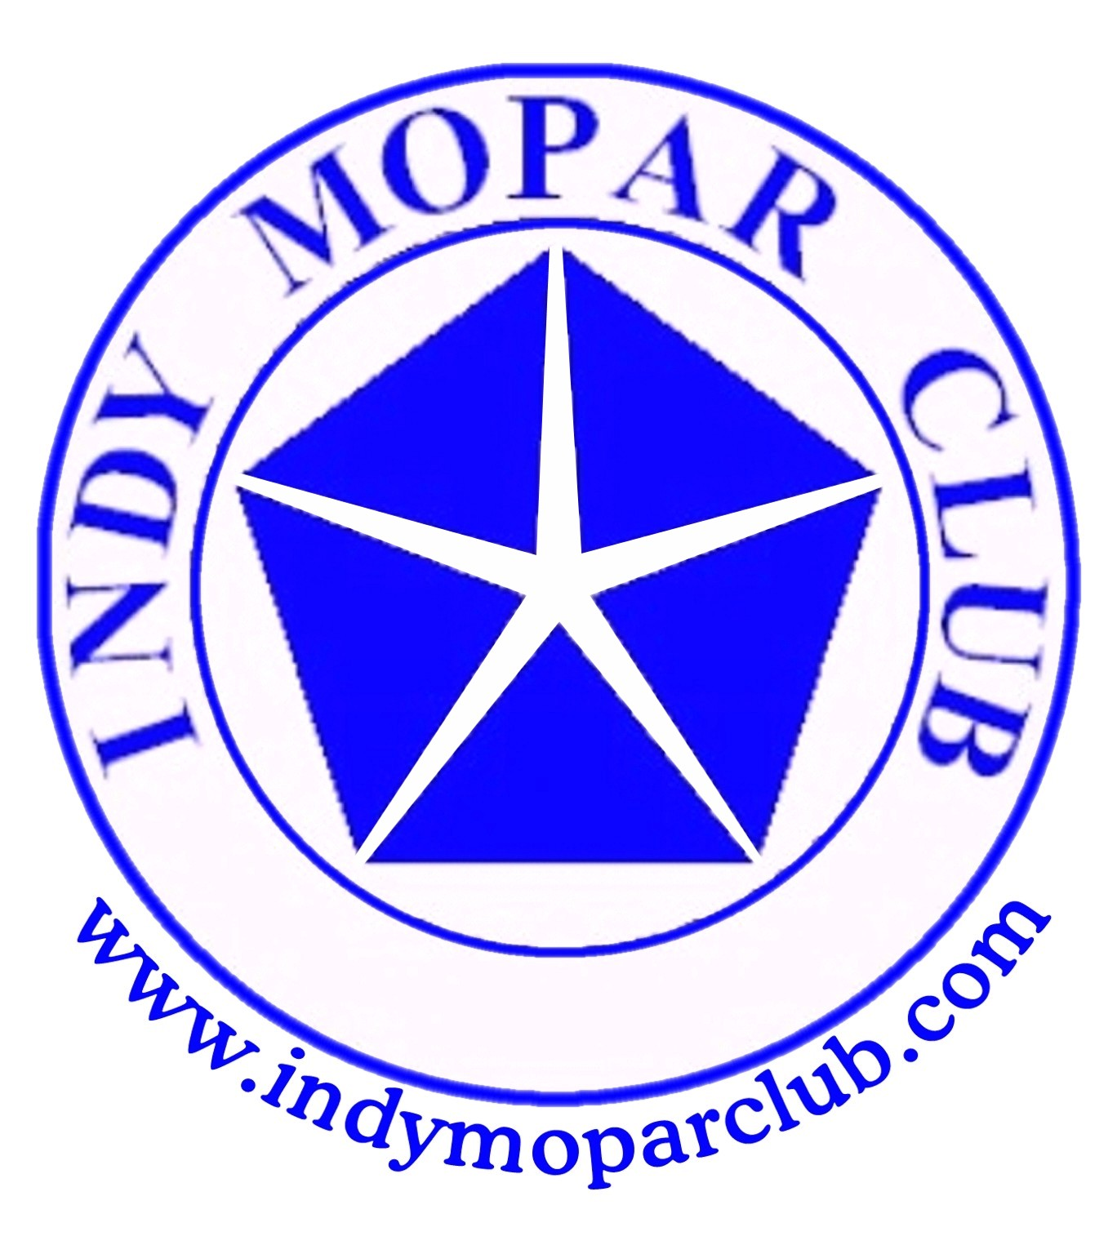
Indy Mopar Club News
June 2008 www.indymoparclub.com Jan Peel and Dave Watt, editors
Meetings are the last Thursday of every month

2008 schedule of events. More events and details on the way.

Next regular meeting: Thursday June 26, 2008 will be held at MCL Cafeteria, 3630 South East street Indianapolis (US 31- N of Southern Plaza between Sumner & National). Meet for dinner at 6pm, meeting at 7pm. A Map Quest link is available on the IMC website.

September 20, 2008 the Indy Mopar Club will host an all Mopar Car Show at Danville Chrysler Dodge Jeep. See website Upcoming Events page for new dealership location. Registration 9-noon, awards at 3pm. Top 20, Presidents Choice, and The Finer Details awards. Event T-shirt and goody bag to the first 40 entries. Door prizes, 50/50 drawing, food, and DJ are some of the events planned. Rain date September 27.

<><><><><><><><><><><><><><><><><><>
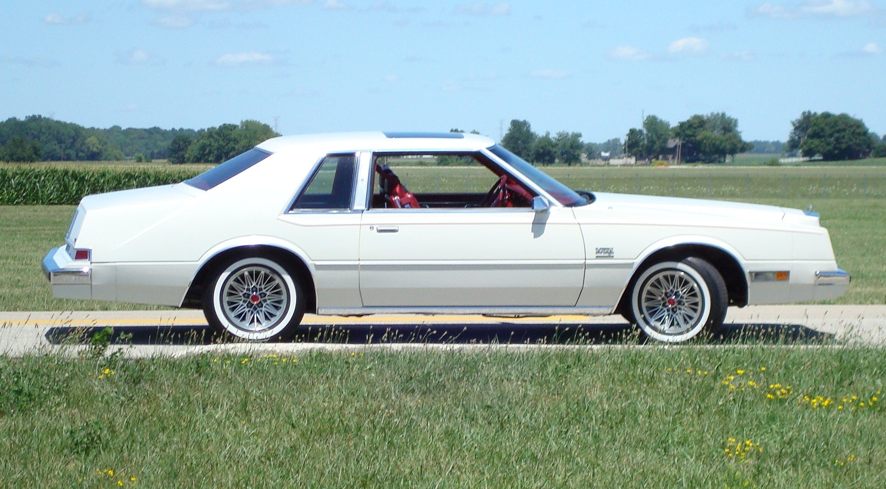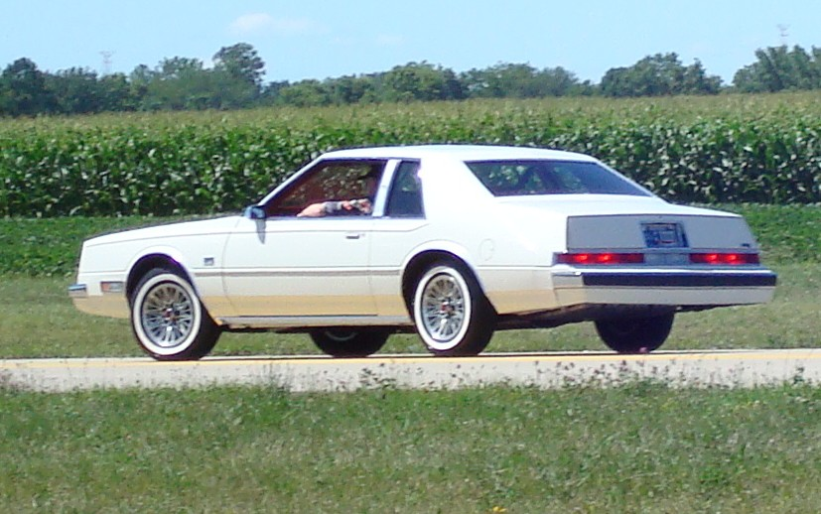
My 81 Imperial by Larry Mayes
Lee Iaccoca wanted to bring the IMPERIAL back to the Chrysler lineup. In late 1980 the all new 1981 Imperial was brought to the public.
The Imperial was to bring a high class luxury car back to the Chrysler lineup when they had very little to offer. There were about 12,000 Imperials built in the 3 years the Imperial Coupe was built. 1981 had the most built with just over 7,200 made. It was the only year the extra cost option of Power Moon Roof was available. All other options were at no additional charge. There were choices in color, Leather or Cloth interior, wire wheel covers or aluminum snow flake wheel, am/fm radio, am/fm cassette or am/fm 8 track. Frank Sinatra was a spokesman for the Imperial and there were a few special FS editions and they came with some of Frank’s best on cassette.
The sale price on the Imperial I have with tax was just over $19,700. It has the optional moon roof, am/fm radio, Mark Cross Leather interior and the snowflake aluminum wheels. It was bought for my mom in Oct 1980 as her company car. The dealership had to have a qualified salesman and service tech. It was purchased from Tom O Brien on North Keystone and Tom Jr. was the salesman. This was not the only car mom had to drive and dad told her at the time he didn’t want her to smoke in the car, park it close at the shopping centers or drive it in the rain or snow. Mom said the car is too damn good for me and she drove it very little. It was only 3 miles one way to work so the car was only driven on nice days. Dad said it was driven in the rain 4 times that he could remember. It has never been driven in the snow. The current mileage is about 14,500 miles and it still has the original tires. I tell people it still has factory air in the tires. It has never had a flat or dismount of the tires so there must still be factory air in them.
In 1988 the car had 9,826 miles on it and mom had flooded it one day. Her boss tried to start it by removing the air cleaner, (a no no with this car) I finally got it running later and the converter was glowing cherry red and I figured it was stopped up. I cut it off (another mistake) and put it in the barn. Dad took it the next day and they told him they should put the conversion kit on it.
It had many 1st items, the electronic Fuel injection, on board computer & Digital dash were among the items that have never used on a production car. As with many 1st, problems arise and the electronic fuel injection was so problematic Chrysler had to replace the units. The retro kit changed the intake, exhaust, computer, dash cluster, fuel lines and tank. At this time they could not FLASH the computer to put the mileage back on the odometer. When it left the dealership they installed a sticker on the drivers door with the miles at the change 9,826 and since 7/88 it has been driven less than 4,500 miles. When the car started to get some age on it I would tell mom, “Don’t be driving the car much, I don’t want a lot of miles on it when I inherit it.”
I always wanted to show the car. Even wanted to paint it with Mother of Pearl on top of the white but never did. It has had maintenance done but is not a restored car. The only body damage was done when mom backed into a car in the mid 80’s and did $115 damage. I cannot tell you where it is on the car. Dad took it and had it fixed before I saw it and I never asked exactly what happened. It was at the dealership just a few times for service. The brake calipers had to be rebuilt in the mid 90‘s. I got a kit instead of replacing the factory ones even though it was cheaper to replace them.
In the early 90’s mom and dad were not driving it and they had a 2 car garage. My house had a 3 car garage and I was single with 2 cars so we stored it in my garage. I have had the car ever since.
A car can be restored over and over, but it is original only once. I have seen several 81~83 Imperials and have yet to see one in the condition ours is. I would guess to say there are very few that have less miles and are in as good of condition anywhere. The car may not have much book value, but it is very dear to me.
It has been shown at the Mopar Nats, World of Wheels and as a survivor at the Chryslers at Carlisle. I’m very glad we did not paint it. It appeared in the Feb/March 2008 Mopar Enthusiast magazine `81 FLAGSHIP IMPERIAL
Author – Larry Mayes
<><><><><><><><><><><><><><><><><><>
Fletcher Used Cars - Edinburgh / Indy Mopar Club May 17th results
The day was sunny and no rain in sight for the 33 non-member and 15 member car registrars (until we were getting ready to leave). As always, everyone enjoyed the music provided by our ABC Dee Jay and the great food from Whosoever Will Community Church. Pictures were taken by Dave Stephenson and have been posted on the IMC website. And a hearty thanks to Fletchers for providing transportation to the Outlet Mall for the women that wanted to shop. It really was a “hit” with them.
And now for the “Rest of the Story” – The Winners (In no particular order)
Non-Members Awards:
Dave Chapman – 1985 Dodge Ram 100 P/U Chris Wheeler – 1957 Chevy Bel-Air
Cliff Simpson – 1981 Corvette Bud Litchfield – 1988 S-90
Dean Burton – 1955 Chevy Bel-Air Bob Lemley – 1964 Corvette
Stephen Rieman – 1964 Dodge Dart Harry Sanders – 1957 Chevy
Dean McGaha – 2005 Honda Shadow Eric Griffin – 1972 Datson 240Z
Bryon Eldridge – 1969 Camaro Gold Steve Humphries – 1970 Roadrunner
Joe Henson – 1930 Ford Mark Hamilton – 2005 Chevy Monte Carlo
Gary Judd – 1963 Nova Glenn Giles – 2003 Harley Road King
Dick Floyd – 1972 Chevy Truck Arlene Watson – 1965 Chevy Impala Conv.
Lewis Burton – 1957 Chevy Black David Williams – 1965 Chevy Chevette
Lewis Burton – 1967 Ford Falcon Don Berkheimer – 2001 Chevy S-10
Daniel Rothwell – 1977 Pontiac Ventura Geoff Fouch – 1983 Z28 Camaro
Wayman Burton – 1993 Corvette
Best GM – Terry Cummings – 1964 Olds 98
Best Chevy – Ron Harris – 1970 Chevelle
Best Paint – Ed Burgett – 1936 Chevy
Best Ford – Rusty Wilkerson – 1966 Ford Fairlane
Best Mopar – Jean Henderson – 1948 Plymouth Coupe
Best Engine – Gary Stafford – 1970 Challenger R/T
Best Truck – Jim Paxton – 1969 GMC
Car Art Sign Award – Ron Harris – 1970 Chevelle
Indy Mopar Club Members Awards
Ronda Cherry – 1971 Challenger R/T
Bob Rosenberger – 1970 Hemi Cuda

Below are some of our hard working volunteers at the Fletchers Edinburgh Show.
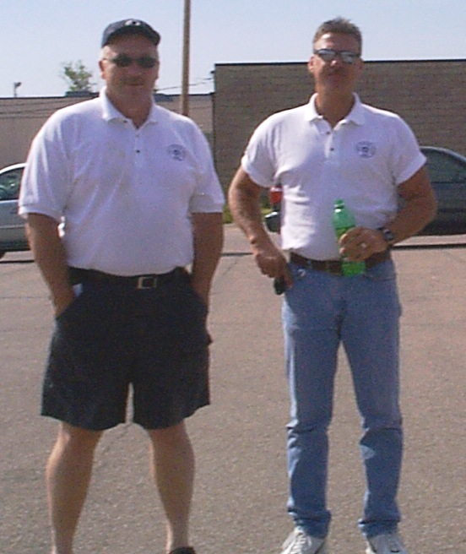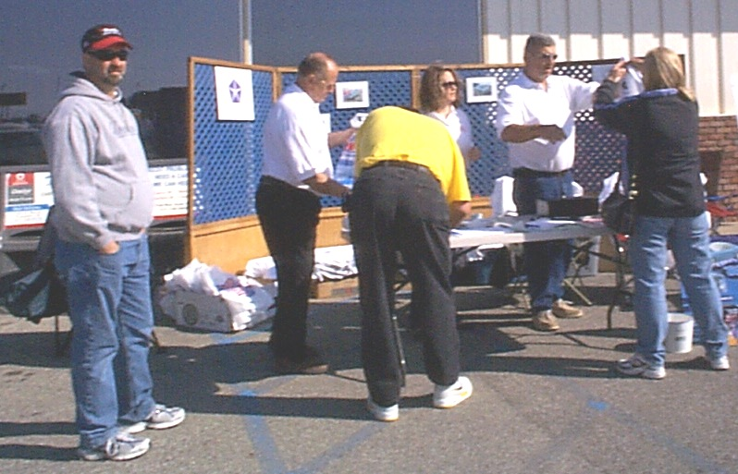
Car Spotters Pat & Rick Our busy registration desk

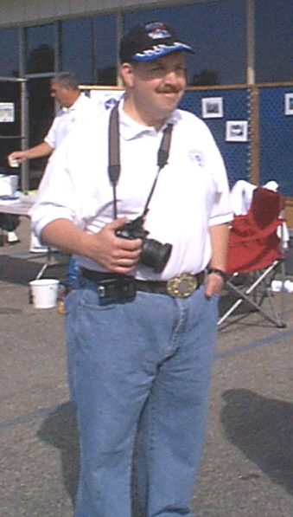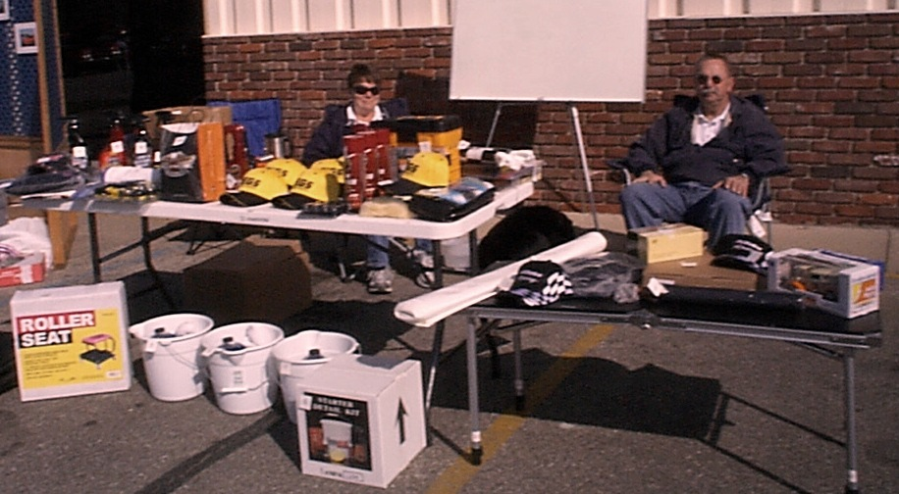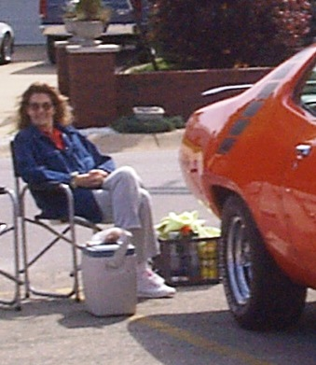
Dave Stephenson Chris Usher & Jim Parker ready to hand out Pat(ricia) McKarski
Photographer the ample supply of Door Prizes taking it easy
<><><><><><><><><><><><><><><><><><>

Congratulations Are In Order
On Saturday, May 18th the Indy Mopar club had a great turn out at the Cool Cars For A Cure. This car show was held at St. Francis Hospital for support to find a cure for Huntington's disease that netted the club a club participation award. The club members in attendance were Ken & Debbie Komlac , Dennis & Rhonda Cherry, Curt Huff, Mike & Lori Benge, and Pat & Pat Mckarski. The show had 128 entries, and all club members also received a top 40 award. The blood mobile was there and several club members gave the precious gift of blood. The Komlancs were on needles and pins awaiting the word of the arrival of their Grandchild that made them wait a few more days. Congrats to them on the birth of their Grandson. All in all the day was a great one, thanks to the club for the participation.
Reported by Pat & Pat McKarski

Ken Moser received top Muscle Car Award at the Good Guys weekend. Reported by Pat McKarski

INDY MOPAR CLUB Monthly Meeting Secretary Report May 29, 2008 7:00 PM
Welcome and sign in – Steve Wisdom, President:
Attendees were: John & Carol Ann Bauer, James & Laura Bratby, Bill Bratton, Ronda & Dennis Cherry, Rick & Susan Eilert, Dave & Terry Fishburn, Ken & Debbie Komlanc, Ed Leyes, Mike Leyes, Gary & Jessica McCormick, Pat & Pat McKarski, “Bud” & Debbie Mounce, Jim Parker, Stan & Jan Peel, Terry & Rose Richard, Bob & Karen Rosenberger, Bob Schonegg, Darren Turpen, Chris Usher, Bob Vorpe, Dave Watt, Bob Thomas, Steve Wisdom, and Rick & Ginger Zimmerman.
Steve Wisdom brought the meeting to order at 7:00 PM by asking all members and guests to introduce themselves and tell about their favorite car.

Secretary’s Report – Ronda Cherry:
Ronda read the highlights of the April 2008 meeting.

Treasurer’s Report/Membership Update – Mike Leyes:
Mike gave the treasurers report as of May 29, 2008. April 24, 2008 Balance was $1,409.27;
Income for May was 7 membership dues of $210.00, received from Ken Mosier for Award Money and
trophies $175.00, extra member shirts $20.00, Palmer Sponsor Check $2,000.00, Palmer Show Money $1,156.00 – Total $3,561.00.
Expenses – Flying W Awards for Palmer plaques $471.98 and for Palmer Finer Detail Plaque $24.02,
Reimburse Steve Wisdom for Flyer Printing $71.02, Jan’s Computing Service for Newsletters
$66.10, Dave Watt for change & Finer Detail Award money for the Palmer Show $300.00, ABC
Dee Jay for the Palmer Show $225.00. – Total $1,158.12
Balance May 29, 2008 is $3,812.15.
We currently have 72 members in the club.
After a membership discussion John Bauer made the motion we send JDRF a check after the
adjustments have been made for the Palmer Show. Total amount to be reported next month.

Event Calendar – John Bauer:
John talked about upcoming events for the year:
June 21st Fletcher Chrysler-Indy Mopar Club all Mopar Car Show
September 20th Danville Chrysler- Indy Mopar Club all Mopar Car Show – Rain date September 27th
John took this opportunity to compliment Dave Watt and Jan Peel, co-editors of the IMC Newsletter, on
the May newsletter being very professional.

Event Advertising – Pat & Pat McKarski:
Pat gave a brief update on the advertising. They are presently advertising in
Indy Auto & RV
Old Cars Only
Mopar Collector’s Guide.
Old Car Trader
Pat also displayed the trophy the Indy Mopar Club won for a Club Participation Award at the Cool Cars
For A Cure May 18th. (See the write-up from Pat on page 3 of this newsletter)
Communications Director Report – Dave Watt:
Dave Watt will have the pictures from both the Palmer show and the Fletcher Edinburgh show on the
web-site. He also read the letter from Ron Harris, who attended the Edinburgh show, thanking us for receiving the Best of Chevy Award and the award from Car Art Sign. He appreciated both the car show and the awards.

Old Business – Steve Wisdom:
- Club Member Profile for Newsletter & Website
  - June – Larry Mayes
  - July – James Bratby
  - August – Mark Smith
  - September – John Bauer
- Joint get together with another Mopar club.
After numerous attempts to arrange a meeting place with the Tri State Mopar Club it was left for them to notify us of a place. This is on hold until then.
- IMC Name Tags (Renewals for 2008) – Larry Mayes sent an e-mail requesting information of the memberships intention with the name tags. It was discussed and the voting response was to stay with the name tags/membership cards we presently have.
- Recap of May Car Shows
  - Palmer Show Pike Plaza – Comments were coming from quite a few that the show was good but not too well attended. Possibly both because of the weather prediction and the location. One comment was it didn’t appear that Palmer was ready for us, although they did correct it.
  - Fletcher Edinburgh Show – The attendance was down and members felt that it was probably due to the fact that there were a couple other shows in the same area that day and ones that have come in the past were probably attending them.

New Business – Steve Wisdom:
- Fletcher Franklin Show Volunteers:
Registration Table – Bob Schonegg and Ed Leyes
Goodie Bags – Steve and Cheryl Wisdom and Laura Bratby
Parking – Rick Zimmerman and Pat McKarski
Pictures – Dave Stephenson
Door Prize Table – Debbie Mounce, Karen Rosenberger
50/50 and Door Prize Tickets – Jan Peel
Food & Drinks – Whosoever Will Community Church
Event T-shirts & Awards – Steve Wisdom - Taken care of
D.J. has been confirmed – ABC Dee Jay
- Confirm Date for Club Christmas Party
- Tom Williams made the motion for December 14th, 2008. Steve will check it out.
- A suggestion was made to contact members that will be going to the Mopar Nationals and some of them may be able to form one or possibly two caravans.

Steve Wisdom then adjourned the meeting.

Respectfully submitted – Ronda Cherry, Secretary
<><><><><><><><><><><><><><><><><><>
July Birthdays: Jim Rockey, 7-3; Tony Fields, 7-4; David Tays, 7-7; Jerry Loy, 7-18; Pat(ricia)
McKarski, 7-29; Vicki LaFollette, 7-30.
July Anniversaries: Ben & Kathy Jones, 7-5; Stan & Kerry Sanders, 7-20; Fred & Linda Kelley,
7-21; Rick & Ginger Zimmerman, 7-28; Darren & Diane Turpen, 7-30; Larry & Susan Mayes, 7-31.
Congratulations to all!
<><><><><><><><><><><><><><><><><><>
Information
Wednesday night cruise–in is located at Dooley O’Tooles which is on Carmel Drive between Rangeline Road and Keystone Ave. When you drive your classic car there you receive 25% off your dinner, food only. They are extremely nice people and they normally have some pretty nice cars. (Reported by John Bauer)

Rick & Ginger’s son, Ryan, was home for a short visit and is now back on duty.

People Helping People
Steve Wisdom, our President, was contacted by Anne Sutton, Manager, Chick-Fil-A in Greenwood. She needed 50’s cars for a 50’s day June 19th and wanted to know if we had any. Terry Cummings agreed to show his 1950 Dodge during the evening. After many phone calls were made and thinking caps put on we called Tony Adamo who won an award with his 1959 Dodge Royal D-500 at the Palmer Show and he agreed to show it during lunch. Thanks to both for giving their time and letting people know we are willing to help.
<><><><><><><><><><><><><><><><><><>

Tech Talk
Tip tip: To clear clogged or restricted windshield washer nozzles use a welding torch tip cleaner, an inexpensive tool that can be found at most hardware stores. If this is done with the washer on, the force of the fluid will help flush out debris.

Socket Starter: Whenever it’s necessary to start a bolt that is too short for your socket, try this tip. Insert a small piece of foam rubber or cork into the socket until the receding bolt’s threads are exposed. You are now able to easily start the bolt.

Screw Starter: If you have trouble removing screws that are so tight the screwdriver keeps slipping out of the slot and damaging the head of the screw, try this tip. Put a dab of valve grinding compound into the slot. The screwdriver will now hold much better. This is good for standard or Phillips screws.
<><><><><><><><><><><><><><><><><><>

Tattler’s Corner
What’s this? Overheard at the May meeting Ronda said she was sick and had gone to the Vet to get medicine. I think most people go to the doctor, but then Ronda has a mind of her own. Right?????
<><><><><><><><><><><><><><><><><><>

A Little Bit of Humor
A Grandparent’s Influence written by an unknown child
A grandmother is a lady who has no children of her own. She likes other people’s little girls and boys. A grandfather is a man grandmother. He goes for walks with the boys, they talk about fishing and stuff like that. Grandmothers don’t have anything to do except to be there. They are so old that they shouldn’t play hard or run. It is enough if they drive us to the store where the pretend horse is, and have lots of money ready. Or if they take us for walks, they slow down for things like pretty leaves and caterpillars. They should never say “hurry up”.
Usually grandmothers are fat, but not too fat to tie your shoes. They wear glasses and funny underwear. They can take their teeth and gums off. Grandmothers don’t have to be smart, only answer questions like, “Why isn’t God married?” and “How come dogs chase cats?” Grandmothers don’t talk baby-talk like visitors do, because it’s hard to understand. When they read to us they don’t skip, or mind if it’s the same story over again. Everybody should have a grandmother, especially if they don’t have a television, because they are the only grown-up who has time.
True Advertisement
True Advertisement for Parts Wanted in the January/February 2007 issue of the Plymouth Club Bulletin:
1940, wanted: horn assembly, other years may fit (i.e., 6 volt, long tubes). If I find horn assy., I’ll let my wife live (she sold mine in her yard sale).
<><><><><><><><><><><><><><><><><><>

A Reminder from your Co-Editor Jan Peel
I would appreciate any news about our members that have attended other events and/or have had their cars or stories in other publications. This is your newsletter, help me make it an even better one by sharing this kind of information so it can be published. You can contact me by E-mail Jpeel83719@aol.com or call me at 317-357-5760 or send it to me by mail: Jan Peel, 5128 E Rowney St, Indianapolis IN 46203-3741. (Complaints can also be handled this way.)

