
Indy Mopar Club News
July 2008 www.indymoparclub.com Jan Peel and Dave Watt, editors
Meetings are the last Thursday of every month

2008 schedule of events. More events and details on the way.

Next regular meeting: Thursday July 31, 2008 will be held at MCL Cafeteria, 3630 South East street Indianapolis (US 31- N of Southern Plaza between Sumner & National). Meet for dinner at 6pm, meeting at 7pm. A Map Quest link is available on the IMC website.

September 20, 2008 the Indy Mopar Club will host an all Mopar Car Show at Danville Chrysler Dodge Jeep. See website Upcoming Events page for new dealership location. Registration 9-noon, awards at 3pm. Top 20, Presidents Choice, and The Finer Details awards. Event T-shirt and goody bag to the first 40 entries. Door prizes, 50/50 drawing, food, and DJ are some of the events planned. Rain date September 27.

<><><><><><><><><><><><><><><><><><>

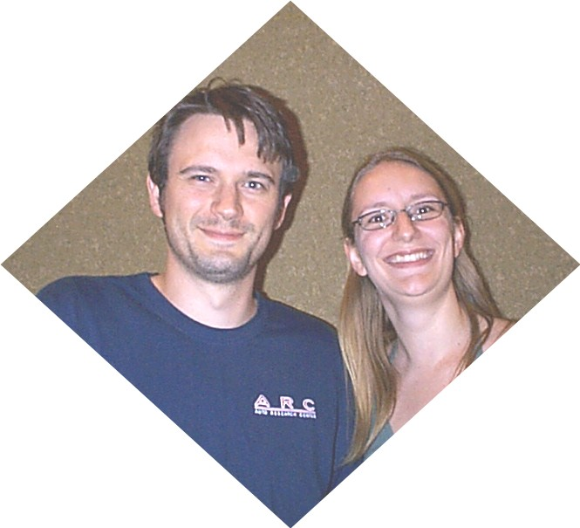
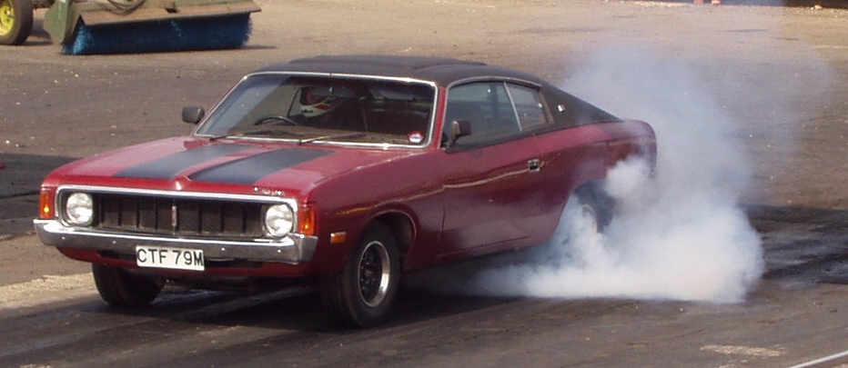
Me giving the tyres a gentle warming at the Mopar EuroNationals, Santa Pod in 2004.
Hello, my name is James Bratby, I have recently moved to Indianapolis from the UK with my wife Laura.
In 1998/99 I lived in Australia as my father was based out there with the Royal Air Force. My first encounter with a muscle car was watching a Valiant Charger jump over a rail road level crossing at speed, with sparks flying out behind the car as it landed; that was it…. I was going to own one!

When we returned to the UK I got my first car, nothing note worthy, just a little 1.2L Renault Clio (that’s French for rubbish!!!) but still I hankered for a muscle car. I looked at getting Dodge Charger’s and Corvettes or similar but the cost of insurance for a 20 year old man on a left hand drive car in UK was just too high. After much searching I eventually found this Australian Valiant Charger for sale in Cornwall (to my amazement since the last one I had seen had been back at the rail road crossing in Melbourne). So one weekend without telling our parents off me and Laura went to go and view it; however, this was no viewing, as soon as I saw the car it was as good as bought! The car had not be used for anything other than a slow drive to the local shop for quite a while so when we got out to the motorway I opened her up. About half way on the 300+ mile trip home the engine decided to go bang during a period of exuberant driving, a visit from the AA (UK equivalent of the AAA) got the old girl moving again then we continued our journey home at a more relaxed pace; much to both sets of parents dismay when it arrived on their driveways!!

I had no idea where to start on a long term repair for the engine, so I found a local person through a UK based American Car club. Unfortunately he was not as reliable as I had been told and I ended up taking the engine back in a worse state then when I gave it to him some £1000’s lighter! I was not pleased.

At this point I was a little lost, I had a broken car and not much money left. A conversation with some friends in the Mopar Muscle Assoc UK went something like this:
Uncle Blue – “So what was the quote by the professional shop to fix the damage?”
Me – “About £700”
Uncle Blue – “You can buy a lot of tools for £700!”

So that is exactly what I did. I showed up at the nearest equivalent to Sears in UK with £700 in my pocket and bought every tool I thought I might need to build an old engine along with some ‘how to’ books. When I got home I began the process of teaching myself how to build engines.

I didn’t use the original block though, I found another 318 that had been sat in someone’s garden for 10 years and used that. Somehow that was easier than trying to repair the damage created by the previous ‘so called’ mechanic.

After months of hard work and late nights we got her going again. 5 years later the configuration of the engine is exactly as it was when I built it (only looking more used) Apart from the Holley 600, Eddy Performer intake and a set of headers the engine is stock. With the 2.92:1 rear ratio she doesn’t seem to want to go faster than 15.2@90 in the ¼ mile. Those 2.92’s sure help cruising at 100mph on the freeway though!

Am I still angry at ‘the mechanic’ for ripping me off for all that money? No. It was having had to do this myself that awakened my interest in engineering. Shortly afterwards I applied to go back to university and 4 years later graduated with a 1st class honors degree and went on to get an MSc in engineering as well. It was this that gave Laura and I the opportunity to move here to Indy and do what I love doing.

So actually in a perverse sort of way I actually thank that guy, doesn’t mean I will give him any more business though ;-)

That is main the reason we brought the old girl along with us, she’s part of the family and I owe my success in the last 6 years to her and my wife, who supported me though the tough times.
Author – James Bratby
<><><><><><><><><><><><><><><><><><>
Fletcher Car Show / Indy Mopar Club, Franklin, June 21st results
The day, again, was sunny and no rain in sight for the 34 registrars (again, until we were getting ready to leave). As always, everyone enjoyed the music provided by our ABC Dee Jay and the great food from Whosoever Will Community Church. Pictures by Dave Stephenson have been posted on the IMC website (and a couple below).

And now for the “Rest of the Story” – The Top 20 Winners (In no particular order)
Bob Schonegg – 1970 Dodge Challenger Bill Bratton – 1999 Dakota R/T
Bud Mounce – 1972 Dodge Swinger John & Carol Ann Bauer – 1968 Roadrunner
Bob Rosenberger – 1970 Hemi Cuda Jim Patterson – 1974 Cuda
Jim Kelly – 1963 Plymouth Wagon Stan Peel – 1969 Plymouth Fury III Conv
Ed & Mary Leyes – 1970 Challenger Convertible Dennis Cherry – 1966 Dodge Coronet
James Bratby – 1973 Valiant Charger Rick Eilert – 1973 Roadrunner
Steve Grantham – 1966 Plymouth Terry Cummings – 1950 Dodge
David Sanders – 1970 Dodge Dart Swinger Jim Parker – 1962 Dart 440 HT
Roger Schnur – 1969 Dodge Coronet Jack Orme – 1967 Dodge Charger
Chuck Hildreth – 1970 Plymouth Cuda Chris Dewees – 1966 Dodge Coronet 500
Best of Show
Ronda Cherry – 1971 Challenger R/T
President’s Choice
David Miers – 1940 Dodge Truck
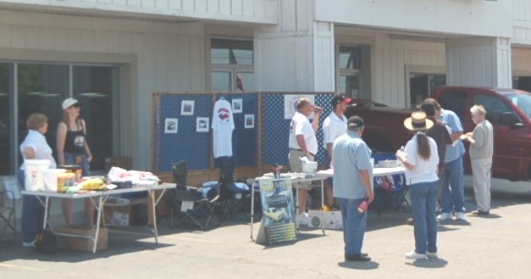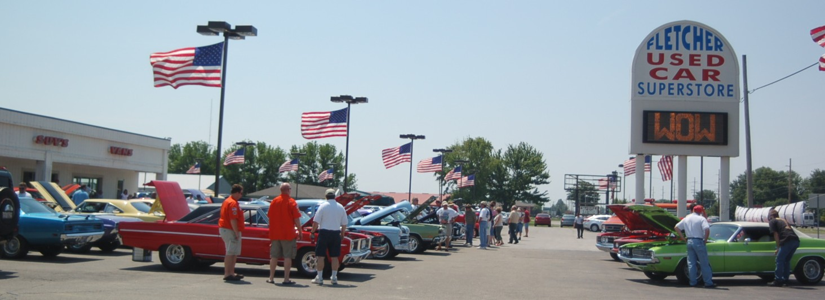
Some of our volunteers and lots of beautiful cars with the crowd inspecting them.
<><><><><><><><><><><><><><><><><><>
Congratulations Are In Order
Check out the September issue of Hemmings Muscle Machines. There is a beautiful 5 page spread featuring Ronda Cherry and her 1971 Challenger R/T. Dennis is pictured burning rubber in it.

On Sunday, May 29th the Indy Mopar club had another great turn out at the Wanamaker Old Settlers Day Car Show. It netted the club another club participation award. The club members in attendance were Dennis & Rhonda Cherry, Rick Eilert, Bob & Karen Rosenberger, Bud & Debbie Mounce, and Dave & Terry Fishburn. Stan & Jan Peel attended for a couple hours. It was a huge show and more cars were coming in as the Peel’s left. Dennis took an award for the Top 3 in Pro-Street Class, Bob and Ronda won awards in the Muscle Car ‘62 to ’74 Class, and Rick won an award in the Stock ’73 to ’79 Class. And Ronda won Best of Show.
Reported by Ronda Cherry
<><><><><><><><><><><><><><><><><><>

Welcome to new members Estell & Pat Claycomb, Crawfordsville, 1968 Plymouth Sport Fury Convertible; and Gerald & Elizabeth Woodard, Danville, 1969 Plymouth Roadrunner. We hope to see you soon.
<><><><><><><><><><><><><><><><><><>
INDY MOPAR CLUB Monthly Meeting Secretary Report June 26, 2008 7:00 PM
Welcome and sign in – Steve Wisdom, President:
Attendees were: John & Carol Ann Bauer, James & Laura Bratby, Bill Bratton, Estell Claycomb, Ronda & Dennis Cherry, Dick & Dorinda Crawmer, Rick & Susan Eilert, Dave & Terry Fishburn, Tom Kelly, Ed Leyes, Mike Leyes, Gary & Jessica McCormick, Pat McKarski, Stan & Jan Peel, Bob Rosenberger, Ken & Sharon Scobel, David Stephenson, Bob Thomas, Darren Turpen, Dave Watt, Steve & Cheryl Wisdom, and guest Jim Lemons.
Steve Wisdom brought the meeting to order at 7:00 PM by asking all members and guests to introduce themselves and tell about their favorite car.

Secretary’s Report – Ronda Cherry:
Ronda read the highlights of the May 2008 meeting.

Treasurer’s Report/Membership Update – Mike Leyes:
Mike gave the treasurers report as of June 26, 2008. May 29, 2008 Balance was $3,812.15.
Income for June was 3 membership dues of $90.00, old show shirts $6.00, Palmer Show shirts $30.00,
Deposit Money from Edinburgh Show $772.30, Fletcher Sponsor Check $2,000.00, Fletcher Show Money $846.00 – Total $3,774.30.
Expenses – Utter’s additional Art Charge $240.00, Utter’s for additional 2008 Member Shirts $56.56,
Utter’s for Fletcher Show Shirts $782.74, Steve Wisdom for Flying W Awards for Fletcher Show $473.53, ABC Dee Joay for Fletcher Show $225.00, Cash for Fletcher Show Change $200.00, Juvenile Diabetes Research Foundation $2,072.48. – Total $4,050.31
Balance June 26, 2008 is $3,506.14.
Mike also reminded the members of a $616.00 Insurance premium coming up.
We currently have 76 members in the club.
Event Calendar – John Bauer:
John talked about upcoming events for the year:
June 21st Fletcher Chrysler-Indy Mopar Club all Mopar Car Show
August 23rd Cruise-In at The Paddock
September 20th Danville Chrysler- Indy Mopar Club all Mopar Car Show – Rain date September 27th
John will check on new caterer for the Danville Show

Event Advertising – Pat & Pat McKarski:
Pat gave a brief update on the advertising. They are presently advertising in
Indy Auto & RV
Old Cars Only
Mopar Collector’s Guide.
Old Car Trader
Auto Roundup

Communications Director Report – Dave Watt:
Dave will have the pictures from the Fletcher Franklin show on the web-site. He also needs a list of the award winners (Jan to E-mail to him).

Old Business – Steve Wisdom:
- Club Member Profile for Newsletter & Website
  - July – James Bratby
  - August – Mark Smith
  - September – John Bauer
  - October – Gary & Jessica McCormick
- Recap of May and June Car Shows
  - Palmer Show – 39 registrations
  - Fletcher Edinburgh – 48 registrations
  - Fletcher Franklin – 32 registrations
Everyone has been helping out at the car shows and it is greatly appreciated.
- Dodge Drivers on the Circle has been cancelled
- Date confirmed for Club Christmas Party, Sunday, December 14, 2008, 5:00 PM

New Business – Steve Wisdom:
- Mopar Nationals
  - Cruise as a club either in one or two groups, depending on the leaving time.
  - Good starting point – Cracker Barrel at I-70 and Greenfield exit was discussed. Dave will E-mail the information for dates and times. Laura Bratby will coordinate, please contact her at tetley1@yahoo.com or call her at 317-313-9443 (prefers e-mail).

- IMC Membership cards – it was discussed and voted upon to keep the present cards we have.
- Danville’s Door Prizes – Tom Kelly and Debbie Mounce
- Amy and Megan’s walk for Breast Cancer.
- Car shows for next year: Discussion followed about changing the number of car shows we do a year since it is mostly our members that are attending.

Our meeting for July and August will be at the MCL Cafeteria. The September meeting will be at Car Art Signs in Beech Grove.

There was a discussion about Cars for the Walk for JDRF and JDRF License plates.

Jan & Stan Peel and the Hoosier Plymouth Owners Club have invited all Indy Mopar Club members to join in a fun morning to play Mini-Golf at the Rustic Gardens Saturday, July 12th, 10:00 AM with lunch in Beech Grove.

Steve Wisdom then adjourned the meeting.

Respectfully submitted – Ronda Cherry, Secretary
<><><><><><><><><><><><><><><><><><>

August Birthdays: Frank Goodrum, 8-1; Kelley Stephenson, 8-1; Diane Biesel, 8-4; Terry Richard, 8-4; Darren Turpen, 8-10; Adam Erwin, 8-16; John Kramer, 8-23; and Phyllis Williams, 8-31.
August Anniversaries: Rick & Joy Kelly, 8-3; David & Cindy Sanders, 8-14; and David & Kelley Stephenson, 8-24. Congratulations to all!
<><><><><><><><><><><><><><><><><><>

Information
Wednesday night cruise–in is located at Dooley O’Tooles which is on Carmel Drive between Rangeline Road and Keystone Ave. When you drive your classic car there you receive 25% off your dinner, food only. They are extremely nice people and they normally have some pretty nice cars. (Reported by John Bauer)

People Helping People
Steve Wisdom, our President, was contacted by the Chick-Fil-A manager on Southport Road. He is going to have a 50’s Day but wanted to know if we had any older cars (not just the 50’s) for a Cruise-In July 23rd from 4PM to 9PM. He will provide special parking for our cars. If you are interested either e-mail Steve Wisdom or call him at 317-888-7019 as soon as possible so we will have ample parking spaces.
<><><><><><><><><><><><><><><><><><>

Tech Talk
440 Engine History
The Chrysler ‘B’ engine series began production in 1958 with a 350 cubic inch block. It was modified through the years to displacements of 361, 383 and 400 cubic inches. In 1958 a version of the ‘B’ engine was introduced with a raised deck block, giving it a longer piston stroke. This engine was known as the ‘RB’ and was initially introduced at 383 cubic inches. Later the displacement was increased to 413 and 426 cubic inches and in 1966 was again increased to 440 cubic inches. The 440 remained the largest passenger car version of the big Chrysler V8’s until production ended in 1978.

Chrysler Big Block Engine Chart
350 8 v90 58 4.06 3.38 B One year only
361 8 v90 58-66 4.12 3.38 B
383 8 v90 59-71 4.25 3.38 B better known 383, (383.596 CID)
383 8 v90 58-60 4.03 3.75 RB Actually 382.667 CID
400 8 v90 71-78 4.34 3.38 B
413 8 v90 59-73 4.18 3.75 RB
426 8 v90 63-66 4.25 3.75 RB Wedge
426 8 v90 64-71 4.25 3.75 HEMI
440 8 v90 66-78 4.32 3.75 RB
-RB is raised deck version of B with longer stroke, bigger mains.
-Hemi block is based on RB, but not interchangeable (cross-bolted mains, different head mounting bolt pattern, etc).
-All OHV, including Hemi.
-75 and earlier are thick wall castings, (up to .060 overbore)
-76 and later are thin wall castings (up to .020 overbore)
(Chart courtesy of the members of the Mopar Mailing List and Andre Roy)

440 engines found their home under many of Chrysler's large luxo-cruisers, such as New Yorkers and Imperials. But, they also powered some of the most memorable performance cars of the 60's and 70's. The durability of the B/RB engines and the simplicity of their design have kept them in the performance spotlight long after their production ceased.

During its production life, the 440 saw few major changes. One that is worth noting is the "440 Six Pack" that was offered in 1969-71. This engine is distinguished by the three Holley 2-barrel carburetors that fed the fuel into a special intake manifold. Besides the tri-carb induction system, the 440-6 used heavier components throughout the engine to help it provide the additional power.
<><><><><><><><><><><><><><><><><><>
Posted by John Gunnell OLD CARS WEEKLY website
1. When gas hits $5 per gallon, interest in small economy cars will grow, just as I suggested in several articles last year. Values on vintage economy models will rise drastically. (Old Geo Metros are the hottest thing on eBay right now).
2. Vintage motorcycle collecting will pick up tremendously. Everyone will be looking for bikes in barns. Japanese motorcycles will remain most affordable. Values will not go totally crazy, as once motorcycle prices get up to "car prices" their appeal starts to taper off.
3. Collector auctions will have to rethink their fee structures to keep customers. If Grant Miller at Central PA Auctions can do his July 19 sale with 4 percent buyer and seller fees and make money, others can do the same and competition will rule.
4. Shrinking economy will cause mergers between large and small parts sellers, with the big guys becoming the "Wal-Marts" of the collector-car industry. One-marque specialization will suffer.
5. Multiple single-marque clubs will start to merge to cut expenses.
6. Hobby will continue to grow, but will undergo change as a reaction to high gas prices. Fuel economy modifications will be permitted at shows.
7. Internet buying and selling will grow a little, but swap meets will survive because old parts purchased on line are often incorrectly described, of poor quality or too pricey to ship at reasonable cost.
8. Local shows will grow in number and size. There will be a shakeout in larger national shows with the best surviving and others going by the wayside.
9. Number of hobby publications will decline. Some are already in trouble. Too many serve the same interests.
10. Club activity will grow more local, with collectors in a certain area forming weekly get togethers to work on each other's cars. One hobbyist will purchase a lift, another an air compressor and a third the welder. Then they will share tools and equipment to save money.
<><><><><><><><><><><><><><><><><><>
Does the above sound familiar to any of you? Time will tell if his predictions will come true but (to me) it is something to ponder on. I believe we’ve already seen some of this in our car shows this year with attendance being what it has been. Other car shows being close to ours on the same day have certainly been a factor, but I can’t help but believe that the gas prices and economy have also been a contributing factor. So, buckle up, and get ready for our next event(s). We hope to see lots of you there.

Reminder from your Co-Editor Jan Peel
I would appreciate any news about our members that have attended other events and/or have had their cars or stories in other publications. This is your newsletter, help me make it an even better one by sharing this kind of information so it can be published. You can contact me by E-mail Jpeel83719@aol.com or call me at 317-357-5760 or send it to me by mail: Jan Peel, 5128 E Rowney St, Indianapolis IN 46203-3741. (Complaints can also be handled this way.)
