 Indy Mopar Club News
July 2007 www.indymoparclub.com Jan Peel and Dave Watt, editors

Meetings are the last Thursday of every month except December due to the holidays.
**Update: Thursday July 26 meeting will not be held at Ryan’s Steakhouse due to the Dodge on the Circle event. Information provided below. August 30 will be the next regular meeting at Ryan’s.

Trivia question: What was the first year of production and body type for the Dodge Super Bee? Answer at the bottom of the page.

July 26, 2007 "Dodge on the Circle" event hosted by Dodge Motorsports, the Indy Mopar Club has been asked to display 15 nice quality classic Dodge vehicles on Monument Circle in conjunction with NASCAR coming into Indy for the Brickyard 400, Busch and Craftsman Truck Series. Many Dodge race vehicles will be on display. *This event is in lieu the monthly meeting, we will not meet at Ryan's Family Steakhouse, so join us downtown for a cool evening with some of NASCARS' brightest stars.

August 10-12, 2007 Mopar Nationals. The club will try to have a gathering area. Details soon.

September 22, 2007, 9-3pm, The Indy Mopar Club will host an all Mopar car show at Danville Chrysler Dodge Jeep located at 20 S. County Road 300 E. #362 in Danville Indiana, (317)-745-5809. Top 20 awards, door prizes, 50/50 drawing, DJ, food and more. Rain date: September 29, 2007.

Trivia answer: 1968 was the first year of production for the Dodge Super Bee, it was only available as a Coupe. Did you get it right?

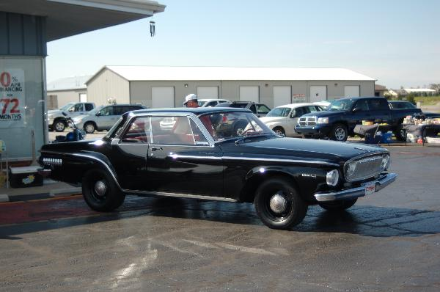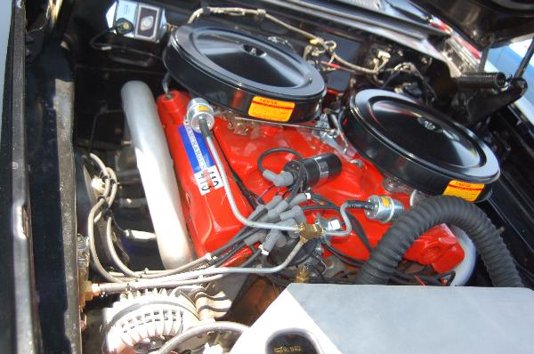

Read about Jim Parker’s sweet 62 413 Max Wedge Dodge below.
My ’62 Dodge Dart by Jim Parker
I purchased my 1962 Dodge Dart approximately 3 years ago in Dugger, In. It had a 413 cu. in. engine bored .030” over, balanced with a hydraulic cam and 10.5:1 compression heads. The previous owner had put the old long ram intake system on it with 500 cfm Edelbrock carburetors. It had a Mallory dual point ignition and a real rusty/leaky set of no name headers.
The Dart was not really configured for this type of carburetors and intake system. I bought a dual carburetor intake manifold and Mopar Performance ICU system and it worked fine.
After going to the Mopar swap meet in Indy, I realized my car was worthy of something better. After a little time, I purchased a crossram intake manifold, breathers, linkage and accessories at A&A transmission in Mooresville. I installed all this plus a new mechanical Mopar billet distributor. I’m on a roll now.
As time has passed, I have rebuilt or replaced a lot of things including all new suspension parts and had them powder coated. The pushbutton 727 transmission has been rebuilt, two transmission coolers have been added along with a Griffin radiator and electric fan. Also, I have put 4 wheel manual disc brakes on. The old tapered axle differential has been replaced with an 8 ¾ Sure Grip rear with 3.55 gears out of a 1967 Coronet.

I purchased aftermarket Max Ram exhaust headers (they fit perfectly) and had a young man at Bells Exhaust fabricate a Max Wedge 3” exhaust system with 3” Delta Flow mufflers.
There are no real expensive items to buy for the Dart now. I just rub on her black 2 stage finish and enjoy driving her, oh I forgot she is named Lucille. Thanks for allowing me to ramble on about her, she is my pride and joy.
Chris and I really enjoy the club and slowly we are getting to know a lot of nice Mopar fans.
Sincerely, Jim Parker
<><><><><><><><><><><><><><><><><><>
Indy Mopar Club Car Show at Fletcher Chrysler Dodge Jeep, Franklin Indiana July 7, 2007
We had a beautiful sunny day for our show, and although it was hot there was a good breeze most of the day. We had 45 entrants, 22 non-members and 23 members. The only true way to describe the showing is AWESOME! The judging had to be a difficult thing with so many beautiful vehicles.
Lots of very good door prizes were on hand. The food service was great, as usual, and very reasonable. There were a couple vendors showing their wares, and a professional photographer was on site also. And, of course, we had a very good DJ. The inflatable Moonwalk for the children was also a big hit. Dave Stevenson the club photographer won the free night at the motel raffle. Ginger Zimmerman won the 50/50 raffle for $124.00.
Awards were given out at 2:30 to the top 20 and are as follows:
Ed Leyes – 70 Challenger
Bob Rosenberger – 70 Hemi Cuda
Larry Lee – 70 Super Bee
Steve Wisdom – 70 Road Runner
Jason Cummings – 69 Super Bee
Dave Watt – 69 ½ Roadrunner 6 BBL
Ginger Zimmerman – 70 Road Runner
Malinda Lee – 70 Challenger Convertible
Mike & Lori Benge – 72 Valiant
Dave Kitner – 69 Road Runner
Bob Schonegg – 70 Challenger
Jack Collins – 71 Duster
Glenn Clark – 63 Dodge Wagon
Jessica Sembach – 70 Challenger
Danny Parker – 68 Charger RT
Denny Parker – 69 Swinger 340
Mike Earlywine – 68 Road Runner
John Kramer – 73 Road Runner
David Tays – 70 Road Runner
David Fishburn – 74 Swinger
President’s Choice – Ray Vansickle – 70 Challenger T/A
Finer Detail Award and $100.00 – Ronda Cherry – 71 Challenger R/T
Congratulations to all!!!
<><><><><><><><><><><><><><><><><><>
Welcome to New Members: Bob & Karen Rosenberger, Greenfield, 70 Plymouth Hemi Cuda (Clone); Scott & Janet Oller, Greenwood, 37 Plymouth P4 Business Coupe; Jerry (Bud) & Debbie Mounce, Greenfield, 67 Dodge Coronet 500; Kirby & Jainy Haskins, Camby, 66 Dodge Barton American Fire Truck; Dave & Terry Fishburn, Fairland, 74 Dodge Dart Swinger; Tony & Thelma Fields, Columbus, 67 Barracuda Fastback; and Bill & Janet Dawson, Southport, 87 Ram 50 Pickup. We hope to see all of you at a meeting or event very soon.

INDY MOPAR CLUB SECRETARY’S REPORT
Monthly Meeting 7:00pm www.indymoparclub.com
June 28, 2007 Ryan’s Steak House, South U.S. 31 Greenwood
WELCOME AND SIGN IN: - JOHN BAUER
- John welcomed all members, and allowed each attendee to introduce themselves and mention their collection of car(s) and anything pertinent. Sign in sheet for attendance records had been passed around by Jan Peel.

MONTHLY MEETING MINUTES: - CHRIS RIGNEY
- Minutes as reported in the June newsletter were accepted.

TREASURER’S REPORT/MEMBERSHIP UPDATE: -MIKE LEYES
- Mike gave the treasurers report as of June 28, 2007. Beginning balance for June was $3,511.55; Income was $1,222.09; Expenses were $2,685.01; Ending balance is $2,047.83. We have a total of 79 members in club as of June 28th.
- Mike gave an interesting report – we have members in 36 cities in Indiana and Illinois.

EVENT CALENDAR: - DAN KELLY
- **July 7, 2007, 9-3pm, the Indy Mopar Club will host an all Mopar car show at Fletcher Chrysler Dodge Jeep at 3099 North Morton (US31) in Franklin Indiana, (317)-738-1470. Top 20
awards, door prizes, 50/50 drawing, Drag Racing simulator, DJ, food and more. Rain date to be determined.
- **July 14, Saturday, “Rollin Back the 70’s Car Show and Carnival, Mike Aulby’s Arrowhead Bowl, 2331 Brothers Dr., Lafayette, IN. For more info call 765-427-8893 or www.arrowheadbowl.com
- **July 26, Thursday. 7 PM Indy Mopar Meeting at Ryan’s Steakhouse, US 31 South in Greenwood – A motion was made and passed for all to enjoy Dodges on the Circle in lieu of the July Meeting
- **August 10-12, Mopar Nationals at National Trails Raceway, Columbus, Ohio
- **August 26th, Sunday, Kokomo Transmission Cruz-In Car Show, Kokomo, Indiana
- **August 30, Thursday. 7 PM Indy Mopar Meeting at Ryan’s Steakhouse, US 31 South in Greenwood
- **September 22, 2007, 9-3pm, The Indy Mopar Club will host an all Mopar car show at Danville Chrysler Dodge Jeep located at 20 S. County Road 300 E. #362 in Danville Indiana, (317)-745-5809. Top 20 awards, door prizes, 50/50 drawing, Drag Racing simulator, DJ, food and more. Rain date is September 29, 2007. John Bauer reported that this show will be held at this location rather than their new uncompleted as yet location.
- **September 25, Thursday. 7 PM Indy Mopar Meeting at Ryan’s Steakhouse, US 31 South in Greenwood
- **October 5th to 7th, Mopar Classic Show. Contact Dave Watt for information.

COMMUNICATIONS REPORT: - DAVE WATT
- Dave reported that he has posted the Fletcher Edinburgh car show pictures provided by Dave Stevenson on the web-site.
OLD BUSINESS:- JOHN BAUER
- Member Profile schedule - Jim Parker, July; Steve Shutters, August; and Rose Richards, September.
INDY MOPAR CLUB SECRETARY’S REPORT continued
- Pat & Pat McKarski reported on the Indy Mopar Club Event advertising, we are now in the Mopar Collectors Guide also.
- Fletcher Franklin Car Show, July 7th. Door Prizes: Steve Wisdom, Rick & Ginger Zimmerman. Steve has a copy from the JDRF to show that we do donate our proceeds to them.
- Danville Chrysler Car Show, September 22nd. Door Prizes: Mark Smith & Pat McKarski.

NEW BUSINESS: - JOHN BAUER
- John gave a brief summary for the Fletcher Franklin Car Show Volunteers as reported in the June meeting.
- John reported that the Insurance premium for 2007 has been paid.
- Dave Watt reported that we need 12-15 Mopar’s for the Dodge’s on the Circle, July 26th. Please notify Dave if you want your Mopar to be included. John Bauer reported that we may have additional space if needed.
- John then gave an interesting talk about oil that should and should not be used in our “older” cars. If anyone would like further information, contact John, or refer to the June IMC Newsletter for the article.
- John then asked Dave Watt to give a “report” on his trip to the Muscle Car Drag Race at Martin Michigan. Dave also announced that the next one will be at the Muncie Dragway, $70.00 for two days, Friday August 17 and Saturday August 18.
- John then adjourned the meeting at 9:00 PM.
- Respectfully submitted – Chris Rigney
<><><><><><><><><><><><><><><><><><>
Attendance June 28, 2007 meeting:
John & Carol Ann Bauer, Bill Bratton, Ronda & Dennis Cherry, Rick & Susan Eilert, Dan Kelly, Ken & Debbie Komlanc, Ed Leyes, Mike Leyes, Susan Mayes, Pat & Pat McKarski, Jim Parker, Stan & Jan Peel, Terry & Rose Richard, Mike & Chris Rigney, Bob Schonegg; Steve & Judy Shutters, Darren Turpen, Chris Usher, Dave Watt, Tom Williams, and Rick & Ginger Zimmerman.
<><><><><><><><><><><><><><><><><><>
August Birthdays: Frank Goodrum, 8-1; Kelley Stephenson, 8-1; Adam Erwin, Terry Richard, 8-4; Darren Turpen, 8-10; 8-16; Jamie Fenner, 8-16; John Kramer, 8-23; Brent Norman, 8-27; Phyllis Williams, 8-31.
August Anniversaries: Rick & Joy Kelly, 8-3 (22 years); David & Kelley Stephenson, 8-24 (5 years). Congratulations to all!
<><><><><><><><><><><><><><><><><><>
Pictures from Tulsarama and “Miss Belvedere”
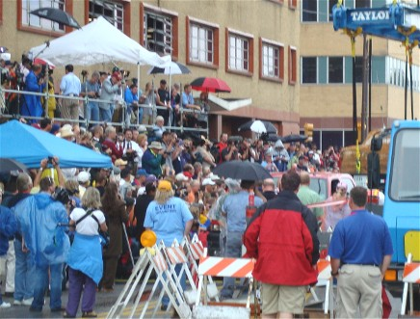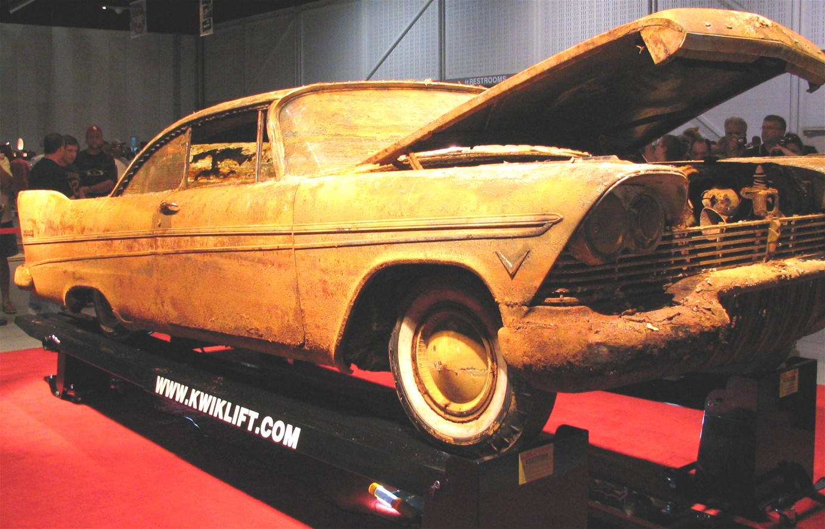
Mass of Humanity to see “Miss Belvedere come up”

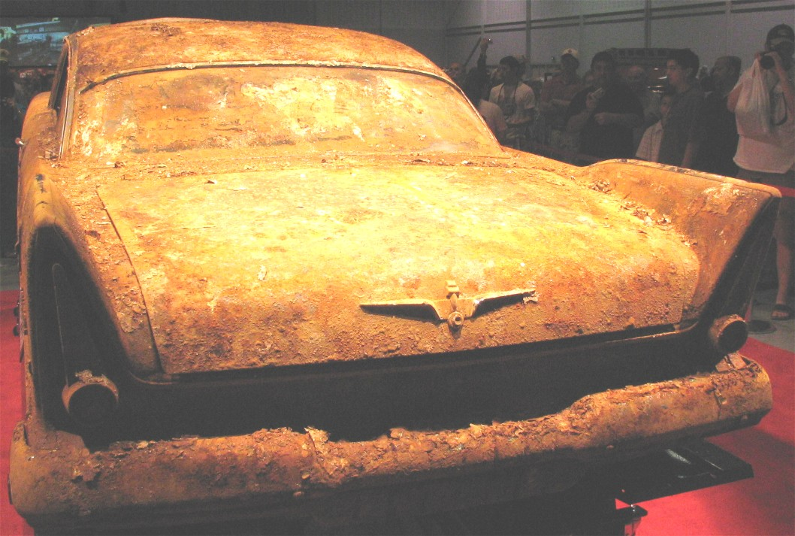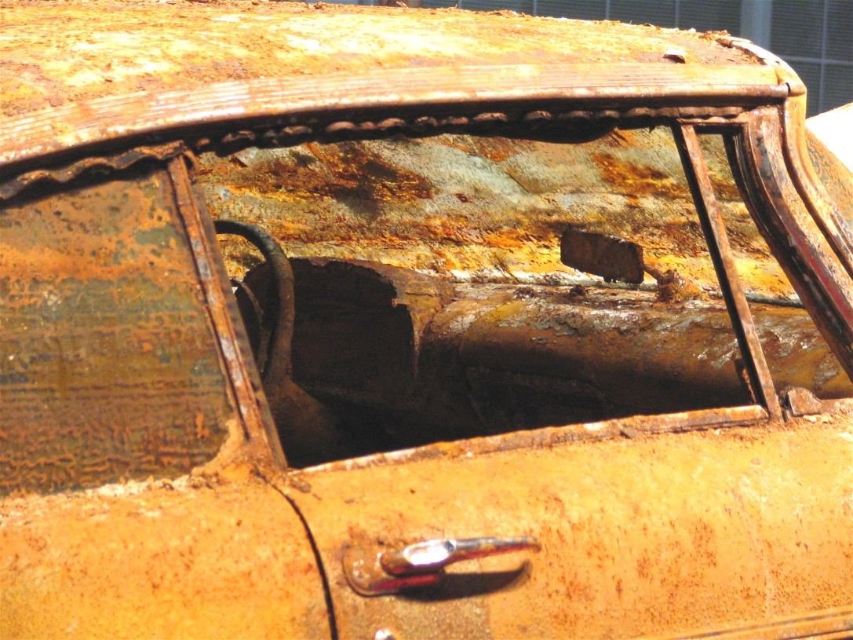
After all the hopes of preservation for 50 years - such a pitiful sight

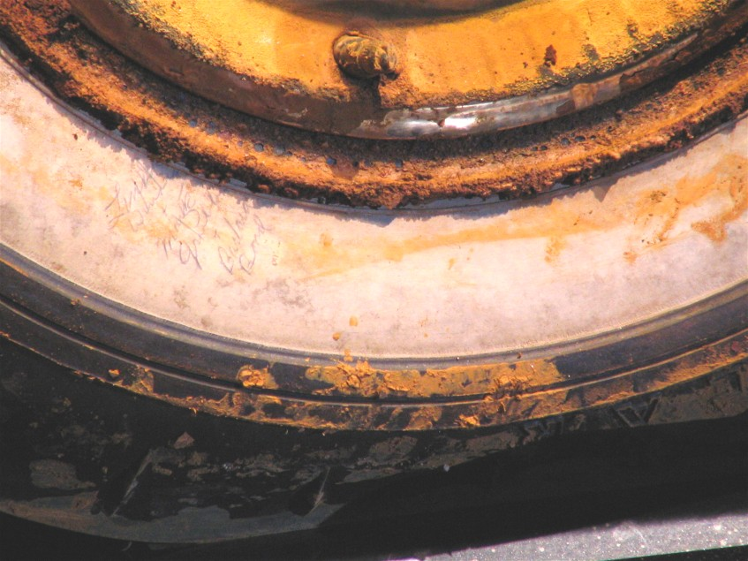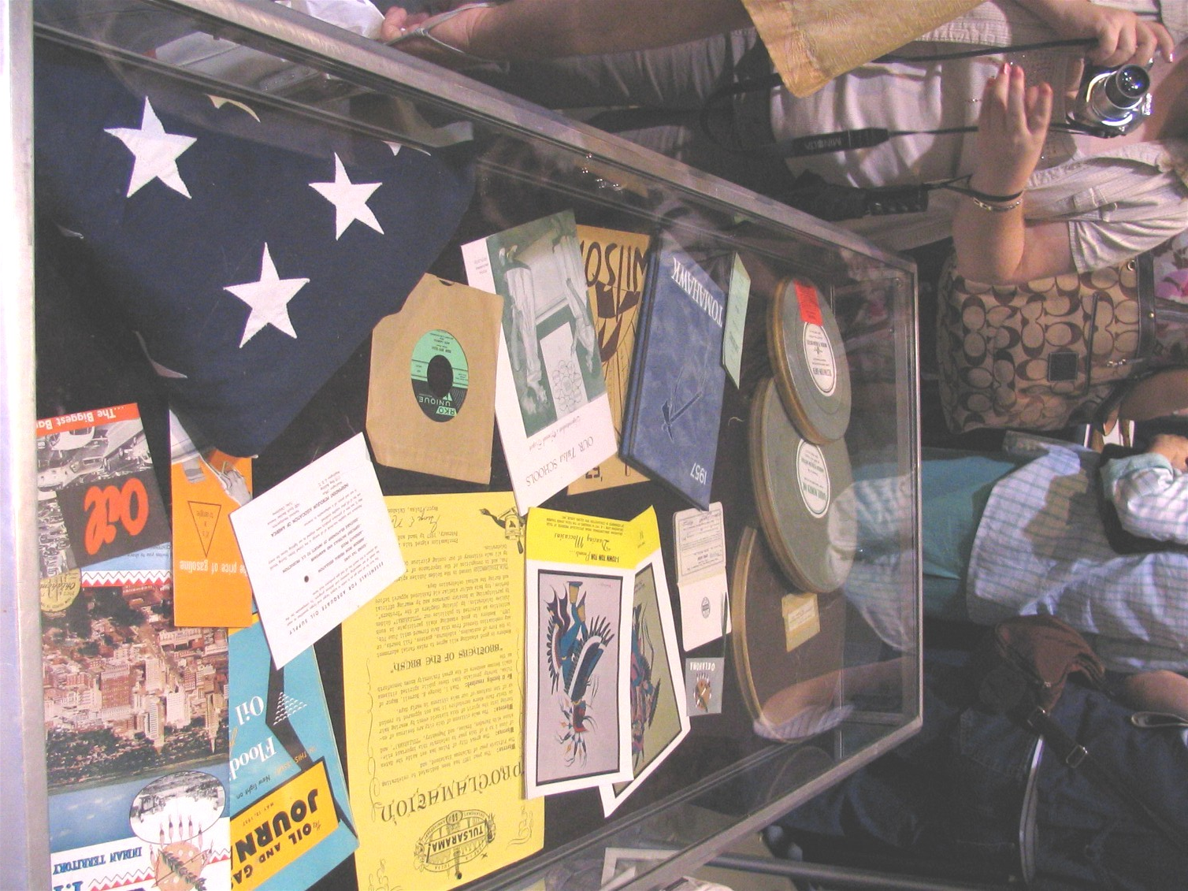
Though you can’t see it – autographs on the tire Memorabilia in tomb

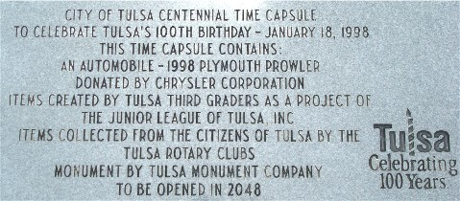
Tulsa really likes to bury cars – will you be present in 2048?????
Pictures by Larry Mayes
<><><><><><><><><><><><><><><><><><>

FOR SALE
For Sale: NEW IN BOX! Never Used. NOS, 4 Cragar S/S 14x6 chrome 5 Spoke wheels plus caps.
5 x 4" bolt circle for A Bodies, Manufacture date: Nov 1988.
$500 firm. Ken 812-372-8046 k.scobel@comcast.net
<><><><><><><><><><><><><><><><><><>

Tattler’s Corner
Wow, the grandchildren keep coming and coming. Chris & Mike Rigney announced they have a new grandson. All those smiling faces at the Fletcher Chrysler show in Franklin, despite the heat, shows what good people we have in our club. They really can’t be beat! Who was most concerned when the “jumping bag” lost power and deflated? The little one in it wasn’t concerned, just wanted to know when it would be up again.
<><><><><><><><><><><><><><><><><><>

A Little Bit of Humor
And Now the Rest of Why God Made Moms ~ Answers given by 2nd grade school children:

Why did your Mom marry your Dad?
1. My dad makes the best spaghetti in the world. And my mom eats a lot.
2. She got too old to do anything else with him.
3. My grandma says that mom didn't have her thinking cap on.

Who's the boss at your house?
1. Mom doesn't want to be boss, but she has to because dad's such a goof ball.
2. Mom. You can tell by room inspection. She sees the stuff under the bed.
3. I guess Mom is, but only because she has a lot more to do than Dad.

What's the difference between Moms and Dads?
1. Moms work at work and work at home and dads just go to work at work.
2. Moms know how to talk to teachers without scaring them.
3. Dads are taller and stronger, but moms have all the real power 'cause that's who you got to ask if you want to sleep over at your friend's.
4. Moms have magic, they make you feel better without medicine.

What does your Mom do in her spare time?
1. Mothers don't do spare time.
2. To hear her tell it, she pays bills all day long.

What would it take to make your Mom perfect?
1. On the inside she's already perfect. Outside, I think some kind of plastic surgery.
2. Diet. You know, her hair. I'd diet, maybe blue.

If you could change one thing about your Mom, what would it be?
1. She has this weird thing about me keeping my room clean. I'd get rid of that.
2. I'd make my Mom smarter. Then she would know it was my sister who did it and not me.
3. I would like for her to get rid of those invisible eyes on the back of her head.

