 Indy Mopar Club News
January 2008 www.indymoparclub.com Jan Peel and Dave Watt, editors
Meetings are the last Thursday of every month (except no meeting in December due to the holidays)
A new meeting place will be announced at the January 31st meeting.

Upcoming events: Thursday, January 31, 2008. Indy Mopar Club will have a pitch-in dinner at the Carefree North Clubhouse on the 1200 block of Leisure Lane in Greenwood (map on page two). We will meet at 6 pm for dinner, 7pm for the meeting. If you plan on attending, RSVP to Dave at indymoparclub@indymoparclub.com or at 317-336-6354. Also see the Upcoming Events website page on the website. See more information about the party on page 2.

Trivia question: Where did the name “Mopar” come from when describing a Chrysler, Dodge, Plymouth or Jeep product? Answer at the bottom of page 1.
2008 schedule of events. More events and details on the way.
March 1 and 2, 2008 The Chrysler Performance Trade Show and Swap Meet by Indy Cylinder Heads held at Blue Ribbon Pavilion of the Indiana State Fairgrounds. The Indy Mopar Club will set up an informational display.

May 3, 2008 The Indy Mopar Club will host an all Mopar Car Show at Palmer Chrysler Jeep Dodge NEW LOCATION, 5051 West Pike Plaza Road. (317)-293-4900. Top 20, Presidents Choice, and The Finer Details awards. Event T-shirt and goody bag to the first 40 entries. Door prizes, 50/50 drawing, food, DJ are some of the events planned. Rain date May 10.

Open Car Show, Fletcher Used Cars, Edinburgh Indiana. Details coming soon.

July 12, 2008 The Indy Mopar Club will host an all Mopar Car Show at Fletcher Chrysler Dodge Jeep, 3099 S. Morton Street (US 31 South), Franklin Indiana. Top 20, Presidents Choice, and The Finer Details awards. Event T-shirt and goody bag to the first 40 entries. Door prizes, 50/50 drawing, food, and DJ are some of the events planned. Rain or shine.

September 20, 2008 The Indy Mopar Club will host an all Mopar Car Show at Danville Chrysler Dodge Jeep. See website Upcoming Events page for new dealership location. Top 20, Presidents Choice, and The Finer Details awards. Event T-shirt and goody bag to the first 40 entries. Door prizes, 50/50 drawing, food, and DJ are some of the events planned. Rain date September 27.
Trivia answer: The parts division of Chrysler started out as Motor Parts and was eventually shortened to MOPAR. It seems that the name caught on with all of the brands being called Mopars.
<><><><><><><><><><><><><><><><><><>
INDY MOPAR CLUB Monthly Meeting
Our annual Christmas Party was cancelled because of the extreme bad weather. We did not have a meeting in December so there is no Secretary’s Report.

Mike Leyes, treasurer, is reporting only 18 members have paid their 2008 dues. A dues renewal is again included in this newsletter for those of you that have not paid.
<><><><><><><><><><><><><><><><><><>

February Birthdays: Dan Kelly, 2-21; Brian Woods; and Tom Kelly, 2-28.

February Anniversaries: Jack & Sheilla Collins, 2-2; Steve & Cheryl Wisdom, 2-7; Ric & Vicki LaFollette, 2-12. Congratulations to all!
<><><><><><><><><><><><><><><><><><>

Map to the Carefree North Clubhouse for the January, 2008 Meeting.

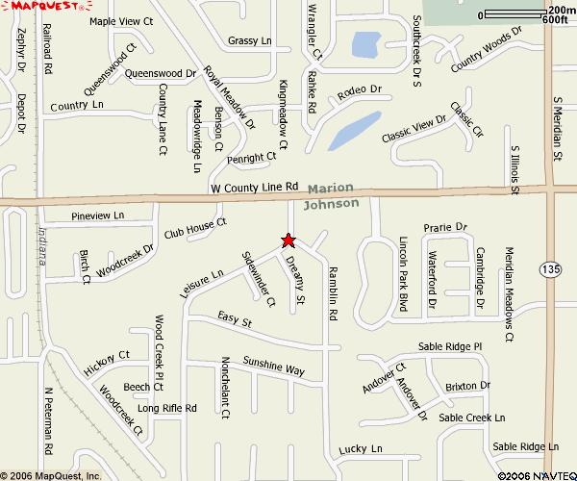
Carefree North Club House is ½ mile west of Meridian Street (Hwy 135) on the south side of County Line Road
(If you come to the railroad tracks you have come too far.)

We need to know how many are coming and children’s ages so please RSVP to Dave ASAP at indymoparclub@indymoparclub.com or 317-336-6354. The club will furnish meat, beverages, and table service. Please bring your favorite side dish and a calorie free dessert.
<><><><><><><><><><><><><><><><><><>

Tattler’s Corner
Since we didn’t have an activity in December there wasn’t anyone acting up that I could report on. Perhaps January will produce an item. Now don’t be on your good behavior just because of this!!!
<><><><><><><><><><><><><><><><><><>
From Ginger & Rick Zimmerman: Their son, Ryan Johnson, is now in Baghdad. For those of you who are interested his E-mail address is Snow_boarder3384@hotmail.com and his address is:
Pvt. Ryan Johnson
1-75 CAV, 2 BCT, 101 ABN
Unit # 43488
APO AE 09344
<><><><><><><><><><><><><><><><><><>
A Little Bit of Humor
It was the day after Christmas at a church in San Francisco. The pastor of the church was looking over the lawn when he noticed that the baby Jesus was missing from among the figures. He hurried outside and saw a little boy with a red wagon, and in the wagon was the figure of the little infant Jesus.
So he walked up to the boy and said, “Well, where did you get your Passenger, my fine friend?” The little boy replied, “I got Him at church.”
The pastor then asked the little boy “And why did you take Him?”
The boy explained, “Well, about a week before Christmas I prayed to the Little Lord Jesus and I told Him if He would bring me a red wagon for Christmas I would give Him a ride around the block in it.
<><><><><><><><><><><><><><><><><><>

INDY MOPAR CLUB
2008 MEMBERSHIP RENEWAL
Your annual membership renewal dues of $30.00 are due and payable by January 31, 2008.

Name

Address

City, State, Zip

Home Phone Cell Phone E-mail

Your Birthday Spouse Birthday Anniversary

Children:

Career Field

The Mopar cars you own (Year, Make, Model, Color) Please list only 6:

Project Cars – Please list only 3
:

Your check should be made payable to Indy Mopar Club. Please return the form, along with your remittance to:

Indy Mopar Club
% Mike Leyes
3130 Hardacre Ct
New Castle IN 47362

