 Indy Mopar Club News
February 2007 w ww.indymoparclub.com
Editor and Communications Director Dave Watt

Meetings are held the last Thursday of every month except December due to the holidays.
More dates and times will be added soon.

February 22, 2007, 7pm., monthly meeting at Ryan’s Steakhouse on US 31 South in Greenwood. Arrive early to enjoy dinner and chat with club members.

March 3 and 4, 2007, the Indy Mopar Club will have a club display set up at the 12th Annual Chrysler Performance Trade Show & Swap Meet hosted by Indy Cylinder Heads. This will be in the Marsh Blue Ribbon Pavilion at the Indiana State Fairgrounds, 9-5pm Sat, 9-4pm on Sunday. We will need volunteers to help out at the display.

May 5, 2007, 9-3pm, The Indy Mopar Club will host an all Mopar car show at Palmer Dodge North at 4545 East 96th Street, Indianapolis, (317)-846-5555. Top 20 awards, door prizes, 50/50 drawing, DJ, food and more. Tell all your Mopar friends to get those cars out of the garage and join us. Rain date is May 12, 2007.

July 7, 2007, 9-3pm, the Indy Mopar Club will host an all Mopar car show at Fletcher Chrysler Dodge Jeep at 3099 North Morton (US31) in Franklin Indiana, (317)-738-1470. Top 20 awards, door prizes, 50/50 drawing, DJ, food and more. Pull those Mopars out of the garage and join us. Rain date to be determined.

September 22, 2007, 9-3pm, The Indy Mopar Club will host an all Mopar car show at Danville Chrysler Dodge Jeep located at 20 S. County Road 300 E. #362 in Danville Indiana, (317)-745-5809. Top 20 awards, door prizes, 50/50 drawing, DJ, food and more. Pound the pavement with that Mopar and join us. Rain date is September 29, 2007.

Trivia question: Who became the first stock car driver to officially exceed 200mph on a closed course and what kind of car was he driving? Answer is at the bottom of the page.

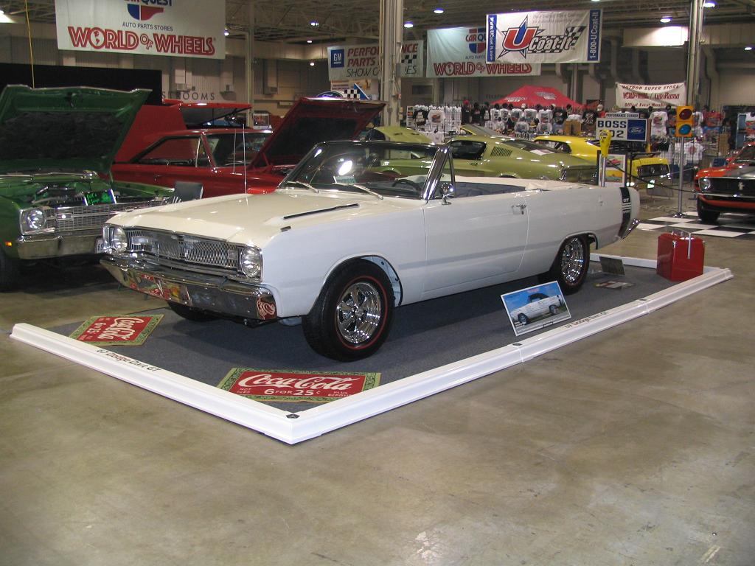 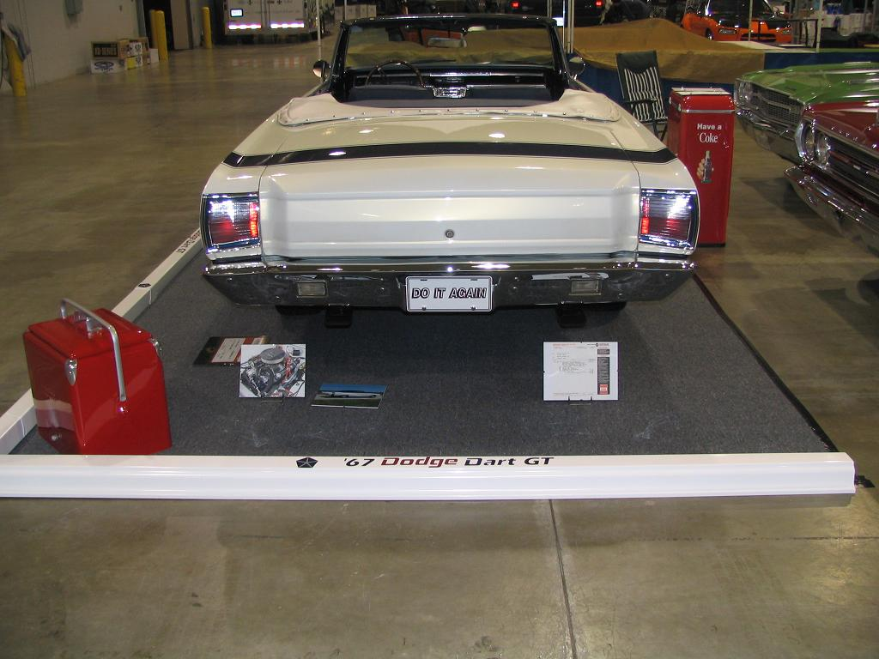 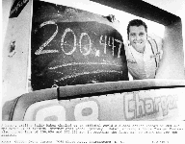Read about Larry and Sue Mayes’ ’67 Dodge Dart GT convertible on page 2. Buddy Baker on the famous day.

Trivia answer: On March 24, 1970, Buddy Baker drove the Chrysler Engineering #88 Dodge Daytona Charger to a closed course speed record of 200.447 Mph to become the first driver to exceed 200 MPH.

Ten Indy Mopar Club Members participated in the 48th Annual Car Quest World Of Wheels car show at the Indiana State Fairgrounds, February 9-11, 2007. Six of the cars were in the Indy Mopar Club display. Special thanks to Larry and Sue Mayes for assembling a great looking border made from white vinyl house guttering laid upside down. At each connector was a 24” tall white painted spindle attached for the blue nylon rope to feed through. Larry and Sue also had blue vinyl graphics printed up with “Indy Mopar Club” and the round club logo. The blue latticework backdrop was there with Mike Leyes printing out new framed blue club logos. Dave Watt added updated photos to the 8”X10” picture frames and had his customary Plymouth and Chrysler Dodge Plymouth flags flying high over the display.
Congratulations to all the participants. Here are the show results for the club members in the order that they were presented. Please let me know if there are any corrections needed.

Larry and Sue Mayes – 1967 Dodge Dart GT convertible
- Class: Best Custom Convertible Award: Best in Class
Bob Beisel –1969 Dodge Charger
- Class: Best Conservative Hardtop 1960-69 Award: Outstanding
Pat and Pat McKarski – 1974 Plymouth ‘Cuda
- Class: Best Conservative Hardtop 1970-up Award: Best in Class
Rick Kelly – 1964 Plymouth Fury
- Class: Best Restored 1958-67 Award: Outstanding
Rick Eilert – 1970 Barracuda Gran Coupe
- Class: Best Restored 1970 Award: Outstanding
Dennis and Ronda Cherry – 1971 Dodge Challenger R/T
- Class: Best Restored 1968-72 Award: Outstanding
Lori and Mike Benge – 1972 Plymouth Valiant
- Class: Best Restored 1968-72 Award: Outstanding
Dave Watt – 1969 Plymouth Road Runner
- Class: Best Restored 1968-72 Award: Best in Class
Jim Kelly – 1963 Plymouth Savoy
- Class: Best Altered Restored Award: Outstanding
Howard Stanley – 1969 Mercury Cyclone
- Class: Best Restored Award: Outstanding

Two special awards were given to club members.
Larry and Sue Mayes – Best Interior
Jim Kelly – Special Event Series’ Pick of the Show
<><><><><><><><><><><><><><><><><><>
“Do It Again”
By: Larry Mayes
I have named our Dart “Do It Again” since so much of what we did over the years was done at least twice to get it to the condition you see today.
This car was purchased as just a fun car to drive in 1993. We paid $1,700 for it and drove it home thinking it had a rod knocking in it. Slant 6’s are almost indestructible so I drove it from Bloomington to the east side of Indy. Once I got it home I changed the oil and noticed the exhaust was loose. With it tightened up the knock went away. We enjoyed the car as it was for the next 2 years all along planning on a repaint and freshening of the interior and possibility a V8. As I started to collect parts I acquired a 76 Dodge wagon with 66,000 miles on a 440, MY NEW ENGINE!!!! The other parts started to get collected including the chrome for the engine, CPPA headers, aluminum intake and Big Block K member.
I thought I could build this for a total of $8~9,000 including the cost of the car. I didn’t have much in the 440 and 727 auto, since I bartered for it. My plan was coming together. I met a few people that had used these guys off London road and I-74 that did great body work and were reasonably priced. I was wanting to get the car done for the Mopar Nationals in 95 so the RUSH was on. They told me that they could get the body done in about 2 weeks once they could get on it. I waited until they said they were ready and took it to have the underbody, engine compartment and floors sandblasted. I went ahead and had him primer it after blasting just in case (that turned out to be the right thing to do).
Once it was at the body shop I was expecting in a few weeks to get it back. Each week he would tell me in 2 weeks and nothing was getting done. He finally cut the ¼’s to repair the rust, I’m thinking my 2 weeks are finally here, WRONG only delay tactics. After months go by I take it back home to work on other stuff and give him a chance to get other stuff at his shop done. The car took a LONG delay since the Prowler came along and was taking all my MONEY.
When I decided to get back on the Dart trying to get it back in the shop was another problem. I should have looked elsewhere then, but I had paid for more work than had been done and hoped he would finish it. All along I was buying parts and parts cars. I bought a 76 Monoco wagon, 68 Barracuda, 67 Dart GT hardtop, 71 Demon 340 and a 68 Dart Convertible. I would say the 2 darts were a good purchase since I could get any part or bolt and see how it went together.
The Demon gave up the rearend, K member and the 340 short block. The 67 hardtop gave up the front fenders and many small items. I bought the 68 convertible for the piece that goes across the back seat to hold the front of the boot but ended up getting much more.
Once I got to looking at the 340 in the Demon I thought, as good as the 340’s were and more room for a 4 speed plus power steering.
Mopar Muscle did a build up of a 340 in December of 2000. Their motor made 391 HP with 5 changes from stock. When we found the block was buildable the article was given to the machine shop and I told them “BUILD THIS” They started with the 71 short block, bored it .040, reconditioned the rods and turned the crank .010/.010. Filled it with new pistons to give stock compression and a comp cam.
I needed a set of heads, I looked for a set of X heads but didn’t find any. So then I was looking at an ad for Indy Cylinder and they listed a small block 915 cast J head. I knew I had a set of heads in the barn and after seeing the ad I looked and the ones I already had were 915 J heads. Steve worked them and installed hardened seats and 2.02/1.60 SS valves, everything was going good and then when he went to assemble the rockers the one shaft was cracked. They had tried to talk me into a set of Comp Cam adjustable rockers. I had told them I didn’t need that, but now I needed a rocker shaft so we spent the money for the new comp cams adjustable.
The whole idea of having the machine shop build the engine was to run it on the dyno so it was ready to run when I put it in the car. They made numerous pulls and the best was 405HP and 438 lb ft torque.
Up to this point other than it taking forever to get the body work done it is coming together. Here is were it started to go bad. The guy at the body shop wouldn’t finish the car. He was partners with his brother in law and they no longer worked together and after trying different things to get him to finish the car he just wouldn’t work on it. He also wanted MORE MONEY. I decided no more money until he got the car done. After a while longer he just said he wasn’t going to finish it. His brother in law (who is also his neighbor) had told me he would finish it. So I picked up my parts and carried them across his yard and left them with Tony to finish my car. Now the ¼’s were READY TO BE PAINTED, by the 1st guy, but had to be cut and realigned at the wheel well openings.
The bumpers I took to a guy in Elwood that was to do great work and was reasonable. After several weeks they call and say they are done. I go to pick them up and they are wrapped and so I open one just enough to see it wasn’t even for a Dodge Dart. A few more weeks and they called again and yes they were off my car. I never opened them completely until I went to install them 1 ½ years later. The front bumper had been chromed but they failed to straighten the right side where it was pushed back about ½”. The rear looked good until it got wet a few times. I ended up calling the guy back and guess what, HE WAS OUT OF BUSINESS, medical reasons he sold out and the new owner would not stand behind it, but told me to bring it up and he would do what he could. After he had it for the 10 weeks he said he would need, I called and he told me, I cannot fix it. I ended up taking the rear bumper off my hardtop and the front bumper off my convertible and sent them out to be chromed, the guy that finished the body and painted the car sent them to the guy he uses. They looked great, EXCEPT, for where they hit the leading edge with a grinder and then chromed the bumper. Once again it went back and was chromed again.
The engine is now in the car and I’m getting ready to shake it down, 2 miles on the car since it was put back together and this is moving it around for the year or so and the 1st trip down the road and the lifters rattle. Working with the builder for months trying different stuff to repair it in the car. At 167 miles I pulled the engine back out and took it to the machine shop. The day I took it, the guy that built it had gotten into it with the owner of the shop and no longer worked there. He worked like a sub contractor in the shop, so now what. The shop owner took it down and checked everything and found the cam bearings had too much clearance. Once I got it backing it run OK but didn’t seem to have the power it should and had one heck of an oil leak.
The front end was completely rebuilt and everything seemed OK until I decided I wanted taller tires. The RWL Goodyears just didn’t do anything for the car, I wanted redlines. I ordered them from Diamondback Classics. The salesperson I talked to told me he had the same tire on his Mach 1 and it was about the same HP and he had sold other A body owners the same size tire and they fit. The right front fit fine, the left was hitting in the front. I took it to a place I was told did good alignments. They spent the morning setting the front end and I still didn’t have enough room. Back to the body shop and he did measurements and found the wheel well openings were the same so to a different alignment shop that has been doing front end work for over 40 years either in a body shop or his own alignment shop. Once he stretched the left side to center it in the wheel opening and bent the right upper control arm to get the alignment done as best as possible, I was able to get the 225/70/14’s on and not have too much clearance problems. (I would not recommend this size tire on again)
The body shop had a 67 GTO that was being restored and had a lady putting in the headliner. I talked to her about what I wanted and she said she could do it. I thought great. So I took the seats and door panels to her and picked out the material I wanted used. She started and told me she would have it done and the World of Wheels 2005 was my deadline to have the car back together. The Monday before the show she brings part of the seats over. She had used different material than I picked out and it looked like cheap boat seats. At this point the car isn’t going to the world of wheels and I’m really disappointed.
I finally talk to a few people and both gave me the name of a guy that does good interior work. I got with Jim of Indy Auto trim and he said he would do it. He drew out the design, which without telling him was like a design I wanted to use in my boat years before. The new deadline was Power tour 2005.
Due to the engine coming back out the car was done other than getting the engine fixed before power tour. The car was finally back together and ready for the Dream Cruise in Detroit in 2005. I got it running on Sunday before, Monday it rained, Tuesday I took it to Auto Air and Larry charged the AC and made a relay to turn the Fan on when the AC was turned on. Wed. I loaded it in the trailer and took it to Detroit on Thursday for a shake down run. 500 miles in Detroit without having a single part fall off.
I told everyone at the World of Wheels last year that I had everything done at least twice except for the top. On Sunday morning after having the top down to show off the interior I decided to put it up. On the right sail panel it ended up with a wear hole in the top. So back to the top shop the day after the show and they said it wasn’t their fault. It seems the top had the wrong rear glass. It took months to get the top company to admit they used the wrong glass. The Top Installer agreed to install the top at cost plus a discounted labor cost. So a new top was ordered with the original glass out of the top when I bought the car installed in a new rear curtain. Thinking the problem was solved, until they run the top up and down a few times and it was still pinching it. When the top was 1st put on there was a wire loop on one side but had broken on the other. The owner of the shop didn’t put it back on and I don’t know where it went. I have talked to other 67~69 Dart convertible owners and they have this wire to push the top out. My guess is the factory had a problem and used the wire to correct it. I have not put the top down since the new one installed. I have to see about getting some wire loops made to correct the issue that caused the hole in the top.
Since the car had been together it has won many awards and given us a lot of enjoyment. I have a few things left to do but it sure has been a long time to get from driver slant 6 to stunning 340 4 speed cruiser. -------------------------------
A Note from the Pres.
Yesterday I spent 5 hours on my lawn tractor with the snow plow trying to clear my driveway. The day before I plowed 2 separate times just trying to stay ahead of the snow and I’m sure many, if not all of you, spent more time in the snow than you wanted but that’s winter in Indiana. It’s hard to feel like getting excited about bringing the muscle / classic car out of hibernation with weather like this but before you know it spring will be here and smell of polish, carpet cleaner and burning rubber will once again fill the air.
I believe the World of Wheels show did a lot to make us realize that it won’t be too much longer so if you have procrastinated in getting your car ready for this year now is the time to get started. Speaking of the World of Wheels show, I want to thank everyone that helped with the club’s display, getting the new membership applications updated and printed for the show and everyone that braved the bitter cold to go out and support the club. A special thanks goes out to Larry Mayes for his unselfish assistance in getting many of the cars to and from the show in his enclosed trailer. I know everyone appreciated your kindness. I even offered to transport Dennis and Ronda Cherry’s Challenger back to their house, with my open trailer, but Ronda’s facial expression made it quite evident that wasn’t going to happen! Wonder why??
I would also like to thank Jim Kelly, Rick Kelly, Pat & Pat McKarski, (and no I didn’t stutter) Dave Watt, Bob Biesel, Dennis & Ronda Cherry, Larry & Sue Mayes, Mike & Lori Benge and Rick Eilert for putting their cars on display and showing the people in Indy that the Indy Mopar Club has some very nice cars and very dedicated people that took the time and effort to bring their cars out when weather conditions were less than favorable. THANKS Gang!
I believe the Indy Mopar Club has a tremendous reputation in the community and a great deal of respect from all of our car show sponsors like Palmer Dodge, Fletcher Chrysler and Danville Chrysler and it goes way beyond the caliber of the cars…it is the people that make our club what it has become. Many of you have been involved with the club much longer than myself and have seen it go through some good times and bad times but during my involvement I have only seen good things happening. The main difference can be attributed to this one thing; people caring for people and I believe this is what sets our club apart from others. The Indy Mopar Club is not only a family of car enthusiasts but it is a family that is concerned for each other and takes the time to get involved in the personal lives of each other. Having said this we all need to keep Chris Rigney’s mother in our thoughts and prayers as she has gone thru some very tough medical issues this month. We also need to extend our sympathies to Jamie Fenner and his family in the unexpected passing of his mother.
In just a few days we have the honor of representing our club again at the Mopar Swap Meet at the Sate Fairgrounds on March 3rd & 4th. Thanks to everyone that has made the commitment to spend time at our booth and help with the reaction time racing event. I hope everyone has an opportunity to come out and enjoy the show. Indy Cylinder Head has asked that we bring out 4 of our nicest cars to put on display with a “new” 1964 Plymouth Nostalgic Super Stock car, which belongs to Russ Flagle, and the 1970 Hemi Cuda that was chosen Good Guys Street Rod of the year. This year’s swap meet promises to be bigger and better than years past so don’t miss out.
I look forward to another great year of enjoyment in our hobby and just can’t wait for May 5th, our first car show at Palmer Dodge North.
<><><><><><><><><><><><><><><><><><>
We’d like to welcome new members: Frank & Jo Goodrum, 68 Dodge Charger R/T (re-joined); Curt & Marily Huff, 70 Plymouth Roadrunner; Howard & Connie Stanley, 67 Plymouth Barracuda; Mark Underwood, 69 Dodge Dart 340 Clone; and last but not least, Chris Usher, 66 Belvedere II 2 Door Hard Top.

Attending the first meeting of 2007 were: John Bauer, Bob Beisel, Ronda & Dennis Cherry, Rick & Susan Eilert, Dan Kelly, Jim Kelly, Ed Leyes, Mike Leyes, Susan Mayes, Pat & Pat McKarski, Jim Parker, Stan & Jan Peel, Bob Schonegg, Ken & Sharon Scobel, Mark Smith, Dave Watt, Tom Williams, Steve Wisdom, Ginger Zimmerman, and new members Frank Goodrum, Mark Underwood, and Chris Usher.

March birthdays: Teresa Kelly, 3-2; Mark Fields, 3-6; Steve Grantham, 3-8; Ken Mosier, 3-20; Sue Kelly, 3-29; and Jeanie Fedoryk, 3-31. March Anniversaries: Verne & Phyllis Williams, 3-9 (17 years); Bob & Julia Schonegg, 3-14 (20 years); and Pat & Pat McKarski, 3-23 (11 years). Congratulations to all!
Tattler’s Corner
Seems as though we have a celebrity amongst us. Dan Kelly was seen on Channel 59 for recruiting for the Indianapolis Police Department. Did I notice a little blush when this was brought up??? Anyway, congrats! And a welcome smiling face we haven’t seen for awhile was Sharon Scobel.
<><><><><><><><><><><><><><><><><><>
WANT ADS
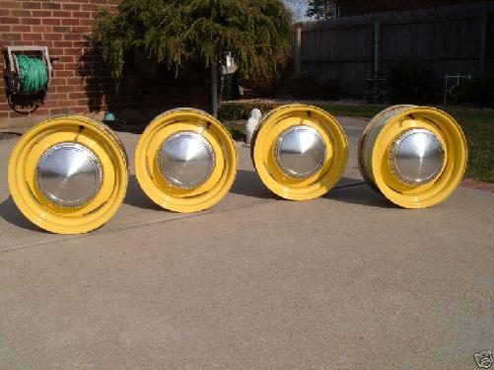
For Sale - 4 Early 70's Mopar dog dish hubcaps, 9 inch aluminum, excellent condition, no dents or cracks, a few minor scratches, $100 set. (Note, rims in picture are NOT for sale.)
Contact Ken at k.scobel@comcast.net or 812-372-8046.

**For Sale: 66/ 67 B-body stuff i.e. wiring harnesses kick panels small chrome pieces. Robert at bkvorpe@sbcglobal.net or 317-753-8385
<><><><>
**For Sale: '78 Cordoba, light blue, 360/904. Reclining buckets, good glass, sell whole for $700 or part out. Located in west central Indiana. See pix at http://360.yahoo.com/gtx4spd Ric LaFollette cell # 317-372-8245 or Email gtx4spd@yahoo.com
**For Sale: N.O.S. front bra for '95 Stratus sedan, still in box, never taken out. Would fit other years, don't know which. $50.For sale: Carbon fiber hood with simulated scoop for '01 Stratus coupe, would fit other years, don't have interchange info. BRAND NEW, never installed, no holes drilled, never painted. $700. OBO.
**For Sale: '63 Plymouth factory shop manual, original, not repro. Very good condition. What's it worth? You tell me! Ric LaFollette 765 482-0985 or 317 372-8245 gtx4spd@yahoo.com
<><><><>
**For Sale: 1969 Plymouth GTX Recreation, triple black, 472 HEMI, 727 Torqueflite, Dana 60, red stripe tires and more. . . . $55,000 Verne Home (815) 935-0405 Cell (815) 216-0220 or gtxman@earthlink.net
<><><><>
**For Sale 1968 440 ENGINE - Less than 1,000 miles on build: .030 over with Ross 11.5 : 1 pistons; Eagle “H” rods; Steel Crankshaft; Milodon 8 quart oil pan; Indy Cylinder Head SR aluminum heads & valve covers; New Indy Cylinder Head roller rocker arms; Solid lift camshaft (No cam card); Mopar aluminum high rise intake manifold; Holley 950 double pump carb.; Fuel pressure regulator and plumbing. This is a VERY strong engine and is complete, less distributor. $6,000 John Bauer 317-769-3312 or 317-430-1265 email bauerconstruction@tds.net
**For Sale1979 Lil Red Express my dad bought new in Michigan and drove daily for 110,000 miles. Engine and transmission were freshened at 103,000 miles. I also have a TCI trans kit for 727, a 318 short block balanced W/Keith black pistons low mileage, A 904 and a 727 for small block and some head cores. I will deal on any of the items. I would make some one a great deal to come take it all!!!!!!!!!!!! Home765-325-9910. Cell 317-409-8422. Calls will be returned.
<><><><><><><><><><><><><><><><><><>

