 Indy Mopar Club News
December 2007 www.indymoparclub.com Jan Peel and Dave Watt, editors
Meetings are the last Thursday of every month except no meeting in December due to the holidays.
January 25 is the next regular meeting at Ryans Family Steakhouse on US 31 South in Greenwood, 7pm.

Upcoming events: December 16, 2007. Indy Mopar Club Christmas Party at the Carefree North Clubhouse on the 1200 block of Leisure Lane in Greenwood (map on page two). This is for current members and their immediate family (spouse, significant other, children, and grandchildren). We will meet at 5pm, but if you would like to help decorate and setup at 4pm, it would be greatly appreciated. If you plan on coming RSVP to Dave at indymoparclub@indymoparclub.com or at 317-336-6354. Also see the Upcoming Events website page. See more information about the party on page 2.

Trivia question: Where did Chrysler install the wing, nose and special back window on the Dodge Charger Daytona and Plymouth Superbird? Answer at the bottom of the page.
2008 schedule of events.
Check the Upcoming IMC Events page on the website for more details and other events to be added.
March 1 and 2, 2008 The Chrysler Performance Trade Show and Swap Meet by Indy Cylinder Heads held at Blue Ribbon Pavilion of the Indiana State Fairgrounds. The Indy Mopar Club will set up an informational display.

May 3, 2008 The Indy Mopar Club will host an all Mopar Car Show at Palmer Automotive Group. The dealership location is to be determined. Top 20, Presidents Choice, and The Finer Details awards. Event T-shirt and goody bag to the first 40 entries. Door prizes, 50/50 drawing, food, DJ are some of the events planned. Rain date May 10.

Open Car Show, Fletcher Used Cars, Edinburgh Indiana. Details coming soon.

July 12, 2008 The Indy Mopar Club will host an all Mopar Car Show at Fletcher Chrysler Dodge Jeep, Franklin Indiana. Top 20, Presidents Choice, and The Finer Details awards. Event T-shirt and goody bag to the first 40 entries. Door prizes, 50/50 drawing, food, and DJ are some of the events planned. Rain or shine.

September 20, 2008 The Indy Mopar Club will host an all Mopar Car Show at Danville Chrysler Dodge Jeep. Top 20, Presidents Choice, and The Finer Details awards. Event T-shirt and goody bag to the first 40 entries. Door prizes, 50/50 drawing, food, and DJ are some of the events planned. Rain date September 27.

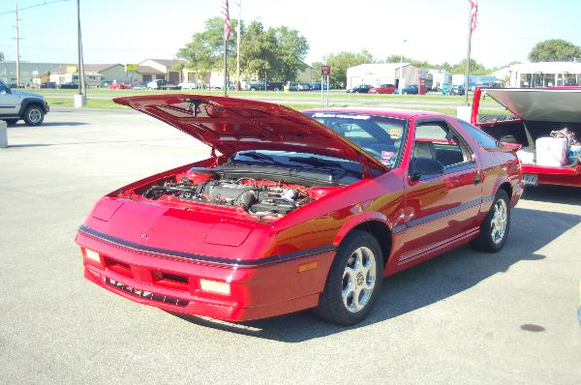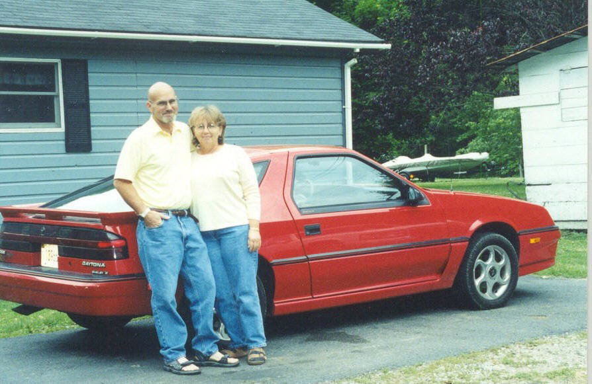
Feature car of the month. Read the story on page two.
Trivia answer: The fiberglass rear window plug, unique piece of glass, wing and nosecone were installed at Creative Industries in Detroit and were used to make the cars aerodynamically smooth. Did you get it right?
We are Tony and Thelma Fields of Columbus Indiana and we joined the club in 2007. We became interested in Mopars in 1971 when we bought a new 1971 340 Duster with an Automatic transmission.
A year or so later we traded the Duster in on a 1970 Plymouth Barracuda Gran Coupe. After a month I was t-boned at an intersection which totaled the car. We then bought a 1971 340 ‘Cuda hardtop. Over the last 37 years we have gone thru 6 Corvettes along with old Mopars. Fast forward to 2000 and we are back into Mopars, the Turbo FWD Mopars that is. At present we have a pair of 1988 Dodge Daytona Intercooled Turbo Shelby Z’s, a 1990 LeBaron GTC VNT black convertible with Variable Nozzle Intercooled Turbo with the A-568 Getrag 5-speed tranny. 1 of 3 produced as it sits. We also have a 1989 Dodge Caravan with the 2.5 Turbo engine. This is a factory setup and was offered in 1989 and 1990.
Last year I retired after 41 years of service and the wife bought me a 1967 Barracuda Fastback as a gift….can you say basket case. It will have a built 360 and a 727 with an 8 ¾” rear end. It should be near 400 h.p. when finished. We are very happy to be members of the Indy Mopar Club.
Tony and Thelma Fields
<><><><><><><><><><><><><><><><><><>
New award program for 2008
The Finer Details has presented The Finer Detail Award at each of the Indy Mopar Club's all Mopar dealership shows the last two years. At the May 3, July 12, and September 20 shows in 2008, not only can your car win The Finer Detail Award plaque and $100 cash, this places you in a three car shootout held at the September 20 Danville show in. A special trophy and $300 cash will go to the winner of the shootout. The rules:
- You must be a current Indy Mopar Club member. Membership forms available at the registration table at each show, on the website, or from a club member.
- Car is not eligible if it has won The Finer Detail Award previously.
- Judging at each of the three participating shows will be done by dealership personnel, not the Indy Mopar Club.
- Judging of the three car shootout will be done by Ken of The Finer Details; a neutral party will be chosen to judge in the event that a car restored by The Finer Details is participating.
<><><><><><><><><><><><><><><><><><>
Map to the Carefree North Clubhouse for the Christmas party.
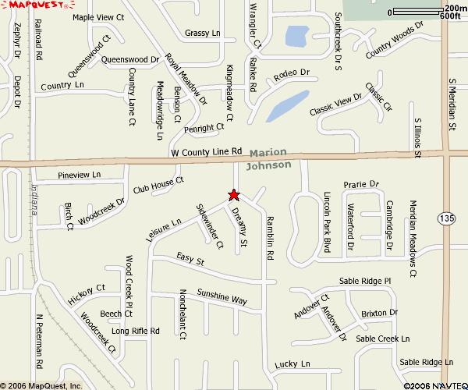
Carefree North Club House is ½ mile west of Meridian Street (Hwy 135) on the south side of County Line Road

We need to know how many are coming and children’s ages so please respond to Dave ASAP. Please bring a wrapped gift with their name on it ($10 limit so they will all be comparable) for Santa (yes, he’ll be there) to give your child. The club will furnish meat, beverages, and table service. Please bring your favorite side dish and a calorie free dessert. Also, there will be a White Elephant gift exchange with a $15 limit for the adults. Women should buy and mark their gift as Female. Men should buy and mark the gift for Male. (With this fun time who knows what can be “stolen” from another person to wind up in your possession at close of evening.)
Welcome to our newest members: Russ Flagle, Indianapolis, 1964 Plymouth Belvedere Hemi and 1934 Dodge 5 window Hemi; and Fred & Linda Kelley, Indianapolis, 1967 Plymouth Barracuda Convertible.
<><><><><><><><><><><><><><><><><><>

Your Dues renewal is included in this newsletter. Be sure and send your dues renewals in.
<><><><><><><><><><><><><><><><><><>
INDY MOPAR CLUB Monthly Meeting November 29, 2007 7:00 PM
Secretary’s Report
Welcome and sign in – John Bauer, President:
John Bauer brought the meeting to order at 7:00 PM. John asked all members and guests to introduce themselves.

Secretary’s Report – Chris Rigney:
Chris gave the highlights of the October meeting.

Treasurer’s Report/Membership Update – Mike Leyes:
Mike gave the treasurers report as of November 29, 2007. October 25, 2007 balance was $3,162.73; income was $92.00; Expenses were $1,856.92; ending balance is $1,397.81.
We currently have 94 members in the club.

Event Calendar – Dan Kelly:
Dan reported the Christmas Party will be December 16, 2007. If you plan on coming please notify either Dave Watt at www.indymoparclub.com 317-336-6354 or Steve Wisdom at beeep70@aol.com 317-888-7019.
The majority of the club members agreed to help with the Edinburgh open car show.

Event Advertising – Pat & Pat McKarski:
Pat gave an update on the advertising. They are presently advertising in Indy Auto & RV; Old Cars Only; and Mopar Collector’s Guide.

Communications Report – Dave Watt:
Dave will continue to E-mail the newsletter to all members that have an E-mail address. The balance will be mailed out.
Dave will be updating for 2008 shortly

Old Business – John Bauer:
- Club Member Profile for Newsletter & Website
  - December 2007 - Tony Fields

- John told about the Indy Cylinder Head Tour and Dyno demonstration.

- Joint get together with another Mopar club.
Tri State Mopar Club: Eric Gegert (513) 892-2042 kagebert@fuse.net River Valley Mopar Club

- Palmer Dodge 2008 show date confirmed for May 3rd, rain date 10th; Fletcher Chrysler show date July 12th, no rain date; Danville Chrysler show date confirmed for September 20th, rain date 27th.

New Business – John Bauer:

- INDY MOPAR CLUB special recognition award

- Russ Flagle, Indy Cylinder Head, will donate the cost of our newsletter expenses.

- 2008 Officers election results:
1. President: Steve Wisdom
2. Vice President: John Bauer
3. Treasurer: Mike Leyes
4. Secretary: Ronda Cherry
5. Communications Director: Dave Watt

- Dan Kelly discussed plans for our Christmas Party, December 16th, at Carefree North Clubhouse, Leisure Lane, Greenwood (see enclosed map) – Indy Mopar Club will again provide ham and turkey with attending members bringing a covered dish. The clubhouse will be open at 4 PM for set-up and decorating. Come at 4 to help or come at 5 PM to join the festivities. If you wish to join in the gift exchange bring a wrapped gift ($15.00 limit) and marked for male or female.
If you plan on coming please notify either Dave Watt at www.indymoparclub.com 317-336-6354 or Steve Wisdom at beeep70@aol.com 317-888-7019.

- IMC Name Tags (Renewals for 2008)

- Swap Meet in March, 2008 – John has a space if anyone is interested in sharing the space with a little bit of $.

- Club Meeting Location – Dan Kelly discussed the possibility of Steak & Ale, South 31 (in Southern Plaza) or Bob Evans on South 31.

John then adjourned the meeting.

Respectfully submitted – Chris Rigney, Secretary
<><><><><><><><><><><><><><><><><><>
Attendance at our October meeting: John & Carol Ann Bauer, Bill Bratton, Ronda Cherry, Rick Eilert, Dave & Terry Fishburn, Dan Kelly, Jim Kelly, Tom & Teresa Kelly, Ed Leyes, Mike Leyes, Susan Mayes, Patrick & Patricia McKarski, Bud & Debbie Mounce, Scott Oller, Jim Parker, Stan Peel, Mike & Chris Rigney, Bob & Karen Rosenberger, Ken & Sharon Scobel, Chris Usher, Dave Watt, Tom Williams, Steve Wisdom, and Rick & Ginger Zimmerman. The following guests were also present: Travis Bell, Jim Shine, & Fred Kelley.
<><><><><><><><><><><><><><><><><><>
January Birthdays: Ric LaFollette, 1-4; Renee’ Neukam, 1-5; Nancy Watt, 1-8; Sheilla Collins, 1-11; Jim Schaefer, 1-13; Bob Vorpe, 1-17; Butch Gillock, 1-19; Pat(rick) McKarski, 1-22; Curt Huff, 1-24;
January Anniversaries: Ron & Jeanie Fedoryk, 1-11 (no year given); Butch & Diane Gillock, 1-24 (38 years); Michael & Patricia Herter, 1-31 (no year given). Congratulations to all!
<><><><><><><><><><><><><><><><><><>
Club Member Information for all
From Ken & Sharon Scobel: Our oldest Daughter delivered our second grandchild last month on October 16th. She had a boy, 6 lbs/1 ounce, 19 1/4" long. Brandon Joseph Payne and his mom are doing great.
- - - - - - - - - - - - - - - - - - - - -
From Ginger & Rick Zimmerman: Their son, Ryan Johnson, went to Kuwait first and is now in BaghdadFor those of you who are interested his E-mail address is Snow_boarder3384@hotmail.com and his address is:
Pvt. Ryan Johnson
1-75 CAV, 2 BCT, 101 ABN
Unit # 43488
APO AE 09344
<><><><><><><><><><><><><><><><><><>
Tattler’s Corner
Well, all you “tattlers” let me down this month. Where are all you “naughty moparing” people hiding? Could it be you are all “trying” to be good so Santa will visit you? Doesn’t help – he watches you ALL YEAR! But he did send me a message to pass along to all the “Good Mopar People”: “As a special gift I am removing all fat and calories from the “goodie desserts” in the month of December so enjoy to your hearts content. You can see by looking at me that this really works”. From Santa & Mrs. Claus.
<><><><><><><><><><><><><><><><><><>
A Little Bit of Humor
Whoever said the Creator doesn't have a sense of humor?
Dwight Nelson recently told a true story about the pastor of his church. He had a kitten that climbed up a tree in his backyard and then was afraid to come down. The pastor coaxed, offered warm milk, etc.
The kitty would not come down. The tree was not sturdy enough to climb, so the pastor decided that if he tied a rope to his car and pulled it until the tree bent down, he could then reach up and get the kitten.
That's what he did, all the while checking his progress in the car.
He then figured if he went just a little bit further, the tree would be bent sufficiently for him to reach the kitten. But as he moved the car a little further forward, the rope broke. The tree went "boing!" and the kitten instantly sailed through the air - out of sight.
The pastor felt terrible. He walked all over the neighborhood asking people if they'd seen a little kitten. No. Nobody had seen a stray kitten. So he prayed, "Lord, I just commit this kitten to your keeping," and went on about his business.
A few days later he was at the grocery store, and met one of his church members. He happened to look into her shopping cart and was amazed to see cat food. This woman was a cat hater and everyone knew it, so he asked her, "Why are you buying cat food when you hate cats so much?"
She replied, "You won't believe this," and then told him how her little girl had been begging her for a cat, but she kept refusing. Then a few days before, the child had begged again, so the Mom finally told her little girl, "Well, if God gives you a cat, I'll let you keep it."
She told the pastor, "I watched my child go out in the yard, get on her knees, and ask God for a cat. And really, Pastor, you won't believe this, but I saw it with my own eyes. A kitten suddenly came flying out of the blue sky, with its paws outspread, and landed right in front of her."

Never underestimate the Power of God and His unique sense of humor.
<><><><><><><><><><><><><><><><><><>
Christmas Card List - When you are making out your Christmas card list this year, please include the following:
A Recovering American Soldier
c/o Walter Reed Army Medical Center
6900 Georgia Avenue, NW
Washington, D. C. 20307-5001
<><><><><><><><><><><><><><><><><><>
Merry Christmas
and
Happy New Year

INDY MOPAR CLUB
2008 MEMBERSHIP RENEWAL
Your annual membership renewal dues of $30.00 are due and payable by January 31, 2008.

Name

Address

City, State, Zip

Home Phone Cell Phone E-mail

Your Birthday Spouse Birthday Anniversary

Children:

Career Field

The Mopar cars you own (Year, Make, Model, Color) Please list only 6:

Project Cars – Please list only 3
:

Your check should be made payable to Indy Mopar Club. Please return the form, along with your remittance to:

Indy Mopar Club
% Mike Leyes
3130 Hardacre Ct
New Castle IN 47362



