 Indy Mopar Club News
August 2007 www.indymoparclub.com Jan Peel and Dave Watt, editors

Meetings are the last Thursday of every month except December due to the holidays.
Thursday August 30 and Thursday September 27 will be the next regular meetings at Ryans Family Steakhouse on US 31 South in Greenwood, 7pm.

Trivia question: What two special “Package Cars” were built in1968 but not street legal? Answer at the bottom of the page.

September 22, 2007, 9-3pm, The Indy Mopar Club will host an all Mopar car show at Danville Chrysler Dodge Jeep located at 20 S. County Road 300 E. #362 in Danville Indiana, (317)-745-5809. Top 20 awards, The Finer Detail Award, Presidents Choice Award, door prizes, 50/50 drawing, DJ, food and more. Rain date: Sept. 29

Our 1970 340 Dodge Dart Swinger by Steve Shutters
My wife Judy and I first met Steve Wisdom, Rick and Ginger Zimmerman at the Fair Oaks Mall in Columbus last year. They told us about the Indy Mopar Club, we joined right then. Because of our work schedules we weren’t able to go to any of the shows last year, but that has changed for this year. I have always been a Mopar guy with my first car being a 1963 Plymouth Fury with a 318. My dad bought it new and I bought it from him. My first modifications were Cragar S/S wheels with Penny’s Scat Trac tires, remember those!?!
My next Mopar was a 1967 GTX which I drove to school and raced on the weekends.
We purchased our 1970 340 Dodge Dart Swinger from the original owner in Miami Florida, it arrived two days before Christmas 1999. In 2000, we drove it to the Mopar Nationals and entered it in the A-body judged class so we could find out what we needed to do to make it better. While there, American Muscle Car was filming a series on the A-body’s and our car was filmed twice for the show. It was also published in the Year One catalog for A-body’s. It is numbers matching 340, 727 Auto, 3.23 Sure Grip and has 21 options including factory air with a final price of over $4,000. We also have several other Mopars which we will share with the club in the future. I have to go for now, I’m trying to get the engine in the ’63 to drive before winter.
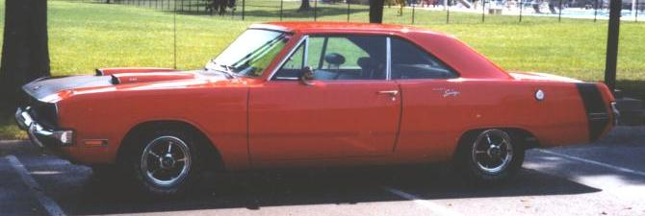

Read about Steve and Judy Shutter’s 1970 Dodge Dart Swinger 340 above.

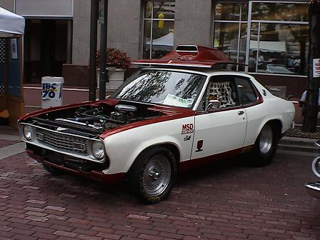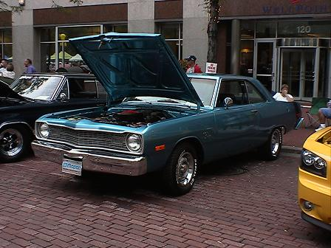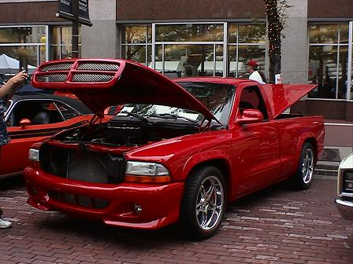
Photos from the 2007 Dodge Racers on the Circle event. Thank you to all 14 participants for bringing out your Dodge muscle.

Trivia answer: The 1968 Dodge Dart and Plymouth Barracuda Super Stock Hemi cars were built as a special “Package Car”. They are still the Kings of NHRA Super Stock competition and in a class all by themselves. They are running in the mid to high 8 second quarter mile times at nearly 150 MPH. Did you get it right?
Welcome to New Members: Preston & Rose Droddy, Indianapolis, with a ’70 Dodge Challenger T/A. We hope to see them again soon.
<><><><><><><><><><><><><><><><><><>
Now that the Dodge Racers on the Circle is in the history books, thank you to everyone who brought out their Dodges to show the great history of the Dodge product line. I will soon be adding a photo page to the website.
A new "Other Events" page has been added for events the club is not associated with. Click on the link to check it out.
http://www.indymoparclub.com/otherevents.html
Flyers and information may be submitted to indymoparclub@indymoparclub.com in .jpeg format for the flyers is requested due to its smaller file size.

Dave Watt
Communications Director for the Indy Mopar Club
www.indymoparclub.com
From our President John Bauer: We did not have any kind of a meeting as the live band was so LOUD you had to yell at the person you were talking to or they couldn’t hear you. Very, very loud but it was a good event. These are the folks that attended the Dodge On The Circle:
Dan Kelly
Tom Kelly
Dave & Nancy Watt & children
Mike Leyes
Ed & Mary Leyes
Preston Droddy
Dennis & Ronda Cherry
Bob & Julia Schonegg
Bob Thomas
Jim Parker
Chris Usher
Bill & Constance Bratton
Rick & Susan Eilert
Jason Cummings
Rick & Ginger Zimmerman
Ken & Sharon Scobel
Steve & Judy Shutters
Dave & Terry Fishburn
Bud & Debbie Mounce
Darren Turpen
Stan Sanders
Steve Wisdom
Me & “Honey”

We hope to have a good attendance at the August meeting as we prepare for the September all Mopar car show
at Danville Chrysler Dodge Jeep located at 20 S. County Road 300 E. #362 in Danville Indiana.
<><><><><><><><><><><><><><><><><><>

September Birthdays: Judy Shutters, 9-4; Ronda Cherry, 9-7; Jason Cummings, 9-7; Kirby Haskins, 9-7; Kim Cummings, 9-8; Chad Neukam, 9-13; and Bob Roserberger, 9-30.
September Anniversaries: Frank & Jo Goodrum, 9-6 (43 years); Ronda & Dennis Cherry, 9-8 (27 years); and Jim & Sue Kelly, 9-12 (26 years). Congratulations to all!
<><><><><><><><><><><><><><><><><><>
WANT ADS FROM INDY MOPAR WEBSITE

FOR SALE

**For Sale: NEW IN BOX! Never Used. NOS, 4 Cragar S/S 14x6 chrome 5 Spoke wheels plus caps.
5 x 4" bolt circle for A Bodies, Manufacture date: Nov 1988. $500 firm. Ken 812-372-8046 k.scobel@comcast.net

**71/72 Dart doors with glass for 2 door hardtop decent shape, no rust; $50 each (317) 894-0827 after 9am and before 9 pm Larry

**Free to a good home: 2 snorkle 2bbl air cleaners; truck headers for a 360; 4 blade fan w spacer; 5 blade fan, no spacer; stock harmonic balancer LA motor. Also For Sale: stock cast iron 4 bbl intake for a small block LA motor make offer. If interested, please email me at wyverin@tds.net or call at 765-522-5665 and ask for Stan

** FOR SALE 1968 440 ENGINE - Less than 1,000 miles on build, .030 over with Ross 11.5: 1 pistons,
Eagle “H” rod, Steel Crankshaft, Milodon 8 quart oil pan, Indy Cylinder Head SR aluminum heads & valve covers, New Indy Cylinder Head roller rocker arms, Solid lift camshaft (No cam card), Mopar aluminum high rise intake manifold, Holley 950 double pump carb., Fuel pressure regulator and plumbing. This is a VERY strong engine and is complete, less distributor. $6,000 John Bauer 317-769-3312.

** For Sale: Small bolt pattern Aluminum Outlaws wheels: 4- 14 x7" $200. For Sale: 66/ 67 B-body stuff i.e. wiring harnesses kick panels small chrome pieces. Robert at bkvorpe@sbcglobal.net or 317-753-8385

** For Sale: I have a TCI trans kit for 727, a 318 short block balanced W/Keith black pistons low mileage, A 904 and a 727 for small block and some head cores. I will deal on any of the items. I would make some one a great deal to come take it all!!!!!!!!!!!! Home765-325-9910. Cell 317-409-8422. Calls will be returned.

** For Sale: N.O.S. front bra for '95 Stratus sedan, still in box, never taken out. Would fit other years, don't know which. $50.For sale: Carbon fiber hood with simulated scoop for '01 Stratus coupe, would fit other years, don't have interchange info. BRAND NEW, never installed, no holes drilled, never painted. $700. obo. Also For Sale: '63 Plymouth factory shop manual, original, not repro. Very good condition. What's it worth? You tell me! Ric LaFollette 765 482-0985 or 317 372-8245 gtx4spd@yahoo.com Thanks!

CARS FOR SALE

** 1982 Imperial, fuel injection to carburetor conversion done in 1987. 62,500 miles, 318 engine, Auto, needs some minor work but runs and drives nice. No rust, light blue paint is OK except hood, decent tires, wire wheel covers, white leather interior. Drive as is or restore, $1,950 OBO. (317)-894-8027 after 9am, before 9pm. Larry

** For Sale: '78 Cordoba, light blue, 360/904. Reclining buckets, good glass, sell whole for $700 or part out. Located in west central Indiana. See pix at http://360.yahoo.com/gtx4spd
Ric LaFollette cell # 317-372-8245 or Email gtx4spd@yahoo.com
<><><><><><><><><><><><><><><><><><>

Tattler’s Corner
Do you remember an old song “You Picked a Fine Time to Leave Me Lucille”? Do a little modification to that and make it “You Picked a Fine Time to Leave Me Loose Wheel”. A certain husband told his honey that if he hadn’t fixed it she would have been singing the second version. And all she could do was laugh until she cried. No names mentioned here.
<><><><><><><><><><><><><><><><><><>
A Little Bit of Good Advice
ATTORNEY’S ADVICE - You will love them for these tips.
Read this and make a copy for your files in case you need to refer to it someday. Maybe we should all take some of his advice! A corporate attorney sent the following out to the employees in his company.
1. Do not sign the back of your credit cards. Instead, put "PHOTO ID REQUIRED."
2. When you are writing checks to pay on your credit card accounts, DO NOT put the complete account number on the "For" line. Instead, just put the last four numbers. The credit card company knows the rest of the number, and anyone who might be handling your check as it passes through all the check processing channels won't have access to it.
3. Put your work phone # on your checks instead of your home phone. If you have a PO Box, use that instead of your home address. If you do not have a PO Box, use your work address. Never have your SS# printed on your checks. (DUH!) You can add it if it is necessary. But if you have it printed, anyone can get it.
4. Place the contents of your wallet on a photocopy machine. Do both sides of each license, credit card, etc. You will know what you had in your wallet and all of the account numbers and phone numbers to call and cancel. Keep the photocopy in a safe place.
I also carry a Photocopy of my passport when I travel either here or abroad. We've all heard horror stories about fraud that's committed on us in stealing a name, address, Social Security number, credit cards.
Unfortunately, I have first hand knowledge because my wallet was stolen last month. Within a week, the thief ordered an expensive monthly cell phone package, applied for a VISA credit card, had a credit line approved to buy a Gateway computer, received a PIN number from DMV to change my driving record information online, and more.
But here's some critical information to limit the damage in case this happens to you or someone you know:
5. We have been told we should cancel our credit cards immediately. But the key is having the toll free numbers and your card Numbers handy so you know who to call. Keep those where you can find them.
6. File a police report immediately in the jurisdiction where your credit cards were stolen. This proves to credit providers you were diligent, and this is a first step toward an investigation (if there ever is one).
But here's what is perhaps most important of all:
7. Call the three national credit reporting organizations immediately to place a fraud alert in your name and also call the Social Security Fraud line number. I had never heard of doing that until advised by a bank that called to tell me an application for credit was made over the internet in my name. The alert means any company that checks your credit knows your information was stolen, and they have to contact you by phone to authorize new credit.
By the time I was advised to do this, almost two weeks after the theft, all the damage had been done. There are records of all the credit checks initiated by the thieves' purchases, none of which I knew about before placing the alert. Since then, no additional damage has been done, and the thieves threw my wallet away this weekend (someone turned it in). It seems to have stopped them dead in their tracks.
Now, here are the numbers you always need to contact about your wallet, if it has been stolen:
1) Equifax: 800-525-6285
2) Experian (formerly TRW): 888-397-3742
3) Trans Union: 800-680-7289
4) Social Security Administration (fraud line): 800-269-0271

