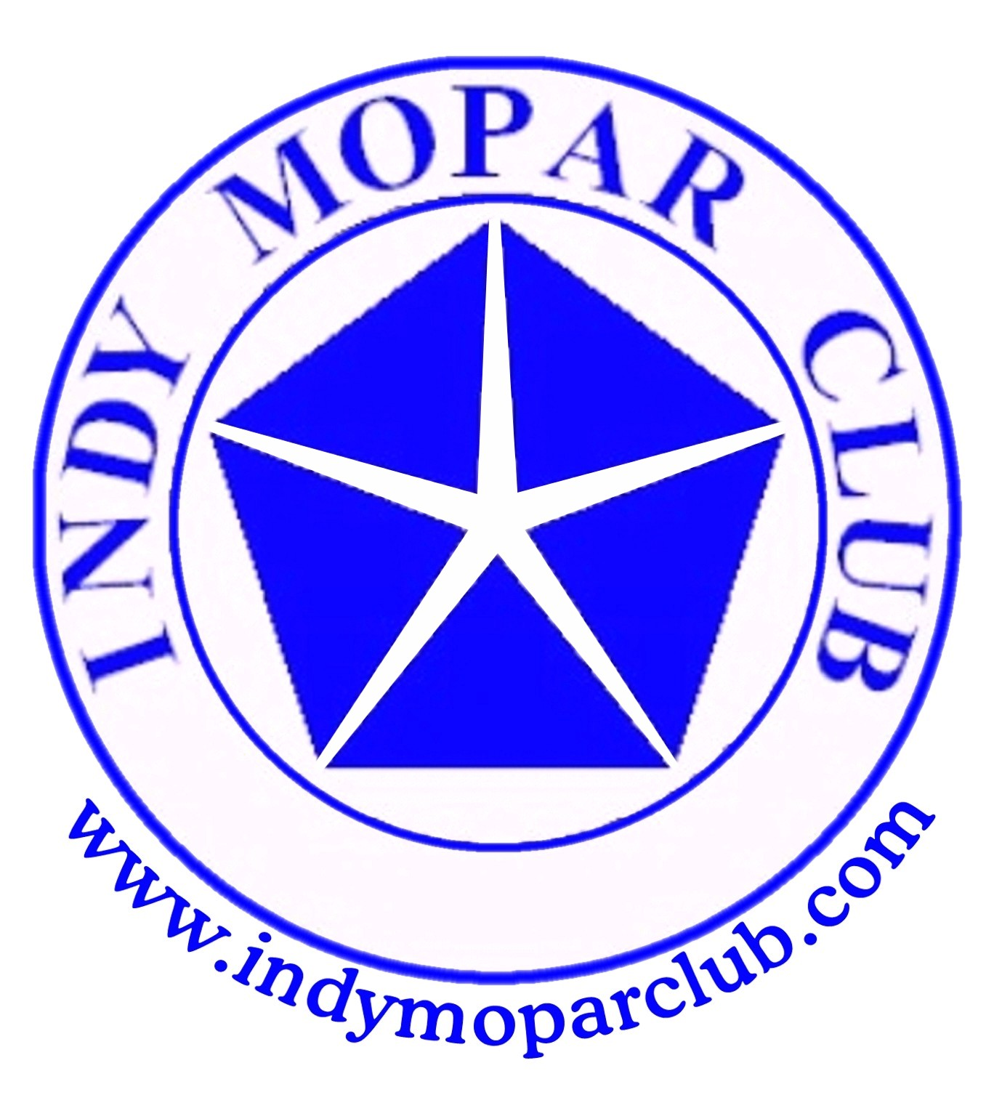 Indy Mopar Club News
April 2008 www.indymoparclub.com Jan Peel and Dave Watt, editors
Meetings are the last Thursday of every month

Next regular meeting: Thursday April 24, 2008 will be held at Indy Powder Coating 1201 Main Street, Speedway, IN 46224 (317)-244-2231. There will be a Powder Coating demonstration at 6 pm (takes 45 minutes to an hour), then a brief meeting at 7 pm. No food will be served so please plan accordingly. Please bring your lawn chairs as they do not have enough for our large group.
A Map Quest link is available on the IMC website.

2008 schedule of events. More events and details on the way.

Next regular meeting: Thursday April 24, 2008 will be held at Indy Powder Coating 1201 Main Street, Speedway, IN 46224 (317)-244-2231.

May 3, 2008 the Indy Mopar Club will host an all Mopar Car Show at Palmer Chrysler Jeep Dodge NEW LOCATION, 5051 West Pike Plaza Road. (317)-293-4900. Registration 9-noon, awards at 3pm. Top 20, Presidents Choice, and The Finer Details awards. Event T-shirt and goody bag to the first 40 entries. Door prizes, 50/50 drawing, food, DJ are some of the events planned. Rain date May 10.

May 17, 2008 the Indy Mopar Club will host an Open Car Show at Fletcher Used Cars in Edinburgh. Registration 9-noon, awards at 3pm. Door prizes, 50/50 drawing, food, and DJ are some of the activities for the day.

June 21, 2008 the Indy Mopar Club will host an all Mopar Car Show at Fletcher Chrysler Dodge Jeep, 3099 S. Morton Street (US 31 South), Franklin Indiana. Registration 9-noon, awards at 3pm. Top 20, Presidents Choice, and The Finer Details awards. Event T-shirt and goody bag to the first 40 entries. Door prizes, 50/50 drawing, food, and DJ are some of the events planned. Rain or shine.

September 20, 2008 the Indy Mopar Club will host an all Mopar Car Show at Danville Chrysler Dodge Jeep. See website Upcoming Events page for new dealership location. Registration 9-noon, awards at 3pm. Top 20, Presidents Choice, and The Finer Details awards. Event T-shirt and goody bag to the first 40 entries. Door prizes, 50/50 drawing, food, and DJ are some of the events planned. Rain date September 27.

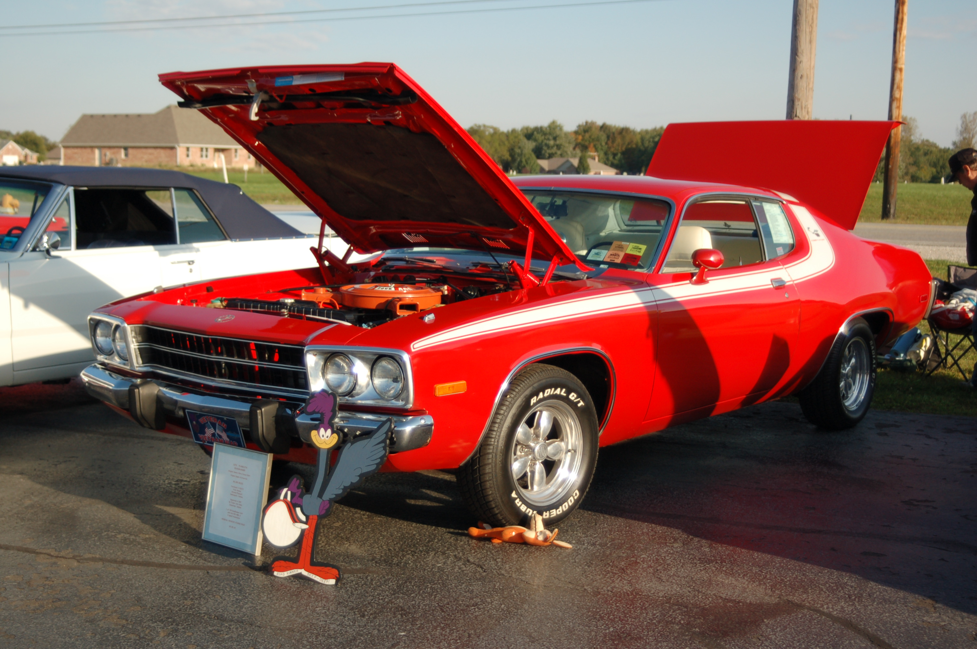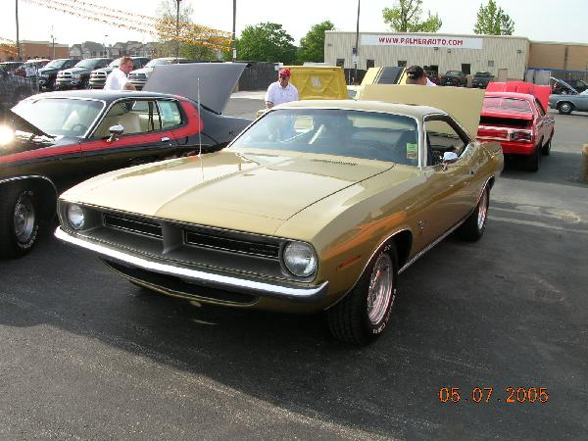
Read the story on page two about Rick being influenced by his dad to be a Mopar guy. His 1973 Road Runner and 1970 Barracuda Gran Coupe are pictured above.
MOPAR OR NOCAR by Rick Eilert

I got into MOPARS because of my Dad. He was parts manager for Charlie Taylor's Hoosier Chrysler / Plymouth on Lafayette Road here in Indianapolis. He helped me pick out my first car while I was a junior at North Central High School. I paid $25 for the 1950 Dodge six cylinder with fluid drive. It was a great first car. Top speed was a whopping 80 mph. For some unknown reason the engine locked up after about six months.

Next I bought a 1950 Plymouth six cylinder with three on the tree for $50. It used almost as much oil as it did gas. After graduating from high school in 1966, I bought my first cool car. A white 1962 Plymouth Fury with a 318 four barrel with the push button transmission.

In 1968 Uncle Sam called me. I received orders to go to beautiful Southeast Asia, so instead of letting the car sit for a year, I sold it. I bought a 1966 Plymouth Fury when I got back to the states.

When Uncle Sam released me (in 1970), I bought a 1969 Fury III convertible with a 383-4. In October 1972 I stopped in at Hoosier Chrysler / Plymouth. There on the showroom floor sat a new 1973 red Roadrunner with white interior, automatic transmission with the 318 engine. It was love at first sight. I told the salesman I wanted one just like it, except with a 400 engine and 4 speed transmission. That evening I ordered my first new car. It took about 3 weeks for it to come in. When I went in to pick it up Charlie Taylor called me into his office to tell me there was a problem. The guy that was supposed to clean it up apparently ran into a work bench and dented the front end. It wasn't much of a dent, but there it was, my first new car, already wrecked before I even had a chance to drive it. The repairs were made and in a few days I was driving the best car I've ever owned.

Thirty-five years later we're still together. It's just luck that I've kept it all these years. My other cars over the past 30 years have been: 1977 Plymouth Trailduster, 1981 Dodge window van, 1986 Dodge van, 1989 Dodge Spirit ES with a turbo, 1992 Dodge van, 1996 Intrepid , 1999 Dodge custom van, and a 2004 Intrepid. My current MOPARS are a 70 Barracuda Gran coupe, the 73 Roadrunner, a 1997 Dodge 2500 4x4, 2002 Neon, 2006 Top Banana Daytona Charger, and a 2008 Jeep Patriot.
Author – Rick Eilert

<><><><><><><><><><><><><><><><><><>

INDY MOPAR CLUB Monthly Meeting Secretary Report March 27, 2008 7:00 PM

Welcome and sign in – Steve Wisdom, President:
Steve Wisdom brought the meeting to order at 7:00 PM. Steve asked all members and guests to introduce themselves and be sure to sign the attendance sheet.

Secretary’s Report – Ronda Cherry:
Ronda read the highlights of the February 2008 meeting.

Treasurer’s Report/Membership Update – Mike Leyes:
Mike gave the treasurers report as of March 29, 2008. February 28, 2008 Balance was $1,286.44;
Income for March was 23 membership dues of $690.00, additional 08 member shirts $110.00, 36 Old
Car Show shirts $72.00, deposit Swap Meet change $200.00, JDRF Bracelets & Donations
$42.00 – Total $1,114.00.
Expenses – Jan’s Computing for News Letters $18.63, Cash for Swap Meet Change $200.00, Reimburse
Mike Leyes for Web Site Fee $59.98 – Total $278.61
Balance March 29, 2008 is $2,121.83.
We currently have 64 members in the club.
Event Calendar – John Bauer:
John talked about upcoming events for the year:
May 3rd Palmer Dodge-Indy Mopar Club all Mopar Car Show – Rain date May 10th
May 17th Edinburgh Open Car Show
June 21st Fletcher Chrysler-Indy Mopar Club all Mopar Car Show
September 20th Danville Chrysler- Indy Mopar Club all Mopar Car Show – Rain date September 27th

Event Advertising – Pat & Pat McKarski:
Pat gave an update on the advertising. They are presently advertising in
Indy Auto & RV
Old Cars Only
Mopar Collector’s Guide.
Old Car Trader
Pat has also been in touch with 101.9 radio station

Communications Director Report – Dave Watt:
Dave reported he will have directions to Indy Powder Coating on the website.

Old Business – Steve Wisdom:
- Club Member Profile for Newsletter & Website
  - April – Rick Eilert
  - May – Larry Mayes
  - June – Dick & Dorinda Crawmer
  - July – James Bratby

- Joint get together with another Mopar club.
Tri State Mopar Club: Eric Gebert (513) 892-2042 kagebert@fuse.net River Valley Mopar Club, maybe August 23rd.
1. Cruise-in or Cruise-in and Park picnic – possibly Greensburg Park sometime in July

- Door Prizes:
  - Palmer Show – Pat McKarski, John Bauer, and Mark Smith
  - Fletcher Edinburgh Show – Steve Wisdom and Rick Zimmerman
  - Fletcher Franklin Show – Steve Wisdom and Rick and Ginger Zimmerman
  - Danville Show – Tom Kelly & one of his brothers.

- IMC Name Tags (Renewals for 2008) – Larry Mayes & Sue were not in attendance – put on hold.

- Indy Powder Coating Tour & Demo
  - Eat before you come, tour at 6:00 and meeting at 7:00 after demo. Bring a lawn chair.

New Business – Steve Wisdom:
- Palmer Show – Pike Plaza – Volunteers:
Registration Table – Bill Bratton and Tom Kelly
Goodie Bags – need to be there at 7:30
Parking – Rick Zimmerman and Pat McKarski
Pictures – Rose Richard
Door Prize Table – John and Carol Ann Bauer
50/50 and Door Prize Tickets – Jan Peel
Food & Drinks – John Bauer will contact the caterer for the Danville Show last year
Event T-shirts & Awards – Steve Wisdom - Taken care of
New Business Continued

D.J. has been confirmed – ABC Dee Jay

- Fletcher Edinburgh Show – Volunteers:
Registration Table – Bob Schonegg and Steve Wisdom
Goodie Bags – need to be there at 7:30 – Jessica and Gary McCormick
Parking – Rick Zimmerman and Pat McKarski
Pictures – Dave Stephenson
Door Prize Table – Chris Usher, Jim Parker and Cheryl Wisdom
50/50 and Door Prize Tickets – Jan Peel
Food & Drinks – Whosoever Will Community Church
Event T-shirts & Awards – Steve Wisdom - Taken care of
D.J. has been confirmed – ABC Dee Jay

- Questions about other Charities
- Dave Watt reported that St. Matthews is raising money for a Seeing Eye Dog for a blind lady. She is presently using a “loaner”. The cost is $12,000 for a replacement.
- Ginger Zimmerman reported that there will be a September Walk-a-thon with Amy Wallace walking 60 miles.
- After a discussion on the subject it was resolved to set up a jar requesting donations for the Walk-a-thon at the 1st and 3rd car shows and the Seeing Eye Dog at the 2nd and 4th shows.
- There was a discussion then about a Cruise-In at the Champion Dealership. This was put on hold for future discussion.

Steve Wisdom then adjourned the meeting.

Respectfully submitted – Ronda Cherry, Secretary
<><><><><><><><><><><><><><><><><><>
May Birthdays: Bob Schonegg, 5-7; John Bauer, 5-9; Dick Crawmer, 5-11; Ed Leyes, 5-12; Debbie Mounce,
5-17; Gary McCormick, 5-21; Steve Wisdom, 5-22; Mary Leyes, 5-23; Terry Fishburn, 5-27; Mike Leyes, 5-28.
May Anniversaries: Gary & Kim Rogers, 5-3; Chad & Renee Neukam, 5-11; Scott & Shari Herring, 5-18; Bob & Karen Rosenberger, 5-26.
Congratulations to all!
<><><><><><><><><><><><><><><><><><>
Information
The enclosed condensed article about the Indy Mopar Club appeared in the Hendricks County Flyer April 12, 2008. It was actually about a ¾ page article. The pictures were scanned in from the newspaper article so are not nearly as good as the original. Thanks to John, Ken, Rick, and Pat for participating. It does help to advertise our club with our charity donation to JDRF.

New information for Rick & Ginger’s son Ryan who is stationed in Iraq:
Pfc Ryan Johnson
1-75 CAV, 2 BCT, 101 ABN
Unit # 43488
APO AE 09344
His E-mail address is now: airborneu173@aim.com

www.flyergroup.com HENDRICKS COUNTY FLYER April 12, 2008

Car enthusiasts share hobby, support cause

BY LINDSAY J. JONES
lindsay.jones@flyergroup.com

BROWNSBURG - The Indy Mopar Club is somewhat unique compared to other organizations for car enthusiasts.

The club began more than 10 years ago, and is exclusively for owners of Chrysler-made vehicles. The word "mopar" is a short version of "motor parts," and there are Mopar clubs throughout the country.

John Bauer of Brownsburg, vice president of the non-profit organization, said the group has about 65 members from Indiana and Illinois, but expects that number to grow to 100 by the end of summer.

He said he joined because of his love of cars.

"I think it's just remembering back to my teenage years to a much simpler life without all the responsibilities you incur as an adult," he said. "I'm just trying to be an 18-year-old again."

The club even has its own charity - the Juvenile Diabetes Research Foundation. All proceeds from each of the group's four shows a year go to the organization. Last year they contributed more than $5,000, the most they've ever raised.

This year's shows include an all-Mopar car show on May 3 at Palmer Chrysler Jeep Dodge, 5051 West Pike Plaza Rd., Indianapolis; an open car show on May 17 at Fletcher Used Cars in Edinburgh; an all-Mopar car show on June 21 at Fletcher Chrysler Dodge Jeep, 3099 S. Morton St., Franklin; and an all-Mopar car show at Danville Chrysler Dodge Jeep, 173 S. Co. Rd. 525 E., Avon.

In addition to car Shows, members attend monthly meetings to talk about their bobby, and sometimes take tours of facilities that build engines or other car parts.

Bauer said members have cars as old as 1936 up to current Chrysler models, but most have cars from the 1960s and '70s.

"We have a fairly large spectrum of cars," he said. "Muscle cars from the late '60s and early '70s, newer vehicles, some more luxurious vehicles from the '60s and '70s."

He himself has three cars, two of which are being restored, the third is ready to be shown. He said some members have as many as 10 cars.

"A lot have cars they raced back in their teenage years," he said. "A period of time when the industry was building factory race cars you could race on the street."

The club's members are as diverse in age as the cars they own, with the youngest member being 19 and the oldest in his 70s.

"It's a very tight-knit organization," Bauer added. "Anyone is welcome to come, as long as they have a Chrysler vehicle." For more information or to join the Indy Mopar Club, visit the website at www.indymoparclub.com or e-mail indymoparcIub@indymoparclub.com.

Pictures from the Hendricks County Flyer

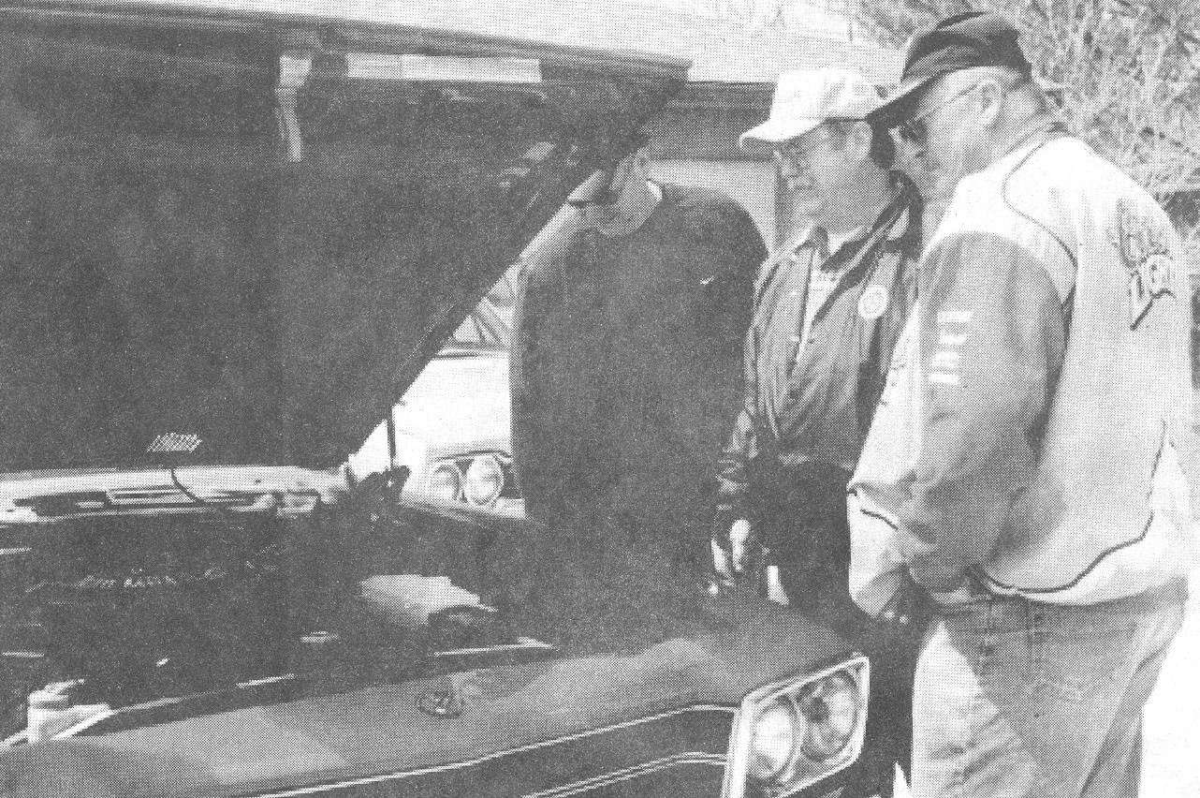
Indy Mopar Club members Ken Komlanc, Rick Eilert, and Pat McKarski look at the engine of Eilert’s 1973 Roadrunner

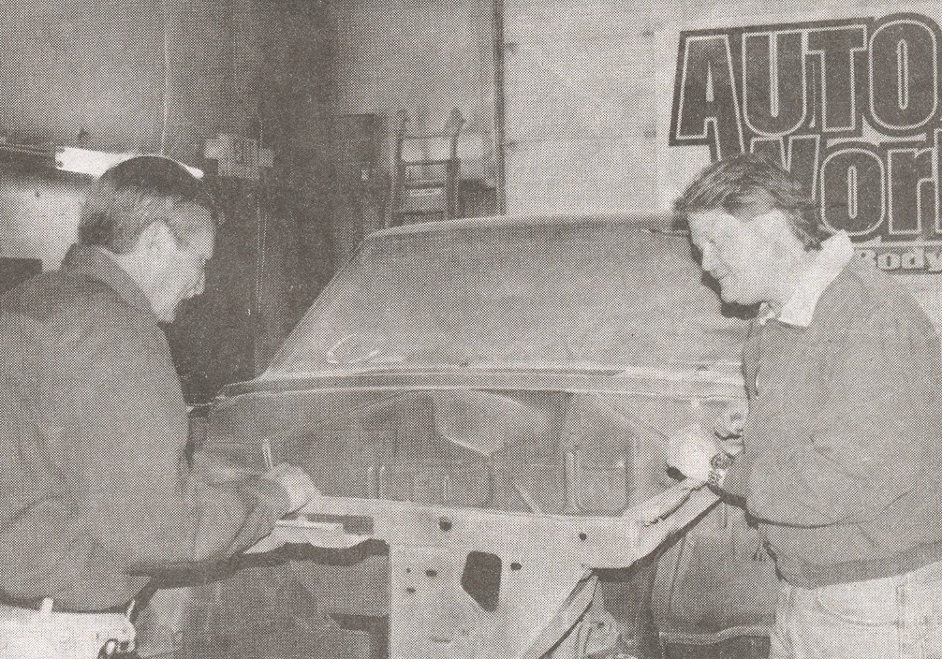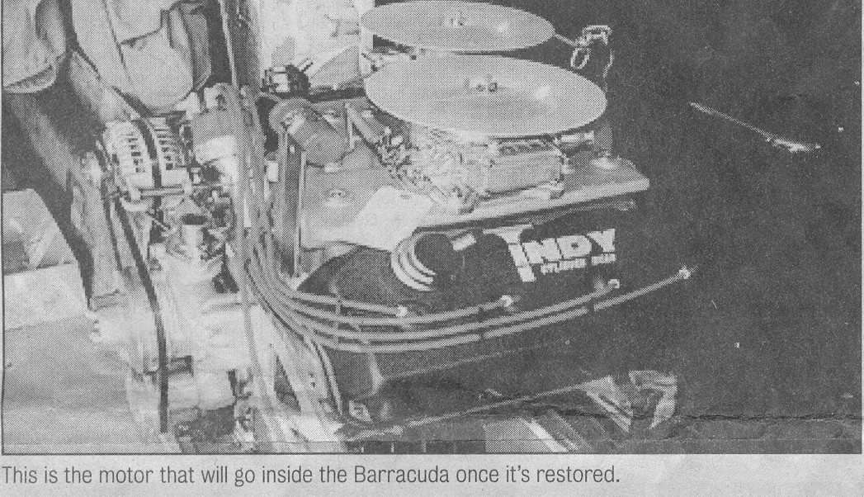
John Bauer talks with Darren Turpen about This is the motor that will go inside the Barracuda
the restoration process of his Barracuda. Once it’s restored.

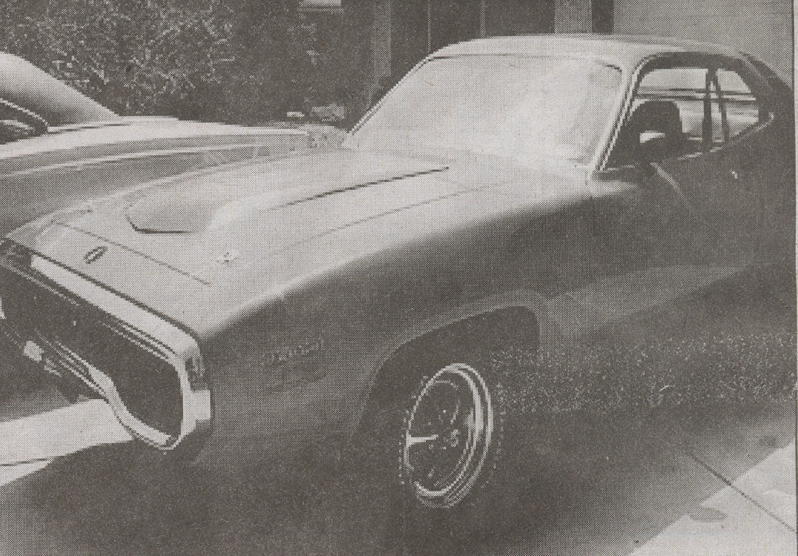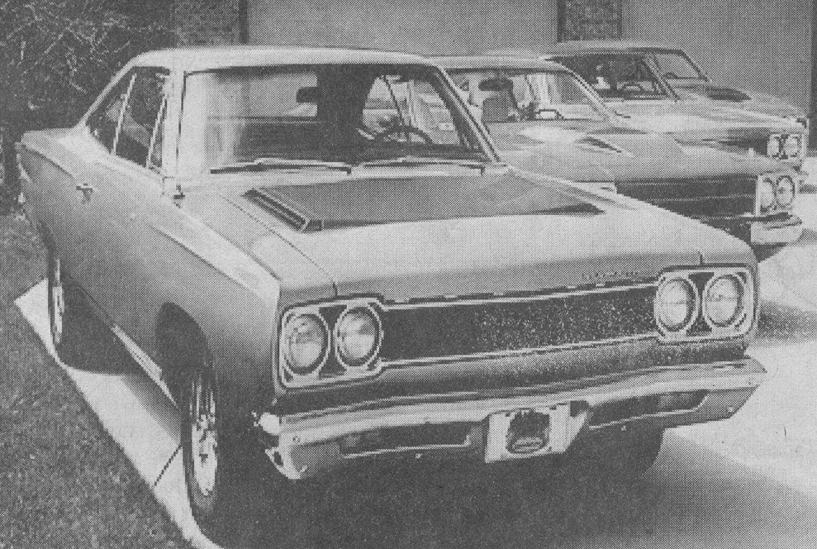
This is a close look at one of the four Road Runners These are four of the Plymouth Road Runners belonging to
belonging to Indy Mopar Club members. Indy Mopar Club members.

